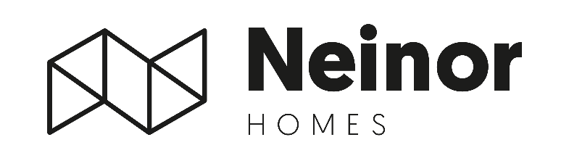

Neinor Homes successfully acquires over 79% of AEDAS, fulfilling its objective of securing a controlling interest before year-end
- At the Voluntary Tender Offer launched on 25 November, Neinor successfully acquired 79.20% stake in AEDAS, fulfilling its objective of securing a controlling interest in the company before year-end
- As previously communicated, Neinor expects to launch a subsequent mandatory tender offer at €24.00/share, representing a 12.5% premium over the voluntary offer price, subject to CNMV’s authorisation
Madrid, 17 December, 2025 – Neinor Homes (“Neinor”), Spain’s leading listed residential developer, announces that it has successfully completed the first Voluntary Tender Offer for AEDAS Homes (“AEDAS”), securing a 79.20% stake in the company after acquiring 34,610,761 shares at a price of €21.335 per share, representing a total investment of c. €740mn. The acceptance period ran from 27 November to 11 December, and settlement of the transaction is expected to take place on 22 December.
Following completion, Neinor’s Deputy CEO and CFO, Jordi Argemí, will join the Board of Directors of AEDAS Homes, replacing Eduardo D’Alessandro, former director appointed by Castlelake.
By reaching the 79.20% threshold, Neinor achieves the central milestone of the acquisition roadmap for AEDAS, completing this phase of the transaction swiftly and in an orderly manner. As previously communicated to the market, Neinor has committed to launching a subsequent mandatory tender offer at €24.00 per share, representing a 12.5% premium over the voluntary offer price, subject to CNMV authorisation. The €24.00 price matches AEDAS’s share price prior to the announcement of the voluntary offer (adjusted for the dividend paid in July) and reflects the applicable regulatory considerations. This second offer will be launched as soon as regulatory approval is obtained, with the objective of maximising acceptance among the minority shareholder base and increasing Neinor’s stake in the company within an accelerated timeframe.
Beyond the transaction mechanics, Neinor highlights that the combination with AEDAS strengthens its position as Spain’s leading listed residential platform, enhancing scale, capital efficiency and long-term visibility at a decisive moment for the sector. The company reiterates that this acquisition will allow it to focus fully on its core mission: developing high-quality housing across Spain and delivering long-term value for all stakeholders.
Borja García-Egotxeaga, CEO of Neinor Homes, commented: “We are very pleased with the outcome of the first offer, which allows us to secure a controlling interest in AEDAS exactly as committed to the capital markets back in June.”
Jordi Argemí, Deputy CEO and CFO of Neinor Homes, added: “This milestone is a clear step change for Neinor and for the Spanish residential sector, positioning us to create the largest homebuilder in a highly fragmented market and to drive meaningful long-term value for shareholders.”

* For the full regulatory announcement please refer to Neinor’s webpage (https://www.neinorhomes.com/en/corporate/investors/market-notifications/other-relevant-information/)
-ENDS-

About Neinor Homes
Neinor Homes is the leading residential property developer in Spain, with a fully owned land bank to develop c11,900 homes, and a GAV to June 2025 of +€1,400mn. This land bank is located in some of the fastest growing regions with the best economic fundamentals in Spain: Madrid, Guadalajara, Western and Eastern Andalusia, Levante, Basque Country and Catalonia.
Neinor is a fully integrated and well-established residential platform of scale in Spain, covering the entire development value chain from land buying, planning and urban management, product design, delegated development and construction, sales and marketing and rentals. We are committed to creating and delivering attractive risk adjusted returns for shareholders through our disciplined capital allocation strategy and our excellence in operations and risk management.
We are the only listed residential property developer with a multi-sector strategy to market in Spain, and our strategies include Build-to-rent (BTR); Build-to-sell (BTS); and the largely untapped senior living rental market in Spain, which we are progressing.
Neinor’s operational excellence, investment strategy and results achieved since 2019 have enabled us to deliver on our 5-year business plan, launched in March 2023, in a sustainable and capital-efficient manner. This plan combines a €600mn shareholder remuneration plan and an investment of €1,000mn in new opportunistic land acquisitions, half of which are expected to be undertaken in joint ventures with strategic partners through co-investment agreements, with a +20% IRR target.
We offer shareholders attractive risk adjusted returns in a country where there are strong and sustainable supply and demand fundamentals and supported by a resilient macroeconomic environment and outlook. Spain remains one the most attractive and safest residential markets worldwide, with one of the lowest ratios of new supply per capita globally since 2013.

For more information:
NEINOR HOMES
Investor Relations Department
investor.relations@neinorhomes.com

H/ADVISORS MAITLAND
NeinorHomes@h-advisors.global
David Sturken +44 7990 595 913
Billy Moran +44 7554 912 008

