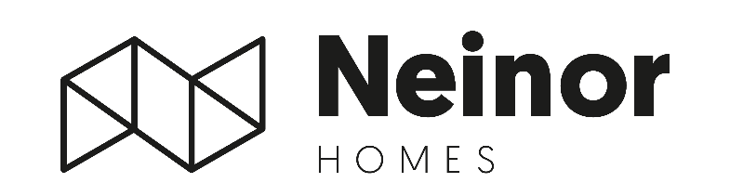
Neinor Homes successfully completes acquisition of AEDAS, reaching c.97% ownership and consolidates Spanish National Champion
Madrid, 5 March, 2026 – Neinor Homes (“Neinor”), Spain’s leading listed residential developer, announces the successful completion of the acquisition of AEDAS Homes (“AEDAS”), having increased its ownership to 96.83% through the mandatory tender offer.
In December 2025, Neinor acquired a 79.20% controlling stake in AEDAS through the voluntary tender offer, securing the support of its main shareholder, Castlelake. In February 2026, Neinor formally assumed control of AEDAS’s Board of Directors.
The mandatory tender offer has now been completed with an acceptance of 17.63%, increasing Neinor’s total ownership to 96.83%. This outcome reflects the strong support of AEDAS shareholders, initially Castlelake and subsequently a substantial majority of minority investors.
In total, Neinor has invested €923mn to acquire its 96.83% stake in AEDAS, at an average price of €21.82 per share, representing a discount of approximately 30% to the appraised value at the time of the transaction announcement.
Borja García-Egotxeaga, CEO of Neinor Homes, commented: “With this transaction completed, we have created Spain’s national residential champion. We delivered exactly what we set out to do — on time and with full control. The focus now is clear: disciplined execution and value creation.”
Jordi Argemí, Deputy CEO and CFO of Neinor Homes, added: “We are very pleased to have taken full control of AEDAS. This level of acceptance reflects the strength of the transaction and the support from a vast majority of shareholders. Our priority now is to execute the business plan and unlock the company’s full value.”

* For the full regulatory announcement please refer to Neinor’s webpage (https://www.neinorhomes.com/en/corporate/investors/market-notifications/other-relevant-information/)
-ENDS-

For more information:
NEINOR HOMES
Investor Relations Department
investor.relations@neinorhomes.com

H/ADVISORS MAITLAND
NeinorHomes@h-advisors.global
David Sturken +44 7990 595 913
Billy Moran +44 7554 912 008

