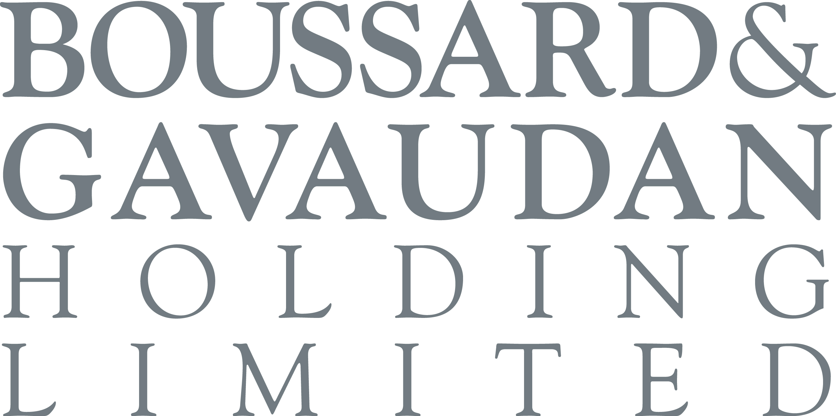

Boussard & Gavaudan Holding Limited (the “Company”)
a closed-ended investment company incorporated with limited liability under the laws of Guernsey with registration number 45582

Legal Entity Identifier: 5493002XNM3W9D6DF327

Extension of deadline for elections and the provision of documentation under
the Rollover Option to 29 August 2024
On 25 June 2024, the Company published a shareholder circular concerning the Rollover Option being made available to Eligible Shareholders (the "Circular"). The Board recognises that a number of Shareholders have expressed their willingness to participate in the Rollover Option but have been unable to meet the deadline of Close of Business on 22 August 2024 for the making of elections and the provision of certain documentation, as set out in the Circular.
As a result, the Board has decided to extend the deadline for the receipt of Election Forms, TTE Instructions and/or the delivery of Shares via Euroclear Nederland (as applicable), Application Forms and AML Documentation (the "Election Date" and "Documentation Date", as defined in the Circular) to Close of Business on 29 August 2024, in order to ensure that all Eligible Shareholders wishing to participate in the Rollover Option have the opportunity to do so.
For the avoidance of doubt, any duly submitted Election Form in respect of which a TTE Instruction or delivery of Shares via Euroclear Nederland was pending (or vice versa) as at the original Election Date will continue to be valid for the purposes of the extended deadline.
Shareholders should refer to the Circular for full details of the Rollover Option, including the procedure for the making of elections and the submission of the relevant documentation.

Unless otherwise defined, capitalised terms used in this announcement shall have the same meaning as set out in the Circular.

For further information please contact:
Boussard & Gavaudan Investment Management, LLP
Emmanuel Gavaudan
+44 20 3751 5389
JTC Fund Solutions (Guernsey) Limited
Secretary
+44 (0) 1481 702400

22 August 2024

Website: www.bgholdingltd.com

The Company is established as a closed-ended investment company domiciled in Guernsey. The Company has been authorised by the Guernsey Financial Services Commission as an authorised closed-ended investment scheme. The Company is registered with the Dutch Authority for the Financial Markets as a collective investment scheme pursuant to article 2:73 in conjunction with 2:66 of the Dutch Financial Supervision Act (Wet op het financieel toezicht). The shares of the Company (the "Shares") are listed on Euronext Amsterdam. The Shares are also listed on the Official List of the UK Listing Authority and admitted to trading on the London Stock Exchange plc's main market for listed securities.

This is not an offer to sell or a solicitation of any offer to buy any securities in the United States or in any other jurisdiction. This announcement is not intended to and does not constitute, or form part of, any offer or invitation to purchase any securities or the solicitation of any vote or approval in any jurisdiction, nor shall there be any sale, issuance or transfer of the securities referred to in this announcement in any jurisdiction in contravention of applicable law.

Neither the Company nor BG Master Fund ICAV have been, and neither will be, registered under the US Investment Company Act of 1940, as amended (the "Investment Company Act"). In addition the securities referenced in this announcement have not been and will not be registered under the US Securities Act of 1933, as amended (the "Securities Act"). Consequently any such securities may not be offered, sold or otherwise transferred within the United States or to, or for the account or benefit of, US persons except in accordance with the Securities Act or an exemption therefrom and under circumstances which will not require the issuer of such securities to register under the Investment Company Act. No public offering of any securities will be made in the United States.

You should always bear in mind that:

- all investment is subject to risk;
- results in the past are no guarantee of future results;
- the investment performance of BGHL may go down as well as up. You may not get back all of your original investment; and
- if you are in any doubt about the contents of this communication or if you consider making an investment decision, you are advised to seek expert financial advice.

This communication is for information purposes only and the information contained in this communication should not be relied upon as a substitute for financial or other professional advice.

END OF ANNOUNCEMENT

