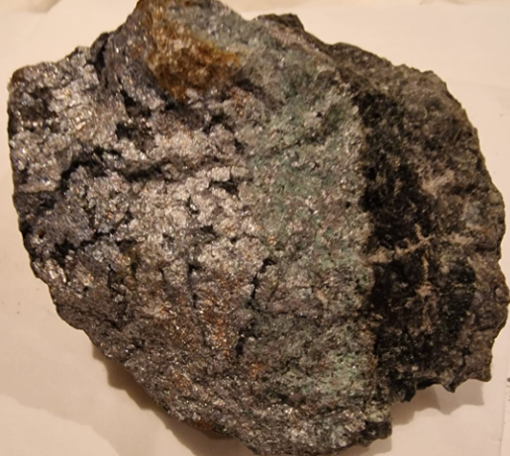 | 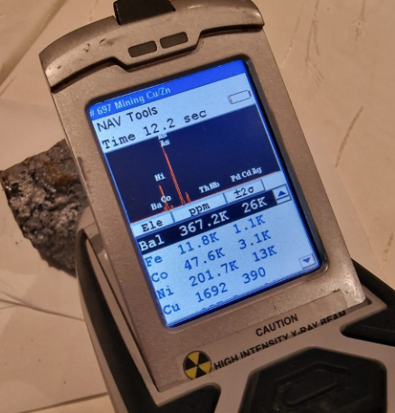
Figure 7 (Left): Piece of a Co-Ni-vein discovered 525 m from the branching point in the cross-cut from G7 towards G4. Image width: 10 cm.
Figure 8 (Right): Hand-held XRF reading on this sample: 4.76 % Co, 20.17 % Ni.
The reader is cautioned that such measurements cover only the surface of a rock with an area on the order of 1 cm² and are neither representative, nor do they indicate reliable mineralization grades. In the context of the work performed here, this XRF-reading has the sole purpose of demonstrating the presence of cobalt and nickel in the encountered mineralization.

