



Business name **AS PRFoods**

Commercial registry code **11560713**

Address **Pärnu mnt 141, Tallinn, Estonia**

Phone **+372 452 1470**

Website [**prfoods.ee**](http://www.prfoods.ee/about)

Main activities **Production and sale of fish products  
 Fish farming**

Reporting period **1 July 2021 – 30 June 2022**

TABLE OF CONTENTS

Corporate Profile 4

Management Report 7

Overview of Economic Activities 7

Management and Supervisory Boards 11

Consolidated Statement of Financial Position 13

Consolidated Statement of Profit or Loss And Comprehensive Income 14

Consolidated Statement of Changes in Equity 15

Notes to the Interim Report 16

NOTE 1. Summary of Material Accounting Policies 16

NOTE 2. Cash and Cash Equivalents 16

NOTE 3. Biological Assets 17

NOTE 4. Equity 17

NOTE 5. Related Party Transactions 18

NOTE 6. Associate Companies 18

NOTE 7. Contingent Liabilities 19

NOTE 8. Disposal of Subsidiary 19

Management Board’s Confirmation to the Interim Report 21

# Corporate Profile

AS PRFoods (hereinafter the "Group") is a company engaged in fish farming, processing and sales, and its shares are listed on the main list of NASDAQ Tallinn Stock Exchange since 5 May 2010 and its bonds are listed since 6 April 2020.

09.02.2022, Saaremere Kala AS, a subsidiary of AS PRFoods, signed an agreement to transfer 100% of the shares of Heimon Kala Oy to Nordic Fish Oy. The transfer of Heimon Kala Oy shares has been completed on 07.03.2022, ie the shares of Heimon Kala Oy have been transferred to Nordic Fish Oy. AS PRFoods will continue to develop fish farming in Sweden and Estonia, with the aim of becoming the largest fish farmer in the region.

Since the acquisition of John Ross Jr. and Coln Valley Smokery in the summer of 2017, the Group has sales experience to 37 countries in Europe, North and South America, and Asia.

Main activities of the Group are fish farming and manufacturing of fish products. The main products are salmon and rainbow trout products. Approximately 2/3 of the raw fish used in the Group’s rainbow trout production comes from the Group’s fish farms in Swedish lakes and from coastal waters of Saaremaa in Estonia, assuring the highest quality and reliable deliveries. The rest of raw fish is purchased mainly from Norway and Denmark. Fish products are manufactured in two modern factories in Saaremaa (Estonia), and in Aberdeen (Great Britain).

Products of the Group are sold as leading brands in their respective operating market and the primary focus is on higher value-added premium products, increasing thereby the profitability of the company.

AS PRFoods plans to introduce a new brand this year, which emphasizes the origin of our Saaremaa. We process mostly rainbow trout and salmon in our factories, in smaller quantities also whitefish, perch, pikeperch, vendace, Atlantic and Baltic herrings. We always keep the fish in a place of honour – both when farming and processing it – that is why we raise most of our red fish ourselves and smoke it with alder chips in the traditional way. As our product range is quite wide, a favourite product can be found for the whole family – lightly salted trout slices that have won the title of the Best Fish Product in Estonia, children's favourite trout cutlets or trout roe for a more festive occasion.

The Group is actively involved in developing new products for expanding also to new export markets.

The Geography of Production and Sales

|  |  |
| --- | --- |
| **Fish farming** | Sweden Estonia |
| **Purchase of raw fish** | Sweden Norway Denmark |
| **Production** | Estonia Great Britain |
| **Sales** | Great Britain Estonia |



Group Structure as at 30.06.2022

In addition, AS PRFoods holds a 20%-share of AS Toidu- ja Fermentatsioonitehnoloogia Arenduskeskus (Competence Center of Food and Fermentation Technology).

Agreement on the transfer of 100% of the shares of Heimon Kala Oy entered into between AS PRFoods subsidiary Saaremere Kala AS and Nordic Fish Oy on 09.02.2022 have been fulfilled by Saaremere Kala AS and the sale of shares transaction has been therefore completed.

The most significant trademarks of the Group are “PRFoods” and “John Ross Aberdeen“.

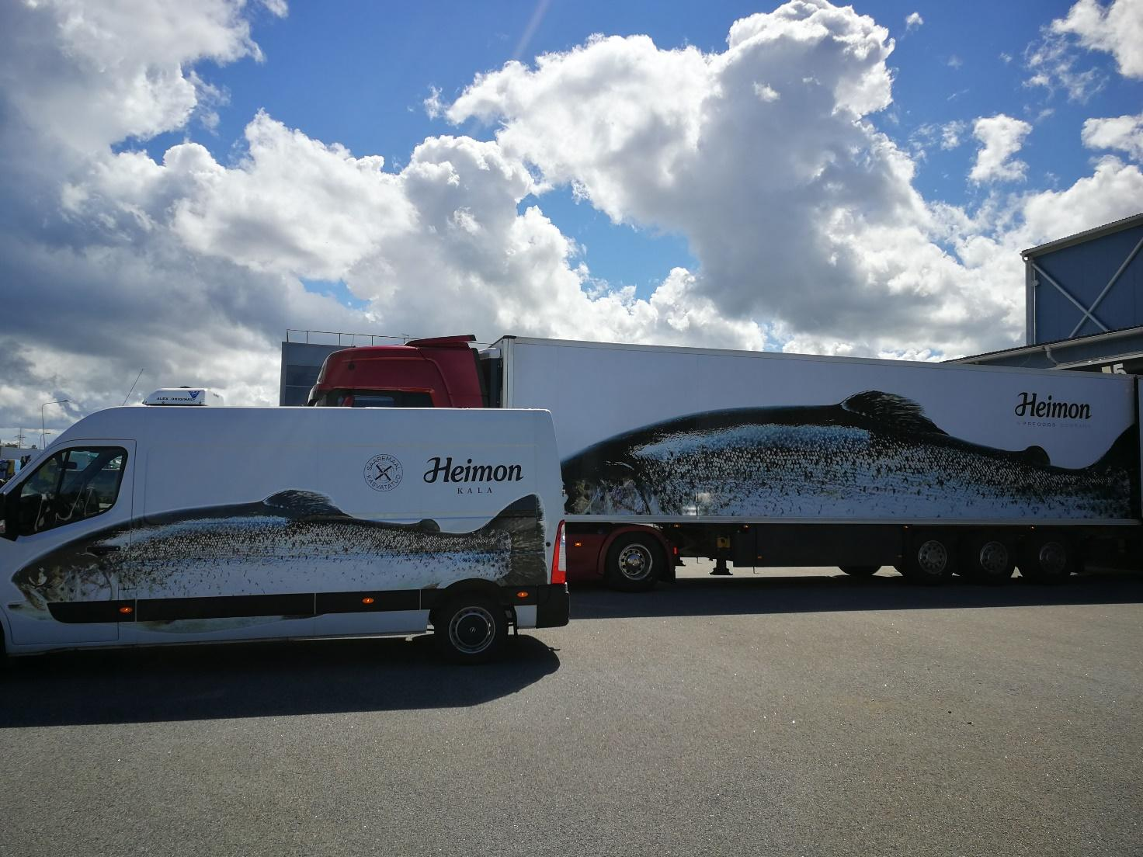

Management report

# Management Report

## Overview of Economic Activities

Unaudited Financial Results of AS PRFoods, the 4th Quarter of the Financial Year 2021/2022 Compared to the 4th Quarter of Financial Year 2020/2021

Balance Sheet

As at 30.06.2022 consolidated total assets of PRFoods stood at 38.2 million euros. The year before i.e. as at 30.06.2021 the balance sheet totalled 55.6 million euros.

The Group`s current assets stood at 8.6 million euros as at 30.06.2022 (30.06.2021: 16.5 million euros). Non-current assets totalled 29.7 million euros (30.06.2021: 39.1 million euros).

Current liabilities totalled 12.3 million euros as at 30.06.2022 (30.06.2021: 19.7 million euros). Non-current liabilities totalled 17.0 million euros (30.06.2021: 20.2 million euros). Equity of PRFoods was 8.9 million euros (30.06.2021: 15.8 million euros).

Revenue

The main products of the Group are salmon and rainbow trout goods. The Group is mainly known as a seller of smoked fish products in the UK and a seller of raw fish in Estonia as well as the biggest supplier of caviar to Estonian stores.

The Group’s revenue during the twelve months of the financial year 2021/2022 was 47.18 million euros, down by 11.51 million euros compared to the same period of the previous financial year, when the sales amounted to 58.69 million euros.

Fish Farming

The competitive advantage of the Group is its vertical integration – fish farming, production and sales. About two thirds of the raw trout used in the Group’s production is harvested from the Group’s own fish farms in the lakes in Sweden, in the archipelago in Turku area in Finland and in coastal area of Saaremaa, Estonia, ensuring that customers receive fast and high-quality deliveries.

Vertical integration enables the Group to reduce costs in certain phases of fish farming and to also enhance control foremost over fish processing and marketing. In the fish business, as fish are livestock, the quality assurance in the technological process has keenly to be maintained throughout the entire product lifecycle. In addition to improved cost control, the vertical integration enables to reduce risks in fish farming, for instance due to poor quality of feed or base materials, and to secure the volume required for processing as well as price stability of raw material.

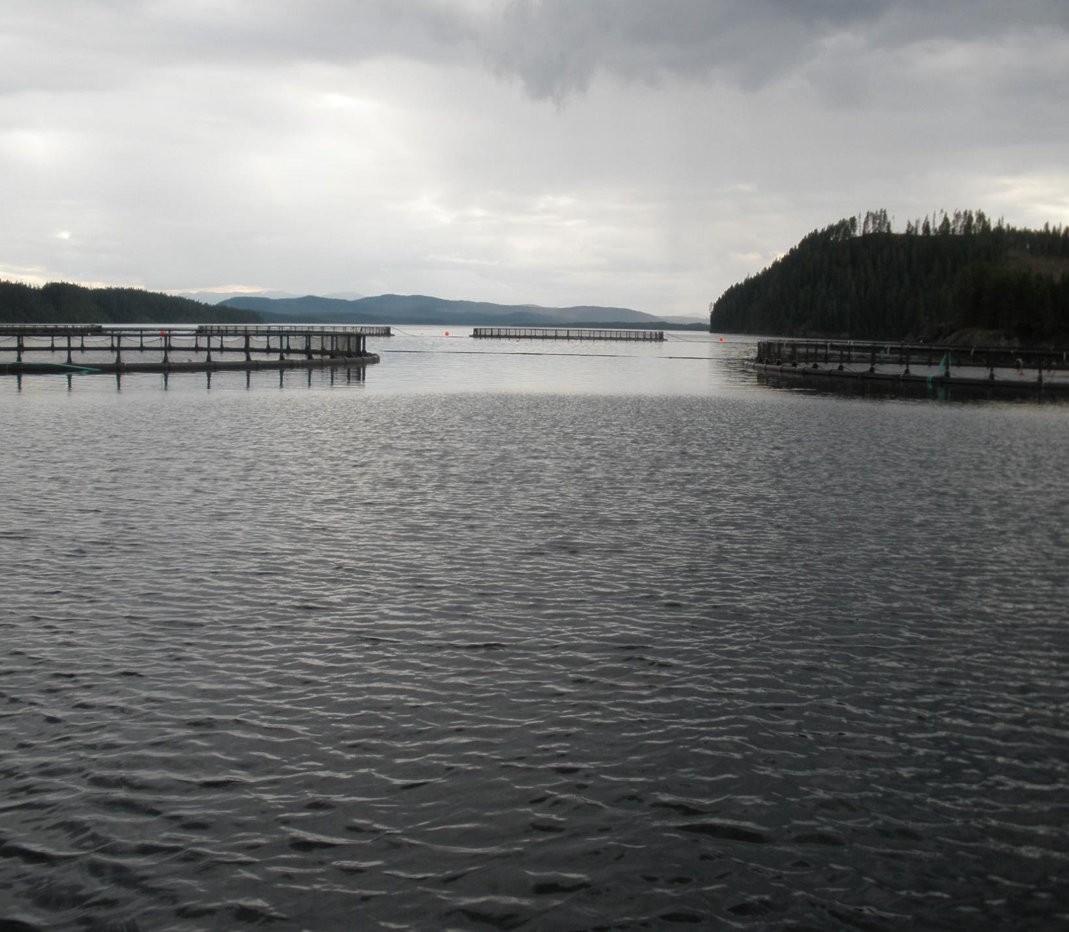

Price of Fish

The fish industry is extremely dependent on availability and the price of raw fish. Large producers make their production plans for three years in advance as it is difficult and expensive in shorter perspective to adapt a fish farm’s production cycle to market needs. Therefore, the world market fish supply is relatively rigid in the short-term, while demand is somewhat shifting depending on the season. This imbalance in fish supply and demand results in constantly fluctuating price of raw fish. Moreover, the far-reaching change in supply chains related to the spread of the virus has increased the amplitude and unpredictability of prices. The Group counters the impact of external environment and volatility of fish price through the changes of the Group’s production and sales strategy.

MARKET PRICE OF fISH

|  |  |  |  |  |  |  |  |
| --- | --- | --- | --- | --- | --- | --- | --- |
| EUR/kg | 30.06.2022 | 30.06.2021 | 30.06.22 vs 30.06.21 | 30.06.2020 | 30.06.22 vs 30.06.20 | 30.06.2019 | 30.06.22 vs 30.06.19 |
| Salmon | 9,44 | 5,63 | 67,7% | 5,31 | 77,8% | 5,74 | 64,5% |
| Rainbow trout | 9,71 | 5,52 | 75,9% | 4,36 | 122,7% | 5,76 | 68,6% |

As at the end of the reporting period the price of salmon has increased by 67.7% and the price of rainbow trout has increased by 75.9% compared to the prices a year ago. Over the two-year period, the price of salmon has increased by 77.8% and the trout by 122.7%. The price of salmon has increased by 64.5% and of rainbow trout by 68.6% compared to the prices three years ago.

The graphs below illustrate weekly average prices of salmon and rainbow trout since the financial year 2016/2017.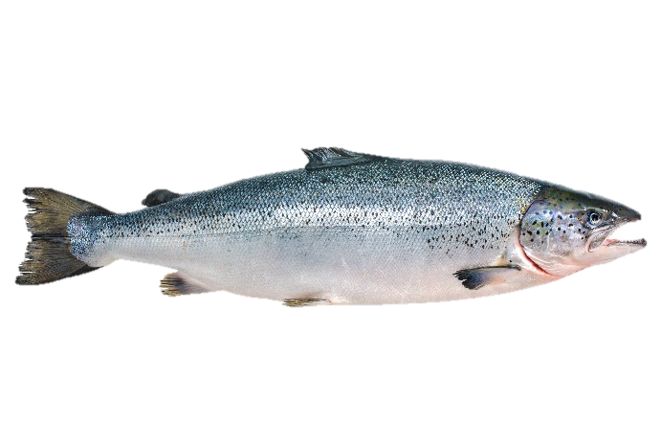

Export Price of Norwegian Salmon

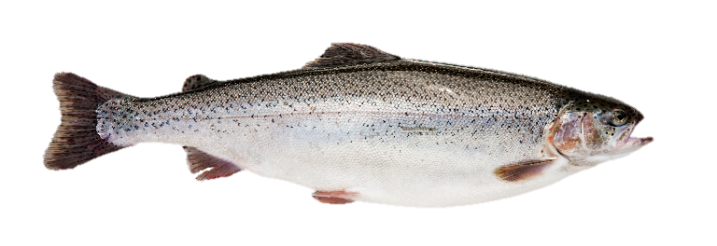

Export Price of Norwegian Rainbow Trout

AVERAGE mARKET PRICE OF fiSH

|  |  |  |  |  |  |  |  |  |  |
| --- | --- | --- | --- | --- | --- | --- | --- | --- | --- |
| EUR/kg | 2021/2022 | 2020/2021 | 2021/2022 vs 2020/2021 | | 2019/2020 | | 2021/2022 vs 2019/2020 | 2018/2019 | 2021/2022 vs 2018/2019 |
| Salmon | 6,95 | 4,79 | 45,1% | 5,57 | | 24,8% | | 6,03 | 15,3% |
| Rainbow trout | 6,75 | 4,72 | 43,0% | 5,14 | | 31,3% | | 5.92 | 14,0% |

As at the end of the reporting period the average market prices of salmon and rainbow trout have increased by 45.1% and 43.0%, respectively, compared to the prices of the same period in the previous financial year.

Biological Assets



Biological assets are fish stock accounted for in PRFoods’ fish farms in live weight, including rainbow trout (*Oncorhynchus mykiss*) and European whitefish (*Coregonus lavaretus*).

The Group uses the Norwegian export statistics (source: akvafakta.no) to assess the value of rainbow trout’s stock. For assessing the value of whitefish stock, the monthly market price survey of the Finnish Fish Farmers’ Association is used. When the price of raw fish increases or decreases, so does the value of fish harvested in fish farms of PRFoods, having either a positive or a negative impact on the Group’s financial results.

CHANGE in BIOLOGICAL ASSETS, TONNES

|  |  |  |  |  |
| --- | --- | --- | --- | --- |
|  | 2021/2022 | 2020/2021 | Change, tons 2021/2022 vs 2020/2021 | Change, % 2021/2022 vs 2020/2021 |
| Biomass at the beginning of the period | *846* | *945* | -99 | -10,5% |
| Biomass at the end of the period | 441 | 846 | -405 | -47,9% |
| Harvested fish (in live weight) | 1 427 | 1 973 | -546 | -27,7% |

Biological assets totalled 441 tonnes as at 30.06.2022, a decrease by 405 tonnes, i.e. 47,9% compared to the same period last year.

BIOMASS VOLUME AND AVERAGE PRICE, EUR/KG

|  |  |  |  |  |
| --- | --- | --- | --- | --- |
|  | 2021/2022 | 2020/2021 | Change, ml EUR 2021/2022 vs 2020/2021 | Change, % 2021/2022 vs 2020/2021 |
| Biological assets at the end of period, mln EUR | 3,00 | 4,80 | -1,79 | -37,4% |
| Biomass volume at the end of period, tonnes | 441 | 846 | -405 | -47,9% |
| Average price, EUR/kg | 6,81 | 5,67 | 1,14 | 20,1% |
| Fair value adjustment of biological assets, mln EUR | -0,17 | 0,31 | -0,48 | -153,2% |

The fair value of biological assets was 3,0 million euros compared to 4,8 million euros a year ago. Average price of biomass was 6.81 euros per kg compared to 5,67 euros per kg during the comparable period a year ago.

|  |  |
| --- | --- |
|  |  |

## Management and Supervisory Boards

The Management Board of AS PRFoods is comprised of one member – Indrek Kasela – who as per the supervisory board's decision serves as the sole member of the management board since 2 February 2015. The management board is independent in its day-to-day management of the business, protects the best interests of all shareholders and thereby ensures the company’s sustainable development in accordance with the set objectives and strategy. It is also responsible for the internal control and risk management processes in the company.

The Supervisory Board of AS PRFoods appoints management board members for a three-year term. The articles of association prescribe the management board to consist of one to four members. Indrek Kasela (born 1971), holds an LL.M (Master of Laws) degree from New York University (1996) and a BA degree in law from the University of Tartu (1994).

In addition to the management position in PRFoods, he is a member of management boards in almost all the Group entities and in several non-Group entities (Lindermann, Birnbaum & Kasela OÜ, ManageTrade OÜ, Noblessneri Jahtklubi OÜ, etc). He chairs or is a member of supervisory boards among others of the following companies: AS Toode, ELKE Grupi AS, ELKO Grupa AS, EPhaG AS, Salva Kindlustuse AS, Ridge Capital AS, AS Ekspress Grupp, Elering AS, SA Avatud Eesti Fond, Tulundusühistu Tuleva, Eesti Avamere Vesiviljelejate Ühistu. He serves also as a board member in several companies and NPOs domiciled abroad.

The Supervisory Board of AS PRFoods is comprised of six members. The board is chaired by Lauri Kustaa Äimä, members of the supervisory board are Aavo Kokk, Harvey Sawikin, Vesa Jaakko Karo, Arko Kadajane and Kuldar Leis.

The highest governing body of a public limited company is a general meeting of shareholders. General meetings of shareholders are either ordinary or extraordinary.

Pursuant to law, a supervisory board of a public limited company is a supervisory body responsible for planning the activities of a company, organising its management and supervising the activities of its management board. According to the Articles of Association of AS PRFoods, the supervisory board has three to seven members elected by the general meeting of shareholders for the term of three years.

Information on the education and careers of the members of the supervisory board as well as their management positions in other companies is available on PRFoods’ website [www.prfoods.ee](http://www.prfoods.ee/about/governance/supervisory-board).

PRFoods’ shares held by the members of the management and supervisory boards and the persons/companies related to them as at 30.06.2022:

|  |  |  |
| --- | --- | --- |
| Shareholder | Number of shares | Ownership interest |
| Member of the management board – Indrek Kasela | 1,613,617 | 4.17% |
| Member of the supervisory board – Kuldar Leis | 1,223,050 | 3.16% |
| Member of the supervisory board – Lauri Kustaa Äimä | 125,000 | 0.32% |
| Member of the supervisory board – Vesa Jaakko Karo | 90,000 | 0.23% |
| Member of the supervisory board – Arko Kadajane | 8,928 | 0.02% |
| Member of the supervisory board – Harvey Sawikin | 0 | - |
| Member of the supervisory board – Aavo Kokk | 0 | - |
| Total number of shares owned by the members of the supervisory and management boards | 3,060,595 | 7.91% |

condensed Interim accounting report

Condensed Interim Accounting Report

## Consolidated Statement of Financial Position

|  |  |  |  |
| --- | --- | --- | --- |
| EUR '000 | Note | 30.06.2022 | 30.06.2021 |
| **ASSETS** |  | . | . |
| Cash and cash equivalents | 2 | 118 | 2 500 |
| Receivables and prepayments |  | 3 253 | 3 512 |
| Inventories |  | 2 196 | 5 691 |
| Biological assets | 3 | 3 003 | 4 795 |
| **Total current assets** |  | **8 570** | **16 498** |
|  |  | . | . |
| Deferred tax assets |  | 0 | 38 |
| Long-term financial investments |  | 323 | 302 |
| Tangible assets |  | 9 551 | 15 300 |
| Intangible assets |  | 19 788 | 23 460 |
| **Total non-current assets** |  | **29 662** | **39 100** |
| **TOTAL ASSETS** |  | **38 232** | **55 598** |
|  |  | . | . |
| **EQUITY AND LIABILITIES** |  | . | . |
| Interest-bearing liabilities |  | 8 398 | 7 325 |
| Payables and prepayments |  | 3 919 | 12 124 |
| Government grants |  | 0 | 207 |
| **Total current liabilities** |  | **12 317** | **19 656** |
|  |  | . | . |
| Interest-bearing liabilities |  | 16 424 | 17 561 |
| Payables and prepayments |  | 328 | 0 |
| Deferred tax liabilities |  | 146 | 1 861 |
| Government grants |  | 140 | 746 |
| **Total non-current liabilities** |  | **17 038** | **20 168** |
| **TOTAL LIABILITIES** |  | **29 355** | **39 824** |
|  |  | . | . |
| Share capital |  | 7 737 | 7 737 |
| Share premium |  | 14 007 | 14 007 |
| Treasury shares |  | -390 | -390 |
| Statutory capital reserve |  | 51 | 51 |
| Currency translation differences |  | 1 155 | 559 |
| Retained profit (loss) |  | -13 882 | -6 723 |
| **Equity attributable to parent** |  | 8 678 | 15 241 |
| Non-controlling interest |  | 199 | 533 |
| **TOTAL EQUITY** | 4 | **8 877** | **15 774** |
| **TOTAL EQUITY AND LIABILITIES** |  | **38 232** | **55 598** |

## Consolidated Statement of Profit or Loss And Comprehensive Income

|  |  |  |  |
| --- | --- | --- | --- |
| EUR '000 | Note | 12k 2021/2022 | 12k 2020/2021 |
| Revenue |  | 47 176 | 58 692 |
| Cost of goods sold |  | -44 090 | -53 727 |
| **Gross profit** |  | **3 086** | **4 965** |
|  |  | **.** | **.** |
| Operating expenses |  | -7 207 | -9 468 |
| Selling and distribution expenses |  | -4 843 | -6 389 |
| Administrative expenses |  | -2 364 | -3 079 |
| Other income / expense |  | -177 | 309 |
| Fair value adjustment on biological assets | 3 | -420 | 311 |
| **Operating profit (loss)** |  | **-4 718** | **-3 883** |
| Financial income / expenses |  | -6 455 | -1 085 |
| Profit (Loss) before tax |  | -11 173 | -4 968 |
| Income tax |  | 82 | -193 |
| **Net profit (Loss) from continuing operations** |  | **-11 091** | **-5 161** |
|  |  | . | . |
| **Net profit (loss) for the period** |  | **-11 091** | **-5 161** |
| Net profit (loss) attributable to: |  | . | . |
| Owners of the Parent Company |  | -11 074 | -5 069 |
| Non-controlling interests |  | -17 | -92 |
| **Total net profit (loss) for the period** |  | **-11 091** | **-5 161** |
|  |  | . | . |
| Other comprehensive income (loss) that may subsequently be classified to profit or loss: |  | . | . |
| Foreign currency translation differences |  | 596 | 925 |
| **Total comprehensive income (expense)** |  | **-10 495** | **-4 236** |
|  |  | . | . |
| Total comprehensive income (expense) attributable to: |  | . | . |
| Owners of the Parent Company |  | -10 478 | -4 144 |
| Non-controlling interests |  | -17 | -92 |
| **Total comprehensive income (expense) for the period** |  | **-10 495** | **-4 236** |
|  |  |  |  |
| Profit (Loss) per share (EUR) | 4 | -0.29 | -0.09 |
|  |  |  |  |
| Diluted profit (loss) per share (EUR) | 4 | -0.29 | -0.09 |

## Consolidated Statement of Changes in Equity

|  |  |  |  |  |  |  |  |  |  |
| --- | --- | --- | --- | --- | --- | --- | --- | --- | --- |
| EUR '000 | Share capital | Share premium | Treasury shares | Statutory capital reserve | Unrea-lised currency differ. | Retained earnings (-loss) | Total | Non-contr. interests | Total equity |
| **Balance at 30.06.2020** | **7 737** | **14 007** | **-390** | **51** | **-366** | **-1 654** | **19 385** | **434** | **19 819** |
| Net profit (loss) for the year | 0 | 0 | 0 | 0 | 0 | -5 069 | **-5 069** | -92 | **-5 161** |
| Other comprehensive income (expense) | 0 | 0 | 0 | 0 | 925 | 0 | **925** | 0 | **925** |
| Total comprehensive income (expense) for the period | 0 | 0 | 0 | 0 | 925 | -5 069 | **-4 144** | -92 | **-4 236** |
| Increase of subsidiary's share capital | 0 | 0 | 0 | 0 | 0 | 0 | **191** | 0 | **191** |
| **Balance at 30.06.2021** | **7 737** | **14 007** | **-390** | **51** | **559** | **-6 723** | **15 241** | **533** | **15 774** |
| Net profit (loss) for the year | 0 | 0 | 0 | 0 | 0 | -11 074 | **-11 074** | -17 | **-11 091** |
| Other comprehensive income (expense) | 0 | 0 | 0 | 0 | 596 | 0. | **596** | 0 | **596** |
| Total comprehensive income (expense) for the period | 0 | 0 | 0 | 0 | 596 | -11 074 | **-10 478** | -17 | **-10 495** |
| Correction of subsidiary’s share capital | 0 | 0 | 0 | 0 | 0 | 3 915 | **3 915** | -317 | **3 598** |
| **Balance at 30.06.2022** | **7 737** | **14 007** | **-390** | **51** | **1 155** | **-13 882** | **8 678** | **199** | **8 877** |

Additional information in Note 4.

## Notes to the Interim Report

### Summary of Material Accounting Policies

AS PRFoods is a company incorporated in Estonia. The interim financial statements compiled as per 30.06.2022 incorporate results of AS PRFoods (hereinafter Parent Company) and companies directly and indirectly held by it: Saaremere Kala AS. Redstorm OÜ and Saare Kala Tootmine OÜ in Estonia. Heimon Kala Oy in Finland (01.07.21-28.02.22). Överumans Fisk AB in Sweden. and JRJ & PRF Ltd. John Ross Jr (Aberdeen) Ltd. Coln Valley Smokery Ltd in the United Kingdom (hereinafter also referred to as the Group). The Group has a stake in associate companies: Competence Center of Food and Fermentation Technologies AS and Avamere Kalakasvatus OÜ. JRJ & PRF Ltd. John Ross Jr (Aberdeen) Ltd. Coln Valley Smokery Ltd are consolidated from 01.07.2017 and Redstorm OÜ from 01.07.2018. AS PRFoods’ shares are listed on Nasdaq Tallinn Stock Exchange since 5 May 2010 and the bonds since 6 April 2020.

The Group’s consolidated audited annual report for the financial year that ended on 30 June 2021 is available on PRFoods’ website [www.prfoods.ee](http://www.prfoods.ee/investor-relations/reports/annual-reports).

Confirmation of Compliance

The current unaudited consolidated interim report complies with the requirements of international accounting standards IAS 34 “Interim Financial Reporting” on condensed interim financial statements.

While preparing the interim report at hand the same accounting principles as in the audited annual report for the financial year ended on 30.06.2021 were applied. The report does not hold all the information that shall be presented in a full annual report. It should thus be read together with the Group’s audited consolidated annual report for the financial year that ended on 30.06.2021 compiled in accordance with the international finance reporting standards (IFRS) as adopted by the European Union.

In the opinion of the management this interim report for the 12 months of the financial year 2021/2022 of AS PRFoods presents correctly and fairly the financial results of the Group as a going concern. The current interim report is neither audited nor reviewed by auditors in any other way and contains only the consolidated reports of the Group.

Basis of Preparation

The functional currency is euro. The consolidated interim report is presented in thousands of euros and all numerical indicators have been rounded to the nearest thousand. if not indicated otherwise. In the report. thousand euros is indicated as EUR ‘000.

### Cash and Cash Equivalents

|  |  |  |
| --- | --- | --- |
| EUR '000 | 30.06.2022 | 30.06.2021 |
| Cash on hand | 1 | 14 |
| Bank accounts | 117 | 2 486 |
| Total cash and cash equivalents | 118 | 2 500 |

### Biological Assets

|  |  |  |
| --- | --- | --- |
| EUR ’000 | 30.06.2022 | 30.06.2021 |
| Fry | 401 | 737 |
| Juveniles | 1 448 | 1 673 |
| Fish suitable for harvesting | 1 154 | 2 385 |
| **Total biological assets** | **3 003** | **4 795** |

The Group farms in its fish farms located in Estonia and Sweden rainbow trout (*Oncorhynchus mykiss*).

CHANGE IN BIOLOGICAL ASSETS

|  |  |  |
| --- | --- | --- |
| EUR ’000 | 9m 2021/2022 | 9m 2020/2021 |
| **Biological assets at beginning of the period** | **4 795** | **4 249** |
| Purchased | 496 | 1 195 |
| Additions | 3 842 | 5 079 |
| Fair value adjustments | -166 | 311 |
| Harvested | -4 900 | -6 120 |
| Written off | -199 | 0 |
| Fry and live fish sold | -728 | -4 |
| Exchange rate differences | -137 | 85 |
| **Biological assets at end of the period** | **3 003** | **4 795** |

In “Additions” the Group has capitalised expenditures incurred on development of immature biological assets therefore in the income statement only the gain/loss from “Fair value adjustments” is presented as a separate line. Group measures biological assets in fair value and at acquisition cost. Detailed information on measuring principles is available in the 2020/2021 annual report.

### Equity

Share Capital

As at 30.06.2022 the Company’s registered share capital is 7.736.572 euros.

As per the resolution of the shareholders’ meeting from 26.05.2016 the shares of AS PRFoods were registered on 30.06.2016 in the Commercial Register without nominal value. The registered share capital of the Company is 7.736.572 euros divided into 38.682.860 ordinary shares without nominal value with accountable value of 0.20 euro per share.

The Articles of Association stipulate 7.000.000 euros as minimal share capital and 28.000.000 euros as maximum share capital. The Articles of Association are available on AS PRFoods website at www.prfoods.ee.

Share Premium

The Company`s share premium comprises mainly of the amount received above the nominal value upon an issue of shares less costs associated with the issue. According to the Commercial Code. a premium may be used to cover a loss of a company if such loss cannot be covered from retained profit of previous periods or from the capital reserve prescribed in the Articles of Association or from other reserves prescribed by the Articles of Association. The premium may also be used to increase share capital via a bonus issue. The share premium may not be distributed to shareholders.

In August 2020 the shareholders of OÜ Redstorm – Saaremere Kala AS and OÜ Fodiator – decided to increase the share capital of the company by 20 euros to 4.020 euros. as a result of which the nominal value of Saaremere Kala AS share increased to 2.050 euros and the nominal value of OÜ Fodiator share to 1.970 euros.

Saaremere Kala AS paid 387.597 euros in kind for the increase of the nominal value of the share of which 387.587 euros was share premium. Saaremere Kala AS paid for the increase in the nominal value by offsetting the claim acquired by Saaremere Kala AS from OÜ Serenest against OÜ Redstorm in the amount of 387.597 euros.

As a result of the above transaction the Group's consolidated share premium increased by 189 923 euros.

Capital Reserve and Retained Earnings

The Estonian Commercial Code requires companies to create a capital reserve. Each year at least 1/20 of profit for the year has to be transferred to the capital reserve until the reserve amounts to 1/10 of share capital. The capital reserve may be used for covering losses and increasing the share capital but not for making distributions to shareholders.

### Related Party Transactions

The Company considers parties to be related when one party has control over the other party or has significant influence over the business decision of the other party.

Related parties include:

* shareholders with significant influence (the largest shareholder of PRFoods is the international investment fund Amber Trust II S.C.A.).
* members of the Supervisory Board and members of all management boards of group entities.
* close family members of the persons mentioned above and the companies related to them.

As at the balance sheet date. there were no receivables from the related parties. liabilities are found in the table below:

|  |  |  |  |  |
| --- | --- | --- | --- | --- |
| Party | Creditor | Payables and prepayments | Payables as at 30.06.2022 | Payables as at 30.06.2021 |
|  |  |  | EUR '000 | EUR '000 |
| Amber Trust II S.C.A. | Shareholder AS PRFoods | Bond and interest of bond | 3 070 | 2 680 |
| Lindermann, Birnbaum & Kasela OÜ | Liabilities | Bond and interest of bond | 100 | 98 |
| Christopher Leigh | Contingent consideration | Payable for non-controlling interests | 0 | 1 732 |
| Victoria Leigh-Pearson | Contingent consideration | Payable for non-controlling interests | 0 | 975 |
| **Total** |  |  | **3 170** | **5 485** |

### Associate Companies

Avamere Kalakasvatus OÜ (50% holding)

On 18.01.2019 Avamere Kalakasvatus OÜ was registered in the Estonian Commercial Registry. The company is an associate of AS PRFoods. and it submitted an application to the Technical Regulatory Authority for the building right of the establishment of an offshore fish farming complex in the Estonian waters off the coast of Paldiski. The building right is to allow establishing a rainbow trout farming complex in the offshore cages.

AS Toidu- ja Fermentatsioonitehnoloogia Arenduskeskus (20% holding)

Since 2010 the Group holds 20% in AS Toidu- ja Fermentatsioonitehnoloogia Arenduskeskus (Competence Center of Food and Fermentation Technology).

### Contingent Liabilities

**Contingent liabilities in connection with setting a mortgage for the benefit of the Customs Board of Finland**

A mortgage was set for the benefit of the Finnish Customs Board in the amount of 84 thousand euros. The purpose of the transaction was a more streamlined organisation of the day-to-day operations by reducing persistent prepayments to the Customs Board.

The management estimated that it is improbable that the Finnish Customs Board will liquate the pledged asset.

**Contingent liabilities relating to tax boards**

The tax authorities may at any time inspect the books and records of the Group within 5 years subsequent to the reported tax year in Estonia and Finland. within 6 years in United Kingdom and within 7 years in Sweden. and may as a result of their inspection impose additional tax assessments. interests and penalties. During the first three months of the financial year and in the previous financial years the tax authorities have not conducted tax audits. The management of the Group is not aware of any circumstances which may give rise to a potential material liability in this respect.

### Disposal of Subsidiary

As of 28.02.2022 Saaremere Kala AS, a subsidiary of AS PRFoods, transferred 100% of the shares of Heimon Kala Oy to Nordic Fish Oy. The assets and liabilities of the Heimon Kala Oy are derecognised from the consolidated statement of financial position as of 30.06.2022. Income and expenses of the Heimon Kala Oy are consolidated only up to the disposal date of 28.02.2022. Loss from the disposal of the subsidiary is recognised in the line “Financial Income/Expenses” in the Consolidated Statement of Profit or Loss.

*Purpose of the transaction and impact on AS PRFoods activities*

PRFoods has stated in the past that its aim is to exit from loss-making units and activities. In Finland, restructuring and an asset sale were carried out. "We are delighted that Heimon Kala Oy has returned to the ownership of Finnish family business and industry leader. In spite of the difficult effects of the corona period on Heimon Kala Oy's financial results, the Heimon Kala brand is one of the best known in Finland and we believe that the combination of the buyer's Kalaneuvos brand and the Heimon Kala brand will have a long-term positive impact on the Finnish market," said Indrek Kasela, management board member of AS PRFoods. “The Finnish unit was our only loss-making unit and the strategic decision to exit from this business had been planned earlier. After lengthy process, we believe we have found the best new owner for our Finnish business, and we wish them and our employees every success in a new corporate family. AS PRFoods is very pleased with the development of its other subsidiaries, especially with the growth of the Estonian retail market, and we are planning to introduce a new brand this year, which will emphasise our Saaremaa origin. Also, John Ross Jr has recovered very quickly from the effects of corona. Above all, credit must go to our fish farming division, under the leadership of Margus Rebane, which has been our real profit centre throughout our operations. I would count as our greatest achievement, in addition to the strong profitability of our fish farming business, the fact that, in partnership with Biomar, the world's leading fish feed manufacturer, we have developed Blue Impact, the most environmentally friendly fish feed in the Baltic Sea, and all the fish we farm today already carry the Blue Impact label as the most environmentally friendly farmed fish. Given that we have recently received approval to multiply our Swedish farming capacity, we are focusing our attention and investment on Sweden this year. We have also reached a stage in the expansion of our fish farming in Saaremaa where we hope to at least quadruple our current capacity by 2023 at the latest, and in the future, we hope to get at least 5,000 tonnes of additional capacity from Estonia as well. The restoration of fish farming in Estonia is a very significant achievement because, in addition to significant exports, it would finally give Estonian consumers year-round access to local fish in industrial volumes. As we did not see the possibility to increase the farming capacity in Finland, it was more rational to sell both production and fish farming in Finland, especially considering that in the conditions of sharply increased raw material prices, there was no prospect in the short or long term of an independent Finnish unit to achieve similar profitability levels in par with other units of PRFoods. PRFoods was once a pioneer in the consolidation of the Finnish fish market, and we are pleased that the Hukkanen family is taking over this baton from us and wish them once again success in this".

*Sales price and payment terms, difference between acquisition and transfer price*

The sales price of the shares in Heimon Kala Oy is EUR 1 plus an additional sales price of up to EUR 500,000. Whether the additional sales price will become due, and the exact amount of the additional sales price will depend on whether the fish farming permits applied for from the Finnish Regional State Administrative Agency (AVI) are approved and on the maximum approved usage of feed. An additional sales price of EUR 500,000 will be due if the respective permits are issued with the maximum approved usage of feed of 994,167 kg. If the maximum approved usage of feed is between 0 and 994,167 kg, the additional sales price will be determined linearly between 0 and EUR 500,000. The additional sales price shall be paid within 45 days of the decision of the Finnish Regional State Administrative Agency.

The sales price was agreed on the basis of Heimon Kala Oy's financial performance, net working capital and net debt as at 31.12.2021. Estimated Enterprise Value at time of signing is 6.6 million Euros.

*The management board of AS PRFoods wants to draw your attention to the fact that the amount of Heimon Kala Oy net assets and the trend of its changes, which has been presented in Annex 1 of the initial market announcement, is relevant on decision-making concerning the divestment of Heimon Kala Oy shares.*

# Management Board’s Confirmation to the Interim Report

**The Management Board confirms the correctness and completeness of the consolidated condensed interim report for the 4th quarter and 12 months of the financial year 2021/2022 of AS PRFoods and its subsidiaries (together the Group) presented in the pages 13 – 20 hereof and confirms to the best of its knowledge that**:

* the activities report of the consolidated interim report presents adequate and fair overview of the development and results of business activities of the Group and the financial position thereof and includes the description of the main risk factors and uncertainties;
* the accounting principles applied in the preparation of the consolidated condensed interim accounting report are in compliance with the International Financial Reporting Standard (IFRS) IAS 34 Interim Financial Reporting as adopted by the European Union;
* the consolidated interim report provides a true and fair overview of the assets. liabilities and financial position of the Group and of the results of its operations and its cash flows.

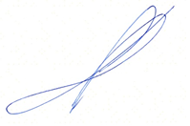

Indrek Kasela

Member of the Management Board

31 August 2022