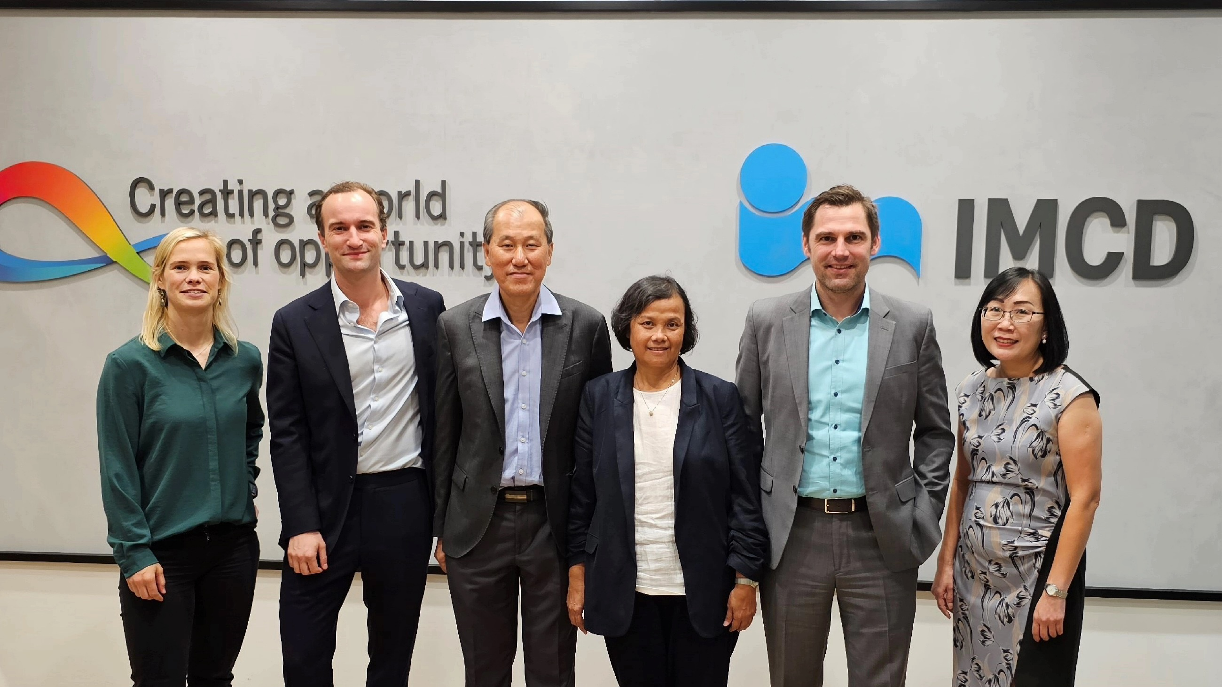

Photographed from left to right:
- Fenna van Zanten, M&A Director of IMCD Group
- Daan Roebbers, Regional Director Expansion, Strategy, and Digitalisation of IMCD APAC
- Tan Seng Kung, Founder & Managing Director of Brylchem Group
- Ang Bee Suan, Director of Brylchem Group
- Andreas Igerl, President of IMCD APAC
- Shellen Chua, General Director of Brylchem Group

