PERSONAL INFORMATION | Inga Kuktiene
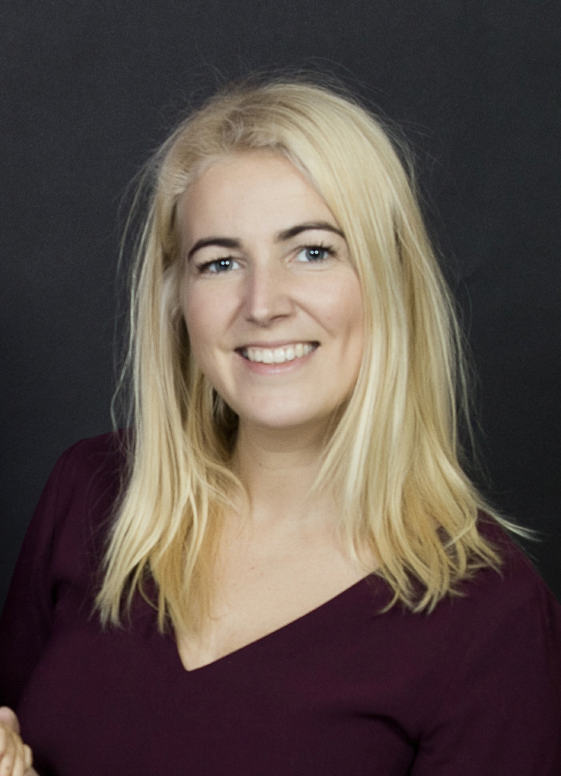 | Varnes str. 64, Vilnius, LT-06200, Lithuania
 | Replace with telephone number +37061040601
 | Email: inga.kuktiene@gmail.com
 | Female | Date of birth 09/02/1980 | Nationality Lithuanian
WORK EXPERIENCE
July 2020 – until now | Independent Audit Committee Member
Lietuvos oro uostai
Assisting the board to fulfill its oversight responsibilities in areas such as an entity’s financial reporting, internal control systems, risk management systems and the internal and external audit functions.
November 2020 – until now | Chief risk Officer, Management Board Member
UAB SME Bank
Responsible for licensing process and communication with regulators.
Responsible for creating, implementing, and continuously improving risk management framework, risk management strategy, risk policies, procedures and tools.
Setting up transaction screening and monitoring solution, developing alert system. AML Program development and set-up.
Setting up risk limit and monitoring system. Risk related prudential ratios monitoring and regulatory reporting.
Preparation of various risk related policies and procedures.
May 2020 – October 2020 | Chief risk Officer, Management Board Member
 | UAB European Merchant Bank (www.europeanmerchantbank.com)
 | Responsible for creating, implementing, and continuously improving risk management framework, risk management strategy, risk policies, procedures and tools. Setting up risk limit and monitoring system. Risk related prudential ratios monitoring and regulatory reporting. Development of AML/CFT program, transaction screening and monitoring solutions. Quality review of risk management processes. Communication with regulators.
April 2019 – May 2020 | Head of Internal Audit
UAB European Merchant Bank (www.europeanmerchantbank.com)
Responsible for development of all internal audit framework, methodologies, templates, audit approach, strategic and agile audit plans.
Consult and foster on developing of risk management framework, compliance framework, internal control system į a new bank from zero to hero.
Since May 2017 – April 2019 | Audit Manager
 | Citco group of companies (www.citco.com)
Performed audits :
- AML, regulatory reporting, depository audits in Citco bank of Netherlands, Ireland, Luxembourg;
- Corporate and trust full scope audits of in Malta, Luxembourg, Jercey;
- KYC and AML program audit in Citco bank of Canada;
- Reporting audit for bank in Curacao, etc.
Responsible for planning leading audits in different Citco group of companies.
Since August 2010 - 2017 April (six years) | Head of Internal Audit Unit
 | AB Citadele bank (www.citadele.lt)
Responsible for the auditing activity in the Bank group in general, which incorporates process improvement initiatives, IT audits, financial audits, consulting on risk management, evaluation of internal control system.
Responsibilities started from risk assessment of all Bank’s activities, setting up long-term and annual audit plan, preparing methodologies and audit programs, leading audit teams, auditing, reporting to the council, Boards and regulator, work with external partners and Bank of Lithuania etc.
During career in AB “Citadele” bankas, I personally audited all business processes within the Bank’s group (IT governance and all IT&IS systems , credit risk management, business due diligence of legal clients for whom credit was issued, deposit transactions, daily banking operations, settlements, AML risk management, brokerage, Treasury deals and liquidity risk management, governance, IT &IS systems, etc.). Audits resulted in process improvements and more effective risk management system, which result in costs savings or better control over reputation of the Bank.
Also, personally accomplished projects in Russia and Ukraine on certain companies’ business evaluations.
Since November 2004- Agust 2010 (six years) | Head of Internal Audit Unit
 | AB Parex bank
My responsibilities included:
- Responsible for the auditing activity in the Bank group (Bank, Leasing Company and Investment Company). Implementing strategic and annual audit plan, preparing methodologies and audit programs, leading audit teams, auditing, reporting to the Council, Audit Committee, Board, work with external partners and Bank of Lithuania;
- Compliance and operational risk management – review of all Bank group’s procedures and major processes before implementation;
- Special assignments on risk management and compliance improvements;
- Branch audits;
- Financial brokerage compliance activities;
- Lead during external audits and investigations.
During career in AB “Parex” bankas, I personally audited all business processes within the Bank’s group, provided assistance in risk management and compliance field, consulted during major new processes such as AMEX implementation; third party agreements; assisted in creating operational risk and compliance risk management departments, etc. Audits resulted in process improvements and more effective risk management system, which result in costs savings or better control over reputation of the Bank.
September 2001 - November 2004 (three years) | Senior Audit Associate in Assurance and Business Advisory Services Department  Consultant in Corporate Finance Services Department
 | PricewaterhouseCoopers UAB (www.pwc.lt)
During three years in PricewaterhouseCoopers, I participated in audits of Lithuanian industrial, energy, retailer, insurance companies and banks. Involved in due diligence projects in pharmaceuticals and meat processing industries. As a team manager I had the following review and audit projects: Stora Enso Packaging UAB, Lindstrom UAB, Rehau UAB, SEB Invesment management, Risk capital management and other. All audits involved review of internal controls and IT controls.
As a consultant, I participated in a privatisation project of Lithuanian agricultural bank as well as in advisory consulting for International Water and Sydcraft on lease of Vilnius Heating Company. I was also involved in preparation of a feasibility study for a business class hotel. Provided financial and consulting services for all types of companies.
MEMBERSHIPS AND AWARDS | Member of Internal audit association www.theiia.org  Certified Anti-money laundering specialist (CAMS designation)  Certified internal auditor (CIA designation)  Certified risk management auditor (CRMA designation)  Certified local internal auditor in Lithuania (Lithuanian internal audit certificate)
EDUCATION
September 2001 – June 2003 | Master of Science (Major: Service Management)
Vilnius University, Faculty of Economics
http://www.ef.vu.lt
August 1998 – May 2001 | Bachelor of Science (Major: Management Consulting)
Stockholm School of Economics in Riga (SSE Riga)
http://www.sseriga.edu.lv
Mother tongue(s) | Lithuanian
Other language(s) | UNDERSTANDING |  | SPEAKING |  | WRITING
 | Listening | Reading | Spoken interaction | Spoken production
English | C2 | C2 | C2 | C2 | C2
Russian | C2 | C2 | C2 | C2 | C2
Spanish | C2 | C2 | B2 | B2 | C
Levels: A1/2: Basic user - B1/2: Independent user - C1/2 Proficient user
Common European Framework of Reference for Languages
Communication skills | I have worked with different companies, various functions and people types. During 20 years of audit experience I have solved numerous different situations and every time solution was found. I am Initiative, communicative, influencing and I have negotiation skills needed for the auditor’s position.
Organisational / managerial skills | I was responsible for up to 10 people reporting directly to me, and to organization overall indirectly as a Board member.  Indirect leading goes to all employees of the bank (around 300).
Job-related skills | - 20 years of audit experience (17 in internal audit and 3 in external audit field);  - Certificated auditor and risk auditor;  - Good command of quality control processes;  - Risk management skills
Computer skills | - Good command of Microsoft Office™ tools  - Internet  - Knowledge of banking system ORACLE Flexcube, Forpost, Temenos, etc,  - Understanding of accounting programs (Navision, other).
Driving licence | B since 2001
TRAINING PROGRAMS | Short list (not all specified)
- Study program for CAMS certificate (AML) and various webinars in AML area for 20 educational hours per year;
- Training on communications styles; coaching, 3 lines of defense, etc, 2017
- How technologies improve business profit 2017;
- Robotisation desitions for efective finance sector management 2017;
- Negotiation risk management 2016 and different
- Practical ways of detecting and investigating fraud and corruption in your organisation, University of Leicester - 5-6 March 2015;
- Quality management system traning, 2014;
- PwC training on business process management (Lean Six Sigma methods, KPI’s for processes) 2013, 2014;
- Effective team work by Human study centre (12th of September, 2013);
- Management pentathlon by OVC (5-6th of December, 2012);
- One day seminar on Operational risk in Norway (22nd of May, 2012);
- International training in Financial risk management in Luxembourg (13-17th of October, 2008);
- Internal audit in the bank in Ukraine (11-14, April 2008);
- Risk management in commercial bank (8th of May, 2007);
- Coaching (6-7th of November, 2007);
- Audit planning process from plan till report (7th of November, 2006);
- Continuous seminars in International audit association on credit risk management, audit and process evaluation techniques, KPI’s, business controls, organizational culture, etc.

