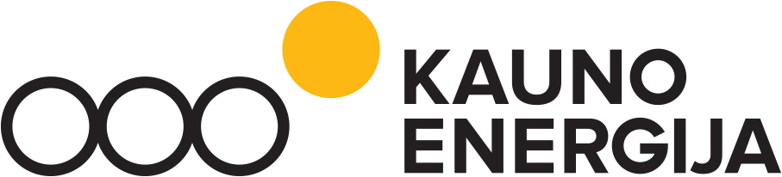

AB KAUNO ENERGIJA

Address Raudondvario av. 84, 47179 Kaunas
Code 235014830
Data is being collected and stored in the Register of Legal Entities

VOTING BULLETIN OF THE EXTRAORDINARY GENERAL MEETING OF SHAREHOLDERS

January 10, 2023

SHAREHOLDER’S information

The shareholder’s (personal) name, surname; the shareholder’s (legal entity) title:

_____________________________________________________________________________

The shareholder’s personal code; the shareholder’s (legal entity) code:

_____________________________________________________________________________

The number of shares:

_____________________________________________________________________________

voting
Please underline the option you choose in the table “YES” or “no”.

No. | Items of agenda | Resolution project | Shareholder’s  Vote  (fill)
1. | To establish that the members of the Supervisory Board of the Company “Kauno Energija” elected for a new term of office in 2023 shall be paid a remuneration for their activities with the Supervisory Board. | First edition of resolution:  1. To establish that the members of the Supervisory Board of the Company “Kauno Energija” elected for a new term of office in 2023 shall be paid a remuneration for their activities with the Supervisory Board.  2. To establish the below monthly remuneration for the activities of a member of the Supervisory Board of the Company "Kauno Energija":  2.1. a monthly remuneration for a member of the Company's Supervisory Board, other than a civil servant serving as a member of the Company's Supervisory Board, shall be 1/4 of the average monthly salary of the Chief Executive Officer of the Company;  2.2. a monthly remuneration of the Chairperson of the Supervisory Board of the Company shall be 1/3 of the average monthly salary of the Chief Executive Officer of the Company;  2.3. a monthly remuneration of a civil servant acting as a member of the Company's Supervisory Board shall be 1/5 of the average monthly remuneration of the Chief Executive Officer of the Company;  3. to authorise the Chief Executive Officer of the Company “Kauno Energija” to sign agreements with the members of the Company's Supervisory Board in respect of the activities of a member of the Company's Supervisory Board.  Second edition of resolution:  1. To establish that the members of the Supervisory Board of the Company “Kauno Energija” elected for a new term of office in 2023 shall be paid a remuneration for their activities with the Supervisory Board.  2. To establish the below monthly remuneration for the activities of a member of the Supervisory Board of the Company "Kauno Energija":  2.1. a monthly remuneration for a member of the Company's Supervisory Board, other than a civil servant serving as a member of the Company's Supervisory Board, shall be 1/4 of the average monthly salary of the Chief Executive Officer of the Company;  2.2.a monthly remuneration of the Chairperson of the Supervisory Board of the Company shall be 1/3 of the average monthly salary of the Chief Executive Officer of the Company;  2.3. a monthly remuneration of a civil servant acting as a member of the Company's Supervisory Board shall be 1/8 of the average monthly remuneration of the Chief Executive Officer of the Company;  3. to authorise the Chief Executive Officer of the Company “Kauno Energija” to sign agreements with the members of the Company's Supervisory Board in respect of the activities of a member of the Company's Supervisory Board.
2. | On reducing the number of the members of the Supervisory Board of the Company “Kauno Energija” | Taking into account that Article 31 of the Law on Companies of the Republic of Lithuania stipulates that the number of the members of the Supervisory Board shall not be less than 3, to reduce the number of the members of the Supervisory Board of the Company “Kauno Energija” to be elected for a new term of office in 2023, to 3 members
3. | On granting powers to the Chief Executive Officer of the Company “Kauno Energija” | To authorise the Chief Executive Officer of the Company “Kauno Energija” to make a draft amendment to the Articles of Association of the Company “Kauno Energija” regarding the reduction in the number of the members of the Company's Supervisory Board to 3 persons and to submit the draft amendment to the Ordinary General Meeting of Shareholders of the Company of the year 2023 for approval.

_________________ _________________________________________________________________________________________
(Date) (Shareholder or any other person entitled to vote his shares. The name, signature, legal person seal)

