Bayport Management Ltd
Social Bond Investor Letter 2019

June 2020

Bayport and Social Bonds

Bayport Management Ltd. (“Bayport”) was founded in 2001 with the aim of making a real difference in the lives of our clients in emerging and frontier markets. By offering a wide selection of financial services in markets where access to such services is often limited to large groups of people, we contribute to financial independence and economic empowerment for both individuals and small companies.
We published our first Social Bond Framework in May 2019. This is our first Social Bond Investor Letter where we aim to provide investors and other stakeholders with information around the allocation of the USD 260 million Social Bond that we issued in May 2019.
Sustainalytics provided a Second Party Opinion on our Social Bond Framework, confirming its alignment with the ICMA Social Bond Principles published in 2018. We have also engaged Sustainalytics to provide a review of this Investor Letter. All documents will be available on our website.

Allocation of Social Bond Proceeds

In 2019, we issued a Social Bond with a total nominal value of USD 260 million. The full volume has been allocated, with 46 per cent of proceeds financing new loans, and 54 per cent for refinancing purposes. The proceeds have been allocated across the following countries and loan categories.
Allocation of proceeds
 | Botswana | Ghana | Tanzania | Zambia | Mozambique | Mexico | Colombia
Education | 1,918,210 | 3,706,448 | 781,748 | 8,375,688 | 819,405 | 1,584,725 | 1,973,073
Housing | 18,323,995 | 177,934 | 123,322 | 10,546,886 | 34,514,054 | 23,893,189 | 4,826,304
Health & Emergency | 9,257,445 | 533 | 130,603 | 101,329 | - | 11,824,824 | 2,323,972
MSE financing | 2,790,831 | 31,141,096 | 17,655,310 | 15,220,338 | 17,930,514 | 38,276,982 | 1,781,241
Total | 32,290,482 | 35,026,011 | 18,690,983 | 34,244,241 | 53,263,972 | 75,579,720 | 10,904,590
New financing | 45% | 33% | 7% | 35% | 58% | 59% | 48%
Refinancing | 55% | 67% | 93% | 65% | 42% | 41% | 52%
Number of loans
 | Botswana | Ghana | Tanzania | Zambia | Mozambique | Mexico | Colombia
Education | 1,577 | 5,836 | 592 | 16,529 | 2,012 | 1,200 | 675
Housing | 7,868 | 1,698 | 61 | 6,565 | 26,986 | 14,786 | 1,361
Health & Emergency | 5,301 | 365 | 92 | 791 | - | 7,013 | 840
MSE financing | 1,567 | 42,219 | 14,267 | 11,230 | 15,497 | 19,214 | 519
Total | 16,313 | 50,118 | 15,012 | 35,115 | 44,495 | 42,213 | 3,395

Allocation of proceeds to loan categories: | Allocation of proceeds per country:

Examples of loans financed by Social Bonds

We provide our clients with a chance at a better life by not only focusing on short-term cash flow relief, but by helping them along the road towards sustainable financial wellness. Through unique and tailored financial solutions and long-term client relationships, we want our clients to have the ability to shape their own future. To provide further insights into what our Social Bonds have financed so far, we have included a number of client stories below.

Lillian Seth Mallya
My Name is Lillian Seth Mallya. I am married, have four children and work as a nurse at Machame Hospital.
Life was difficult and very tight: I struggled to pay school fees for three children and stock a small business, but Bayport has really empowered me.
The Bayport loan officer educated us on the loans, explaining I could choose to take a loan for up to five years, depending on my affordability and requirements, and informing me that my loan will be deducted directly from my salary.
I took the loan and it really helped me. I am very happy with Bayport.
With my first loans I paid my child's university fees, made some home improvements, and bought more chickens for my poultry and eggs business. I also bought more cows and pigs. The cattle dairy business is seasonal in Machame. If the season is good then dairy is plentiful; during droughts there is no cow feed and therefore less milk. Right now the season is good and I can get 10 litres in the morning and 10 litres at night. The money from the milk helps my family with food and medical treatment.
I was interested in Bayport because they are not bureaucratic in their loan process and there is no need for collateral. As long as you on the payroll Bayport trusts you, and they cut their deductions straight from your salary.
I have taught my children that if you have money, use it for the right reasons and not on things that are not productive.
Bayport has really made me happy. It has made me feel like a human being and has reduced my life burdens a lot.
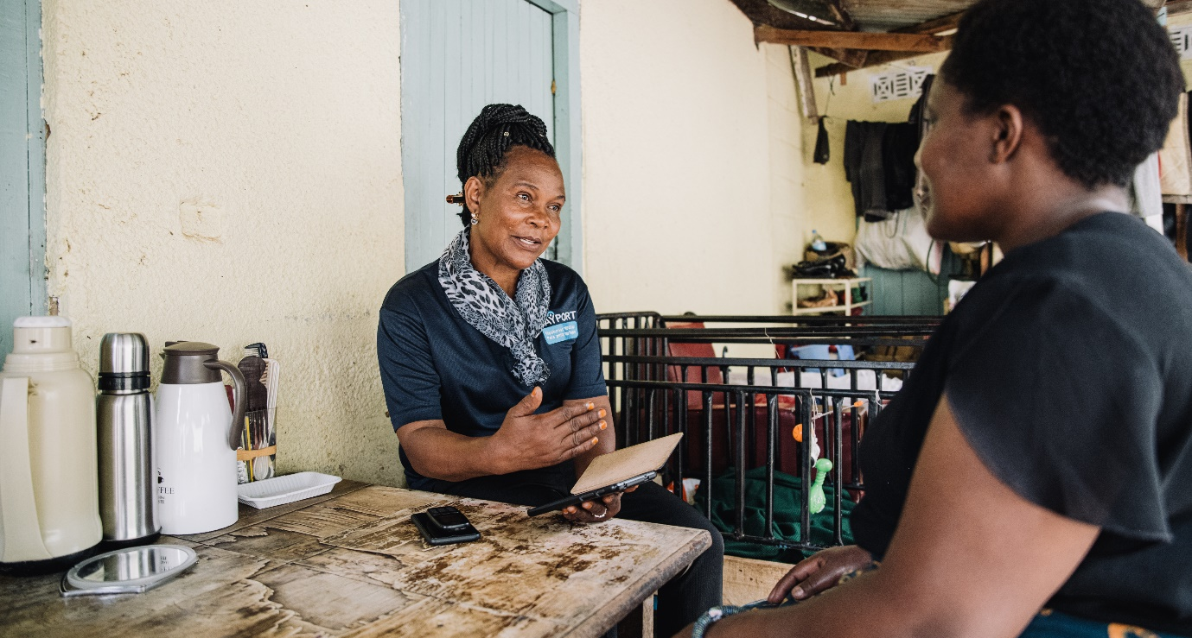

Juma Ali Mazinda
“My name is Juma Ali Mazinda. I work as a village district executive. Most of the people in this district are rice and maize farmers, but climate change is causing big challenges here, mainly because we no longer get the rain we were accustomed to. The rain arrives at the right time, but stops halfway through the season, thus the crops cannot grow as expected. This means that farmers no longer grow enough crops for their own food and to sell.
As a result of climate change, I could also no longer rely on my rice paddy and my maize crop. I also realised I am getting old and will reach a point where I won’t have money for basic needs like buying salt. I therefore decided to create a farm at home for long-lasting crops, such as papaya, coconut, lime and sugarcane.
To do this, I decided to borrow from Bayport. My loan was just over Tsh1 million. I divided the loan in three sections: Tsh200 000 I used to buy four goats to start a business that will eventually help pay for school fees. With Tsh400 000 I created the farm here at home, and the other Tsh400 000 I spent on improving my rice paddy farm.
I see that the development plan I had set for the Bayport loan, is heading towards success. For example, I estimate I can get at least 700 papayas this season and sell them for Tsh300 each.
When I decided to borrow, my two children were still in primary school. Education is expensive, but I wanted money to educate them. Also, as I get older, I want to depend on myself with the farm I created and not rely on my children, asking them for Tsh500 to buy salt.
I am really thankful to Bayport. You make payments on your loan and they invite you to get top ups to continue your development plans. Bayport's loan has really helped me achieve my goals.
When my children are older, I will educate them about loans based on my experience. Without my loan, I would have not reached this success. A loan helps if you have a plan. My plan was to look after the wellbeing of my family, how they will live and how I will live.”

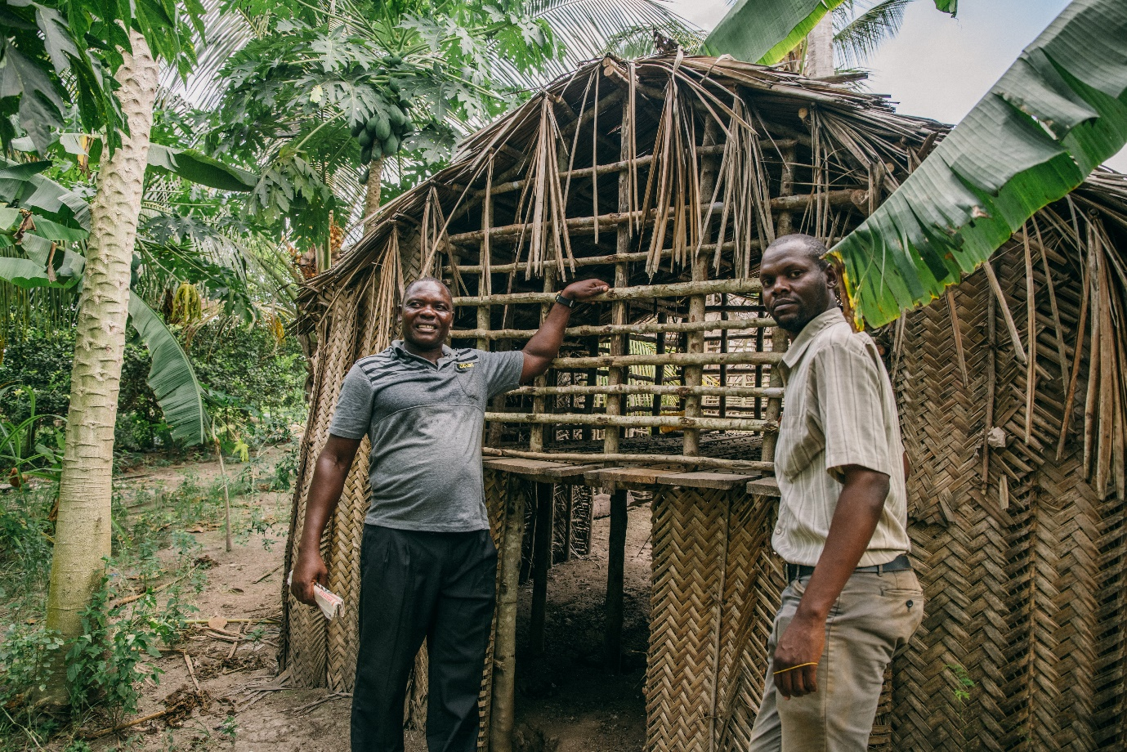

Micro and small-sized enterprises

