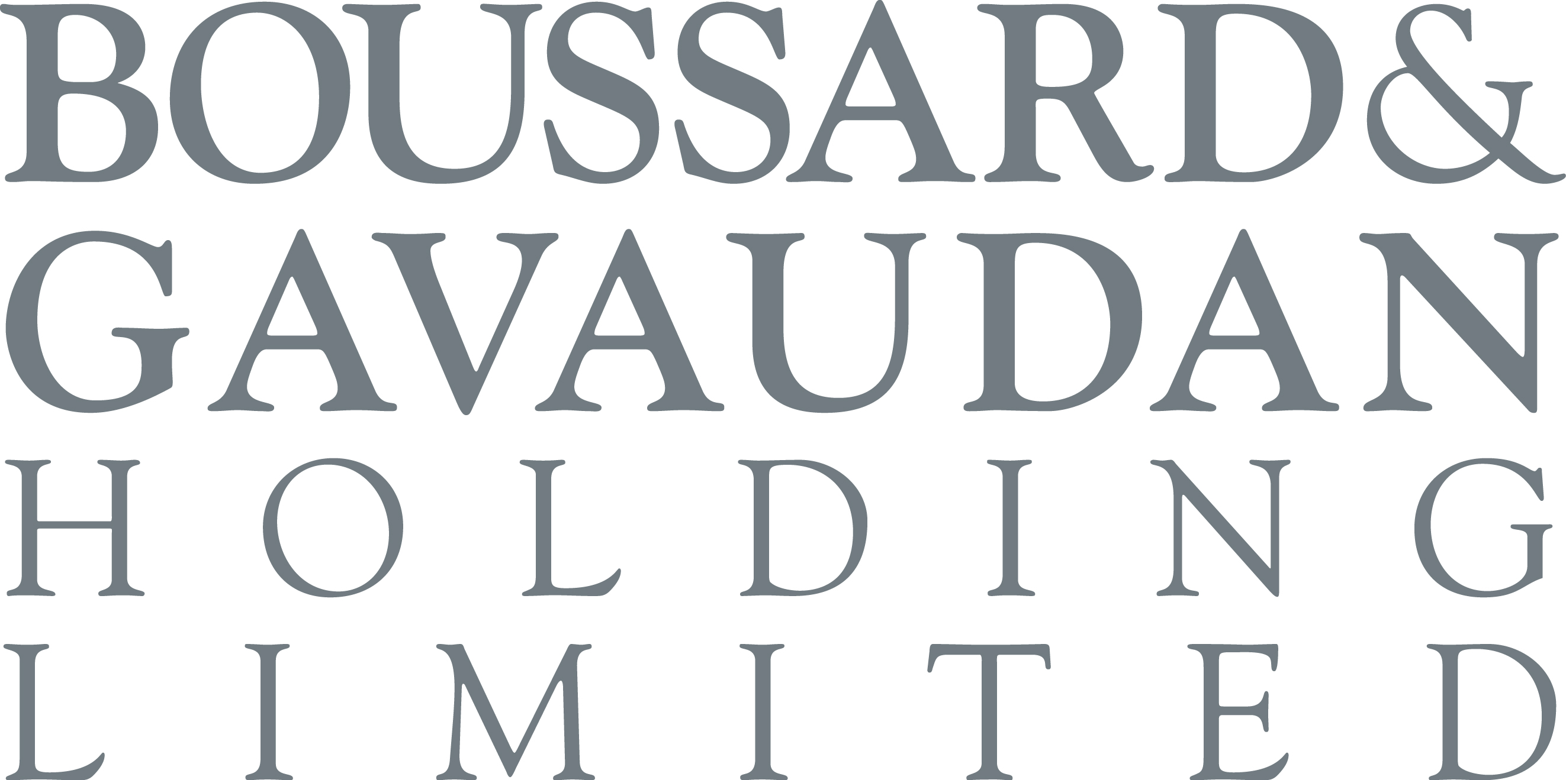

Boussard & Gavaudan Holding Limited (the “Company”)
a closed-ended investment company incorporated with limited liability under the laws of Guernsey
with registration number 45582

Legal Entity Identifier: 5493002XNM3W9D6DF327

Results of Annual General Meeting

The Company hereby gives notification that at the annual general meeting of the Company held on Thursday, 28 September, 2023 at 11.00 a.m., all resolutions set out in the notice of meeting were duly passed. The Board would like to thank the shareholders of the Company for their continued support.

In accordance with listing rule 9.6.2 a copy of the resolutions passed as special business have been submitted to the National Storage Mechanism and will shortly be made available for inspection at:
https://data.fca.org.uk/#/nsm/nationalstoragemechanism.

The details of all resolutions passed are as follows:

ORDINARY BUSINESS - ORDINARY RESOLUTIONS

- That the Company’s annual report and audited financial statements for the year ended 31 December 2022 be received. (10,358,021 votes cast, all in favour, none against and none withheld)

2. That Ernst & Young LLP be re-appointed as auditor of the Company, to hold such office until the conclusion of the next annual general meeting, and that the directors be authorised to agree the auditor’s remuneration. (10,358,021 votes cast, all in favour, none against and none withheld)

3. That Mr Erich Bonnet who, being eligible and having offered himself for re-election, be re-appointed as a director of the Company. (10,103,410 votes cast, 9,945,461 in favour, 157,949 against and 254,611 withheld)

4. That Ms Sylvie Sauton who, being eligible and having offered herself for re-election, be re-appointed as a director of the Company. (10,357,721 votes cast, all in favour, none against and 300 withheld)

5. That Mr Luke Allen who, being eligible and having offered himself for re-election, be re-appointed as a director of the Company. (10,357,721 votes cast, all in favour, none against and 300 withheld)

6. That Mr Frédéric Hervouet who, being eligible and having offered himself for re-election, be re-appointed as a director of the Company. (10,357,721 votes cast, all in favour, none against and 300 withheld)

SPECIAL BUSINESS – ORDINARY RESOLUTIONS

7. THAT the waiver granted by the Panel of the obligation which may otherwise arise, pursuant to Rule 9 of the Code, for a member of the Concert Party to make a general offer to the other Shareholders for all of their Shares as a result of market purchases of Shares by the Company pursuant to the authority granted under Resolution 8 that could potentially increase the Concert Party’s interest in Shares from approximately 27.66 per cent. of the total Voting Rights in connection with the BG Remuneration Policy to a maximum of approximately 35.28 per cent. of the total Voting Rights, be approved. (8,829,021 votes cast, 8,147,779 in favour, 681,242 against and 29,000 withheld)
8. THAT, conditional on approval of Resolution 7 above, in replacement for all previous authorities, the Company be generally and, subject as hereinafter appears, unconditionally authorised, in accordance with section 315 (1)(a) of The Companies (Guernsey) Law, 2008, as amended (the "2008 Law"), to make market acquisitions (within the meaning of section 316 of the 2008 Law) of shares ("Shares") in the capital of the Company and to cancel such Shares or hold such Shares as treasury shares, provided that:
a) the maximum number of Shares hereby authorised to be purchased shall be up to an aggregate of the lesser of (a) 1,843,202 Euro Shares and 18,931 Sterling Shares or (b) such number as shall represent 14.99 per cent. of each class of Shares in issue (excluding Shares held in treasury), rounded down to the nearest whole number, on the date on which this resolution is passed;

b) the maximum price which may be paid for a Share shall be the higher of (a) an amount equal to 105.00 per cent. of the average of the closing quotation for a Share of the relevant class taken from and calculated by reference to (i) in the case of the Euro Shares, Euronext Amsterdam or (ii) in the case of the Sterling Shares, the London Stock Exchange plc's Daily Official List, as the case may be, for the five Business Days immediately preceding the day on which the Shares are purchased and (b) the higher of the price of the last independent trade and highest current independent bid on the relevant market when the purchase is carried out, provided that the Company shall not be authorised to acquire Shares at a price above the estimated prevailing net asset value of the relevant class of Shares on the date of purchase;

c) the minimum price which may be paid for a Share shall be €0.01 or £0.01, as the case may be; and

d) unless previously varied, revoked or renewed, the authority hereby conferred shall expire on the earlier of 31 December 2024 or the date of the next annual general meeting of the Company, whichever is the earlier, save that the Company may, prior to such expiry, enter into a contract to purchase Shares under such authority, and may make a purchase of Shares pursuant to any such contract notwithstanding such expiry.

(10,358,021 votes cast, all in favour, none against and none withheld)

For further information, please contact:

Boussard & Gavaudan Investment Management, LLP
Emmanuel Gavaudan
+44 20 3751 5389

JTC Fund Solutions (Guernsey) Limited
Secretary
+44 (0) 1481 702400

28 September, 2023
Website: www.bgholdingltd.com

The Company is established as a closed-ended investment company domiciled in Guernsey. The Company has been authorised by the Guernsey Financial Services Commission as an authorised closed-ended investment scheme. The Company is registered with the Dutch Authority for the Financial Markets as a collective investment scheme pursuant to article 2:73 in conjunction with 2:66 of the Dutch Financial Supervision Act (Wet op het financieel toezicht). The shares of the Company (the "Shares") are listed on Euronext Amsterdam. The Shares are also listed on the Official List of the UK Listing Authority and admitted to trading on the London Stock Exchange plc's main market for listed securities.

This is not an offer to sell or a solicitation of any offer to buy any securities in the United States or in any other jurisdiction. This announcement is not intended to and does not constitute, or form part of, any offer or invitation to purchase any securities or the solicitation of any vote or approval in any jurisdiction, nor shall there be any sale, issuance or transfer of the securities referred to in this announcement in any jurisdiction in contravention of applicable law.

Neither the Company nor BG Master Fund ICAV have been, and neither will be, registered under the US Investment Company Act of 1940, as amended (the "Investment Company Act"). In addition the securities referenced in this announcement have not been and will not be registered under the US Securities Act of 1933, as amended (the "Securities Act"). Consequently any such securities may not be offered, sold or otherwise transferred within the United States or to, or for the account or benefit of, US persons except in accordance with the Securities Act or an exemption therefrom and under circumstances which will not require the issuer of such securities to register under the Investment Company Act. No public offering of any securities will be made in the United States.

You should always bear in mind that:
- all investment is subject to risk;
- results in the past are no guarantee of future results;
- the investment performance of BGHL may go down as well as up. You may not get back all of your original investment; and
- if you are in any doubt about the contents of this communication or if you consider making an investment decision, you are advised to seek expert financial advice.

This communication is for information purposes only and the information contained in this communication should not be relied upon as a substitute for financial or other professional advice.

END OF ANNOUNCEMENT

