.
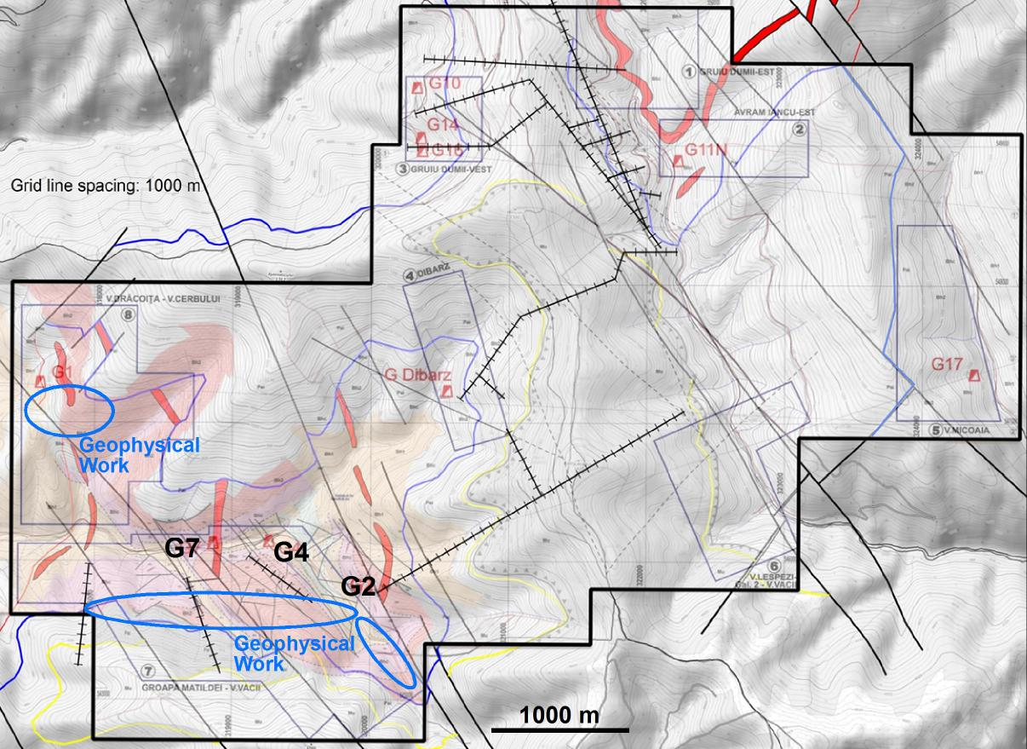
Figure 1; License overview map showing the principal gallery mouth locations; those currently reopened are highlighted in black (G2, G4, G7). Geophysical work consists mainly of IP (induced potential) and NP (natural potential) sections of 500 and 2000 m length. A ground magnetic survey covering these sections and G4+G7 has already been carried out by the Company in 2018.

