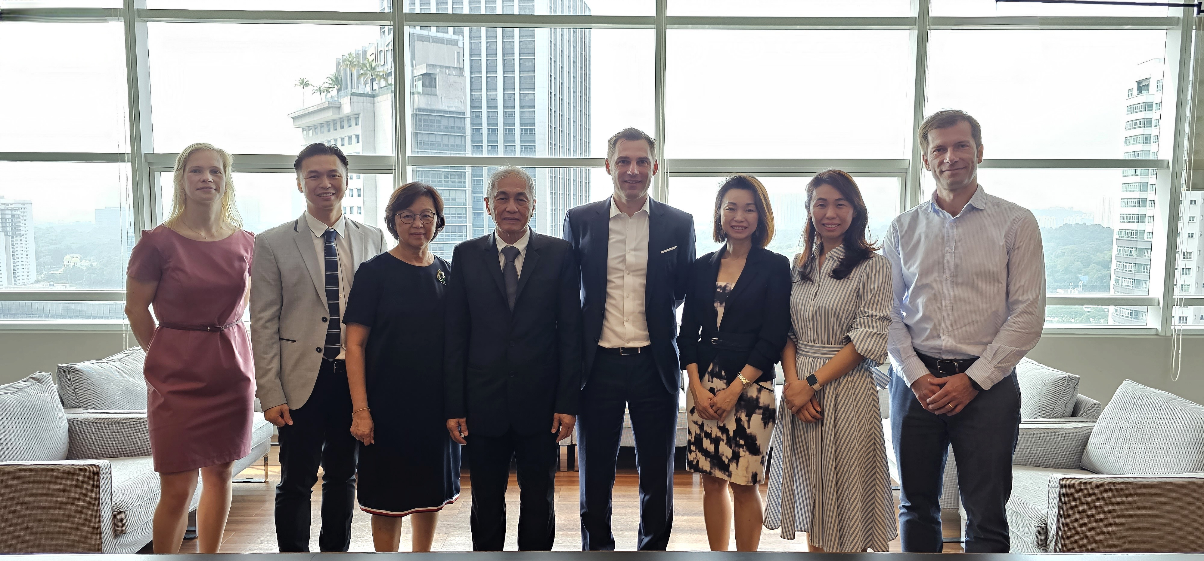

In picture, from left to right
- Fenna van Zanten, Global Director M&A of IMCD Group
- Jeryl Tan, Executive Director of Euro Chemo-Pharma
- Teoh Seok Har, Director of Euro Chemo-Pharma
- Tan Hooi Pheng, Founder and Managing Director of Euro Chemo-Pharma
- Andreas Igerl, President of IMCD APAC
- Vivien Tan, Executive Director of Euro Chemo-Pharma
- Sylvia Tan, Shareholder of Euro Chemo-Pharma
- Emmanuel Colette, APAC Business Group Director of IMCD Food & Nutrition

