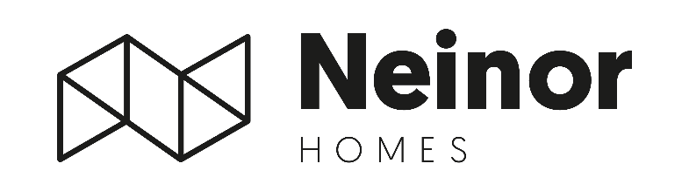
Neinor Homes approves €77mn (€0.78/sh) shareholder distribution supported by high FY26 earnings visibility

- Solid FY26 earnings visibility, with +950# housing units notarized during 1Q26 for nearly €400mn of development revenues
- Highly dynamic commercialization activity, with more than 1,100# pre-sold in 1Q26 for c.€450mn, despite geopolitical uncertainty
- Given the high visibility, the BoD has approved a shareholder distribution of €77mn (€0.78/sh) continuing to accelerate FY26 targets

Madrid, 4 May 2026- Neinor Homes (“Neinor”), Spain’s leading listed residential developer, has delivered a strong start to the year across all fronts, following the successful closing of the AEDAS acquisition at the beginning of March and continued solid operational performance throughout the first quarter.
The company announces that during 1Q26 total deliveries of the Group reached +950# fully owned, generating €395mn of Development Revenues, reflecting the continued execution of its development activity.
In terms of commercialization activity, as previously announced, Neinor has maintained robust momentum, pre-selling more than 1,100 units during 1Q26, equivalent to over €450mn in future revenues. Despite heightened geopolitical uncertainty, we have also seen the continuation of this trend into April, with a very solid pre-sales performance, further reinforcing the strength of underlying demand across Neinor’s core markets.
Execution proven with more than 60% of shareholder returns delivered with substantial distributions ahead
Neinor will distribute €77mn to its shareholders on June 8, equivalent to a payment of €0.7794 per share. The last trading date with entitlement to the distribution will be June 3. The distribution will be executed through two components: €37mn will be paid as an extraordinary dividend charged to the share premium, while the remaining €40mn will be implemented through a capital reduction with a return of contributions, both approved by Neinor’s General Shareholders’ Meeting. The withholding taxes, if applicable, will be deducted in accordance with current tax regulations.
Borja García-Egotxeaga, Neinor Homes’ Co-CEO comments that: “Over the past few years, we have significantly strengthened our business, scaling our platform and consistently delivering on our targets. We are entering this next phase with greater scale, strong fundamentals and high visibility on earnings, while maintaining a resilient margin profile. This gives us a clear ability to continue delivering both growth and attractive returns to shareholders, despite the current macro and geopolitical environment.”
Jordi Argemi, Neinor Homes’ Co-CEO says: “The distribution announced today reflects the strong visibility we have on FY26 results and cash generation, which allows us to continue to accelerate part of our shareholder remuneration and the continued execution of our strategy.”

* The corresponding communication of ‘other relevant information’ to the Spanish Securities and Exchange Commission (CNMV) can be found here: (https://www.neinorhomes.com/en/accionistas-inversores/regulatory-announcements).

-ENDS-

For more information:
NEINOR HOMES
Investor Relations Department
investor.relations@neinorhomes.com

H/ADVISORS MAITLAND
NeinorHomes@h-advisors.global
David Sturken +44 7990 595 913
Billy Moran +44 7554 912 008

