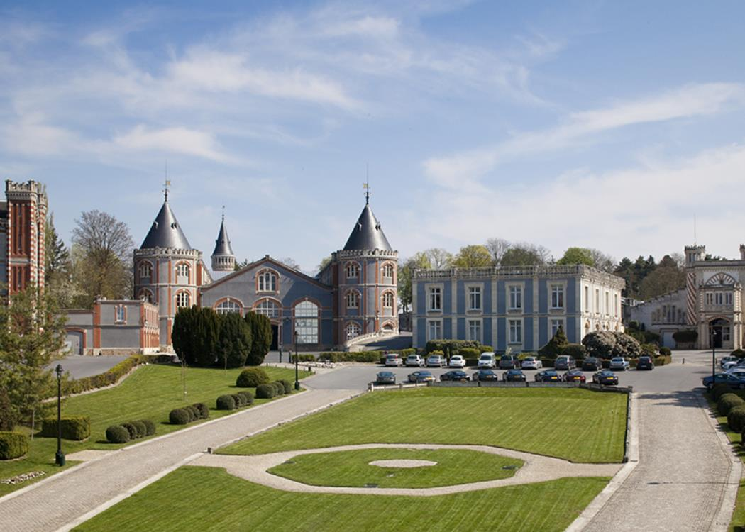

**2024 HALF YEAR RESULTS**

**Current Operating income up 22.8%**

**CONSOLIDATED TURNOVER**

**€ 109,6 million**

**-8,1 M€**

**CURRENT OPERATING INCOME**

**€ 15,1 million**

**+2,8 €M**

**NET INCOME**

**€ -1,9 million**

**-0,9 €M**

**€ 679,5 million**

**NET BANK AND BONDS DEBT\***

***vs H1 2023***

*\*excluding IFRS16 : 661,3 €M*

**Reims, september 12, 2024**

The Board of Directors of Vranken-Pommery Monopole met on September 12, 2024 under the chairmanship of Mr. Paul François Vranken, and in the presence of the Statutory Auditors, to approve the Group's financial statements for the half year 2024.

The limited review procedures on the half-yearly financial statements have been performed by the statutory auditors. Their limited review report is being issued.

|  |  |  |  |  |  |  |  |  |  |  |  |  |
| --- | --- | --- | --- | --- | --- | --- | --- | --- | --- | --- | --- | --- |
|  |  | |  | |  | |  | | **Vs published** | | **Vs restated** | |
| ***Consolidated data in €M*** | | **06/2024** | | **06/2023 published** | | **06/2023**  **restated (*)** | |  | **Change in €m** | **Change in %** | **Change in €m** | **Change in %** |
| ***Turnover*** | | **109,6** | | **117,7** | | **117,7** | |  | **-8,1** | **-6,9%** | **-8,1** | **-6,9%** |
| ***Current Operating Income*** | | **15,1** | | **11,0** | | **12,3** | |  | **+4,1** | **+37,3%** | **+2,8** | **+22,8%** |
| ***Operating Income*** | | **14,7** | | **11,2** | | **12,6** | |  | **+3,5** | **+31,3%** | **+2,1** | **+16,7%** |
| *Financial result* | | *-16,4* | | *-12,8* | | *-12,8* | |  | *-3,6* |  | *-3,6* |  |
| ***Net Income*** | | **-1,9** | | **-2,0** | | **-1,0** | |  | **+0,1** |  | **-0,9** |  |
| *Attributable to equity holders of the parent* | | *-1,9* | | *-1,9* | | *-1,0* | |  | *0,0* |  | *-0,9* |  |
|  | |  | |  | |  | |  |  |  |  | |
| ***Shareholders' equity*** | | **410,9** | | **404,9** | | **401,5** | |  | **+6,0** | **+1,5%** | **+9,4** | **+2,3%** |
| Minority interests | | *5,3* | | *5,1* | | *5,1* | |  | *+0,2* |  | *+0,2* |  |
| ***Net financial debt*** | | **729,5** | | **701,2** | | **701,2** | |  | **+28,3** | **+4,0%** | **+28,3** | **+4,0%** |
| **Net bank and bonds debt** | | **679,5** | |  | |  | |  |  |  |  |  |

*(*) At the close of the 2023 financial year, an error was identified in the valuation of inventories relating to the 2019 to 2022 financial years. This error was corrected in the second half of 2023, but was still present when the consolidated financial statements at June 30, 2023 were published. In application of IAS 8 “Accounting policies, changes in accounting estimates and errors”, VPM's consolidated financial statements have therefore been treated retrospectively for this error correction. The comparative income statement for 2023 has been restated, with a positive impact of 1 million euros on the published net income for the six months to June 30, 2023. These corrections have no impact on the income statement for fiscal 2024.*

**Sales down slightly**

Half-year consolidated sales for Vranken-Pommery Monopole were down 6.9% at **€109.6 million**.

**France** (37% of consolidated sales), where the Group relies on strong positions notably in all networks, was **stable** compared with the first half of 2023.

Exports were down 8.9%, representing **63% of Group sales**.

After two particularly dynamic years, the wine market is experiencing a slowdown worldwide, due to the climate of economic and geopolitical uncertainty that has prevailed since the end of 2023. Champagne expeditions are following this trend, falling by 15.2% in volume at the end of June (source Comité Champagne).

Against this backdrop, the most prestigious cuvées - Cuvée Louise from Champagne Pommery & Greno and Cuvée Diamant from Champagne Vranken - managed to hold their own, with a favorable impact on margins.

**Operating income: value creation strategy confirmed**

The strategy of moving brands upmarket and internationalizing them produced results in the first half of 2024, reflected in improvements in EBITDA margin and operating margin before non-recurring items. **EBITDA** for H1 2024 rose by 14.2% to **€22.3m** (vs. €19.2m in restated H1 2023).

* **Current operating income** came to **€15.1m** **(+€2.8m), up +22.8%.**
* The operating margin on ordinary activities was 13.8%, compared with 10.4% in 2023.
* **Operating income** rose by **+16.7%** to **€14.7 million**.
* The increase in margins partly offset the rise in interest rates in the first half of 2024 and the a €3.6 million decrease in net financial income.
* **Net income** came to **-1.9 M€.**

**A stable financial structure**

**Shareholders' equity** rose by **€9.4m** to **€410.9m**, representing **31.2% of the balance sheet total**.

Net financial debt rose by 28.3 M€ to 729.5 M€ (711.2 M€ excluding IFRS 16 impact). This increase is due to :

* the seasonal nature of champagne sales
* higher inventories (+20.5 M€).

During the first half of the year, the Group repaid the June 19, 2024 bond maturity of €50 million with a current account advance from parent company Compagnie Vranken for the same amount.

**With this injection of stable capital, net financial debt (bank and bond) has been reduced to 679.5 M€ (661.2 M€ excluding IFRS 16).** On this occasion, the Vranken family reaffirms its commitment to strengthening the Group's financial structure and pursuing its debt reduction strategy.

The Group's next bond maturity is in July 2025.

Post-closing, the Group has renewed almost €235 million of ageing loans, the maturity of which has been extended to July 2026.

During the summer, the Group hedged a significant portion of its variable-rate debt against interest-rate trends.

**Société à Mission « La Vérité du Terroir »**

The Mission Committee is continuing its work on the preservation of biodiversity, and in particular on the construction of relevant indicators on this subject.

The Group is also committed to a global approach to reducing its carbon footprint and promoting renewable energies. It was against this backdrop that last June, the sailboat Grain de Sail left the port of Saint-Malo with a prestigious cargo: **the first pallet of Maison Pommery's Apanage Brut 1874 cuvée, bound for the United States**. The ship arrived in New York in September.

This exceptional sea voyage revives an historic tradition. Just 120 years ago, on the occasion of the World's Fair in Saint-Louis (Missouri), Champagne Pommery arrived in America by sailboat.

This initiative to transport its champagnes by sailboat is a perfect illustration of Maison Pommery's commitment to sustainable, environmentally-friendly practices.

**Forecast**

**In Champagne**, the harvest has just begun and the appellation yield has been set at 10,000 kg/ha. Poor weather conditions in 2024 have reduced harvest potential without compromising quality. The Champagne regulation mechanism (release of reserve wines) will cushion the effects of these climatic hazards.

**In Provence**, harvesting at Château La Gordonne is underway. The maximum AOP Côtes de Provence yield of 45 hl/ha will be reached.

**In Camargue**, the harvest is drawing to a close, and the yield for AOP Sable de Camargue will be 18% lower than in 2023

**In Douro Valley**, harvesting began in mid-August, with yields and grape quality on target

The Group believes that after two years of strong post-covid growth, 2024 will be a year of business normalization.

**Next communication :** Publication of 2024 sales on January 28, 2025 after close of trading

**About Vranken-Pommery Monopole**

Vranken-Pommery Monopole manages 2,600 hectares of land, owned outright or under lease and spread over four vineyards in Champagne, Provence, Camargue and Douro. The group’s wine-making activities range from production to marketing, with a strong commitment to the promotion of terroirs, sustainable wine-growing and environmental conservation.

Its brand portfolio includes:

* the Vranken, Pommery & Greno, Heidsieck & Co Monopole, Charles Lafitte and Bissinger & Co champagnes;
* the Rozès and Sao Pédro port wines and the Terras do Grifo Douro wines;
* the Domaine Royal de Jarras and Pink Flamingo Camargue wines and the Château La Gordonne Provence wines;
* the Sparkling wines, the Louis Pommery California, Louis Pommery England, Brut de France and Pink Flamingo sparkling wines.

*Vranken-Pommery Monopole is a company listed on NYSE Euronext Paris and Brussels.*

*(code "VRAP" (Paris), code "VRAB" (Brussels); ISIN code: FR0000062796).*

Contacts

|  |  |
| --- | --- |
| **Vranken-Pommery Monopole :**  Franck Delval, Directeur des Contrôles Financiers  +33 3 26 61 62 34, [comfi@vrankenpommery.fr](mailto:comfi@vrankenpommery.fr) | **Press**  Laurent Poinsot, +33 1 53 70 74 77, [lpoinsot@image7.fr](mailto:lpoinsot@image7.fr)  Caroline Simon, +33 1 53 70 74 65, [caroline.simon@image7.fr](mailto:caroline.simon@image7.fr) |
|  |  |

