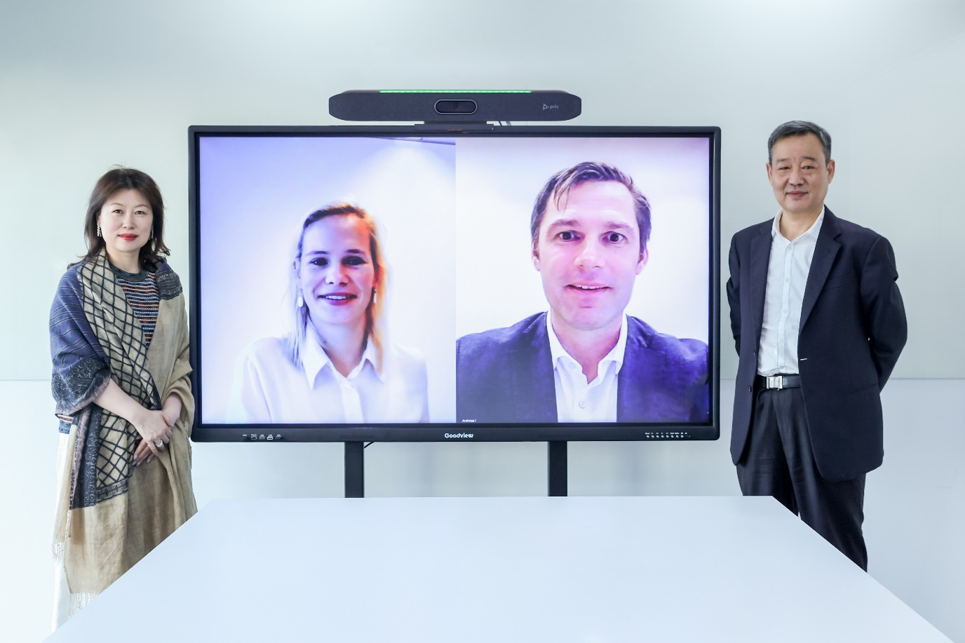

Photographed left to right:
- Grace Jiang, Vice General Manager of Sanrise
- Fenna van Zanten, General Counsel of IMCD Group
- Andreas Igerl, President of IMCD Asia
- Mr, Tony Wang, General Manager of Sanrise

