Interim report 1–3/2020
Tulikivi Corporation
Interim report 1–3/2020: Net sales and operating profit on the previous year’s level

8 May 2020 at 1 pm

- The Tulikivi Group’s first-quarter net sales were EUR 5.7 million (EUR 5.8 million, 1–3/2019).
- The Tulikivi Group’s first-quarter operating profit was EUR -0.5 (-0.7) million and the profit before taxes was EUR -0.7 (-0.9) million.
- Net cash flow from operating activities in the first quarter was EUR 0.1 (0.1) million.
- Order books at the end of the review period stood at EUR 4.4 (4.5) million.
- Nordic Talc Oy was established for exploiting the talc reserves in Suomussalmi.
- Future outlook: Net sales are expected to amount to EUR 27–29 million in 2020, and the comparable operating profit is expected to be positive.

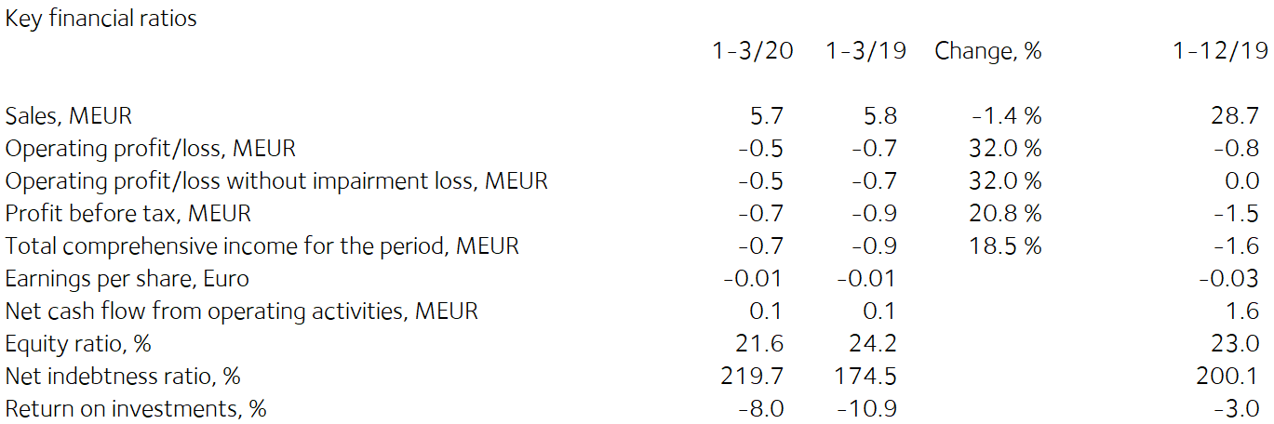

Comments by Heikki Vauhkonen, Managing Director:

Net sales in the first quarter were at a low level, in line with normal seasonality in the sector. Net sales grew in Finland, but the restrictions imposed in Central Europe because of the Covid-19 pandemic postponed deliveries somewhat, due to which net sales fell slightly from the previous year’s figure. The sales margin improved in the first quarter due to price increases and measures improving productivity. Fixed costs decreased as planned in the review period.

Net sales from fireplaces grew in Finland as a result of higher renovation sales and redesigned product ranges. The sales of fireplaces for new buildings were slightly lower than in the previous year. We are continuing our efforts to enhance sales efficiency in Finland to further increase renovation sales. The sales of saunas and interior decoration stone products have developed favourably in the first months of the year.
In the first quarter, net sales continued to develop favourably in the largest export countries, Germany and Russia.
Tulikivi’s order books at the end of the review period amounted to EUR 4.4 (4.4) million. In the first quarter, the company’s order intake was EUR 7.3 (7.2) million.
The Covid-19 pandemic will decrease second-quarter sales particularly in France, Belgium, Italy and Germany, where curfews have prevented dealers from conducting sales for the past several weeks. Similarly, the Covid-19 pandemic has had an impact on other markets, where the activities and movement of people have been restricted.
In Finland, the effects of the Covid-19 pandemic have so far been more moderate. In part, the impact has even been positive as households have increased renovation projects, but on the other hand, cancellations of fairs and marketing events have made it more difficult to acquire new customers. Tulikivi has put more resources than before into digital marketing in 2020.
In the long term, it is expected that the number of new buildings will decrease but the number of renovation projects in homes and holiday homes will increase. The sales trend will be impacted by the severity of the economic crisis arising from the coronavirus crisis as well as the effectiveness of stimulus measures.
Due to the uncertainty in net sales, operations have been adjusted by laying off production and office staff and postponing development projects.
In March 2020, the Board of Directors of Tulikivi Corporation decided to establish Nordic Talc Oy. The company’s objective is the industrial exploitation of Tulikivi’s talc deposits in the Suomussalmi mining district. At the same time, an advisory board of professionals in the field of industrial minerals and mining was appointed for Nordic Talc Oy. It includes Jan Ekblom, Mikael von Hertzen, Eeva Ruokonen and Tarmo Tuominen.

Currently the company is planning a feasibility study of the Suomussalmi talc project, the purpose of which is to further specify the project's profitability, environmental and mining plans for industrial operations. At the same time, Tulikivi is exploring opportunities to attract outside financing and investors to start and develop Nordic Talc Oy’s operations for industrial exploitation.

Interim report 1–3/2020

Operating environment

In Finland, low-rise housing construction and the renovation of fireplaces have stabilised at a lower level than before. The reduction in consumer confidence as a result of the Covid-19 pandemic may weaken the demand for Tulikivi products.
In the EU area, the volume of low-rise housing construction and the demand for fireplaces are at the same level as in previous years. Demand may be affected by the Covid-19 pandemic, by country-specific construction and emissions regulations and by investment subsidies. Demand for Tulikivi products is growing in Russia, but is dependent on the exchange rate of the rouble.
Rising consumer energy prices are increasing consumers’ interest in alternative heating solutions in the long term.

Net sales and result

The Tulikivi Group’s first-quarter net sales totalled EUR 5.7 million (EUR 5.8 million, 1–3/2019). Net sales in the first quarter were at a low level, in line with normal seasonality in the sector. Net sales grew in Finland, but the restrictions imposed in Central Europe because of the Covid-19 pandemic postponed deliveries somewhat, due to which net sales fell slightly from the previous year’s figure.
The Tulikivi Group’s first-quarter operating result was EUR -0.5 (-0.7) million and the profit before taxes was EUR -0.7 (-0.9) million. The sales margin improved in the first quarter due to price increases and measures improving productivity. Fixed costs decreased as planned in the review period. The first half of the year has usually been weaker in the industry than the second, in terms of both net sales and operating profit.
Tulikivi’s order books at the end of the review period amounted to EUR 4.4 (4.5) million. In the first quarter, the company’s order intake was EUR 7.3 (7.2) million.
Net sales in Finland in the review period were EUR 2.6 (2.4) million, or 44.6% (41.9%) of total net sales. Net sales from fireplaces grew in Finland as a result of higher renovation sales and redesigned product ranges. The sales of fireplaces for new buildings were slightly lower than in the previous year. We are continuing our efforts to enhance sales efficiency in Finland to further increase renovation sales. The sales of saunas and interior decoration stone products have developed favourably in the first months of the year.
Net sales in export markets in the review period were EUR 3.1 (3.4) million, or 55.4% (58.1%) of total net sales. The principal export countries were Germany, Russia, France, Sweden and Denmark. In the first quarter, net sales continued to develop favourably in the largest export countries, Germany and Russia. The good reception of our new Pielinen collection among customers had a positive effect on our net sales in Germany. In Russia, our revamped collections have enabled a stronger focus in sales on the premium market. The new Karelia and Pielinen fireplace collections continued to significantly increase dealers’ and consumers’ interest in Tulikivi products in Central Europe and Russia. This has enabled us to open new dealer locations and reactivate old ones. Thanks to these collections, Tulikivi has further strengthened its market position in exports.
The products in the Karelia and Pielinen fireplace collections are based on modern Scandinavian design and feature a new soapstone surface finish technique. The Pielinen products are compact and easy to install. They are particularly well suited for the Central European market and for markets where there is no expertise in installing heat-retaining fireplaces.
The highly successful development work on the Karelia and Pielinen collections provides us with an opportunity to increase our market share in euros and our profitability in both Finland and exports in 2020.

Financing

Net cash flow from operating activities in the first quarter was EUR 0.1 (0.1) million. Working capital decreased by EUR 0.2 (0.3) million in January–March 2020. Working capital totalled EUR 0.4 (0.9) million at the end of the review period.

Loan repayments totalled EUR 0.1 (0.0) million in the review period. At the end of the review period, MFI loans and working capital loans totalled EUR 15.5 (15.4) million, and net financial expenses during the period were EUR 0.2 (0.2) million. The equity ratio at the end of the review period was 21.6% (24.2%). The ratio of interest-bearing net debt to equity, or gearing, was 219.7% (174.5%). The current ratio was 0.4 (0.4), and equity per share was EUR 0.12 (0.14). At the end of the review period, the Group’s cash and other liquid assets came to EUR 0.9 (0.6) million.

On 20 December 2019, Tulikivi Corporation signed a financing agreement with its finance providers concerning the 2019–2020 repayment programme in ratio to the finance providers’ exposures. The agreement also includes loan covenants given to the finance providers. The company is in compliance with the covenants of the financing agreement according to the situation on 31 March 2020. Otherwise, the loans will mature fully on 28 February 2021, due to which they are classified as current financial liabilities. The company has also agreed with its finance providers that it will commence financing negotiations on the repayment programme for 2021 and subsequent years and its terms no later than 30 September 2020 and complete the negotiations by 31 December 2020.

The parent company’s equity was EUR -0.1 million (consolidated equity EUR 7.0 million) at the end of the review period, while share capital was EUR 6.3 million (consolidated share capital EUR 6.3 million). An external expert has prepared an appraisal of the fair value of the machinery in Suomussalmi, according to which the difference between the probable current price and the book value of the machinery and equipment at the Suomussalmi factory is EUR 1.4 million. This has been accounted for as an addition to equity, as referred to in chapter 20, section 23(2) of the Limited Liability Companies Act. When the addition is taken into account, the equity of the parent company is positive, and therefore the negative equity has not been recorded in the Trade Register.

Investments and product development

The Group’s investments totalled EUR 0.1 (0.2) million during the review period. The Karelia collection was complemented with the Petro model, which has an L door, and the Pielinen collection was expanded with a compact convection fireplace with a C door. The new models have been well received in the market.
Research and development expenditure in the review period was EUR 0.2 (0.2) million, or 3.0% (3.4%) of net sales. EUR 0.1 (0.1) million of this was capitalised on the balance sheet.

Suomussalmi talc reserves
On 27 March 2020, Tulikivi announced that the Board of Directors of Tulikivi Corporation decided on 26 March 2020 to establish Nordic Talc Oy. The company’s objective is the industrial exploitation of Tulikivi’s talc deposits in the Suomussalmi mining district. In the first stage, the objective is to plan and implement a feasibility study of the Suomussalmi talc project, the purpose of which is to further specify the project’s profitability, environmental and mining plans for industrial operations. At the same time, Tulikivi is exploring opportunities to attract outside financing and investors to start and develop Nordic Talc Oy’s operations for industrial exploitation.
The Board of Directors of Tulikivi Corporation has appointed an advisory board for Nordic Talc Oy composed of professionals in the field of industrial minerals and mining. It includes Jan Ekblom, Mikael von Hertzen, Eeva Ruokonen and Tarmo Tuominen. The advisory board will be responsible for supporting the planning of a commercial product portfolio, logistics and industrial processes.
The JORC-compliant mineral deposit estimate completed in autumn 2019 confirmed that the talc deposit in the Suomussalmi mining district is significant on a European scale. Based on surveys performed, it is estimated that the deposit can be utilised profitably.
It is too early to evaluate whether the project will be carried out or to estimate its financial impacts.

Personnel

The Group had an average of 180 (184) employees in the review period. Salaries and bonuses during the review period totalled EUR 1.9 (1.9) million. The number of personnel will be adjusted through lay-offs in accordance with the level of demand.

Annual General Meeting
On 20 March 2020, Tulikivi announced that the Annual General Meeting of Tulikivi Corporation planned to be held on 22 April 2020 will be postponed to a later date. Tulikivi Corporation takes the threat of the coronavirus (Covid-19) seriously and has, based on the development of the situation and the guidance of the Finnish Government, cancelled the Annual General Meeting that was scheduled for 22 April 2020. On 16 March 2020, the Finnish Government announced that public gatherings will be limited to a maximum of ten persons. In accordance with the Finnish Government’s guidance, Tulikivi’s Board of Directors decided that the Annual General Meeting will not be held due to the prevailing exceptional circumstances. Tulikivi wants to ensure a safe meeting environment both for its shareholders and employees. Tulikivi’s Board of Directors will convene the Annual General Meeting at a later stage.

The Annual General Meeting of Tulikivi Corporation held on 24 April 2019 resolved not to distribute a dividend for the 2018 financial year. Jaakko Aspara, Liudmila Niemi, Markku Rönkkö, Reijo Svanborg, Jyrki Tähtinen and Heikki Vauhkonen were elected as members of the Board of Directors. The Board elected Jyrki Tähtinen as its Chair. The auditor appointed was KPMG Oy Ab, Authorised Public Accountants, with Kirsi Jantunen, APA, as principal auditor.

The Annual General Meeting authorised the Board of Directors to decide on issuing new shares and on assigning Tulikivi Corporation shares held by the company in accordance with the proposals of the Board. Tulikivi can issue new shares or assign treasury shares as follows: a maximum of 15,656,622 Series A shares and a maximum of 2,304,750 Series K shares.

The authorisation includes the right to decide on a directed rights issue, deviating from the shareholders’ right of pre-emption, provided that there is a compelling financial reason for the company. The authorisation also includes the right to decide on a bonus issue to the company itself, where the number of shares issued to the company is no more than one tenth of the total number of the company’s shares.

The authorisation also includes the right to issue special rights referred to in chapter 10, section 1 of the Limited Liability Companies Act, which would give entitlement to Tulikivi shares against payment or by setting off a receivable. The authorisation includes the right to pay the company’s share remuneration. The Board is authorised to decide on other matters concerning share issues. The authorisation is valid until the 2020 Annual General Meeting.

Treasury shares

The company did not purchase or assign any treasury shares during the review period. At the end of the review period, the total number of Tulikivi shares held by the company was 124,200 Series A shares, corresponding to 0.2% of the company’s share capital and 0.1% of all voting rights.

Near-term risks and uncertainties

The Group’s most significant risk is a decline in net sales in the principal market areas. New construction and renovation projects affect the sales of Tulikivi products in Finland. The political and economic uncertainty in Central Europe and Russia are having an effect on the demand for Tulikivi’s products.

Improving the Group’s financing position and securing the continuity of financing require an improvement in profitability. If the company’s business operations and result do not develop as planned, the repayment of its loans may create a greater burden on the company’s cash flow than anticipated. There is also a risk of breach of the loan covenants and that the talc project will not succeed. A further risk is that the company will not succeed in negotiating a sufficient repayment programme and terms with its financiers. If the profitability of the business does not improve as planned, there is also a risk of the company being forced to recognise impairment on its business operations and to reduce the amount of deferred tax assets on its balance sheet.

With regard to the company’s foreign currency risk, the most significant currencies are the Russian rouble and the US dollar. About 90% of the company’s cash flow is in euros, meaning that the company’s exposure to foreign currency risks is low. A weakening of currencies may have an adverse effect on the sales margin.

The Covid-19 pandemic could have an impact on the company’s market environment, employees and business. The overall financial impact on Tulikivi’s operations depends on the scale and duration of the Covid-19 pandemic, which cannot be estimated precisely at this stage. The Board of Directors and management are closely monitoring the progress of the Covid-19 pandemic and will update their assessment of its impact as the situation progresses.

The risks are described in more detail on page 84 of the Annual Report 2019.

Events after the review period

As a consequence of the Covid-19 pandemic, the company’s order intake especially from Cental Europe has fallen in April and May, and therefore the company updated its outlook for 2020 on 6 May 2020.
Due to the uncertainty in net sales, operations have been adjusted by laying off production and office staff and postponing development projects.
The Board of Directors and management are closely monitoring the progress of the Covid-19 pandemic and will update their assessment of its impact as the situation progresses.

Future outlook
Net sales in 2020 are expected to be between EUR 27 and 29 million, and the comparable operating profit is expected to be positive.

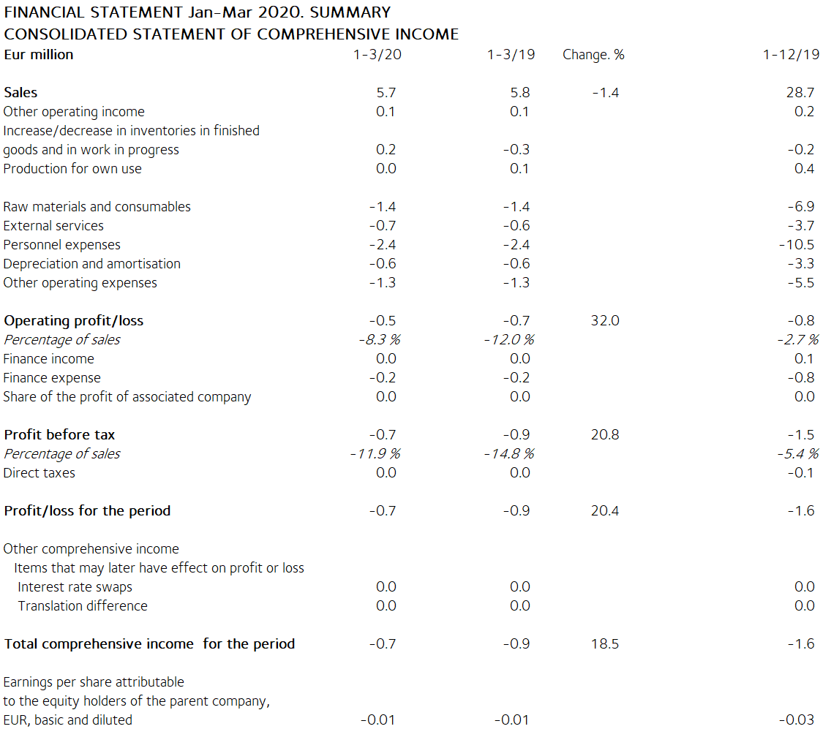

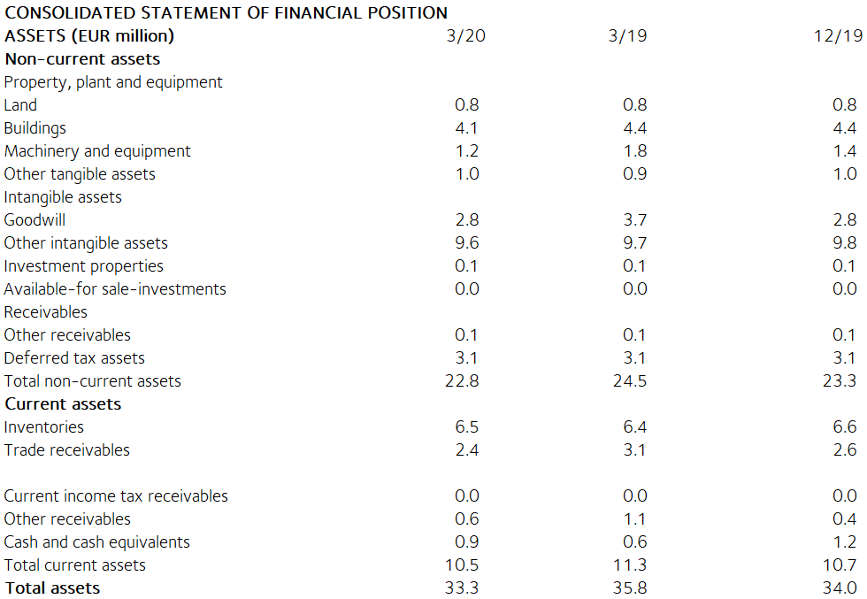

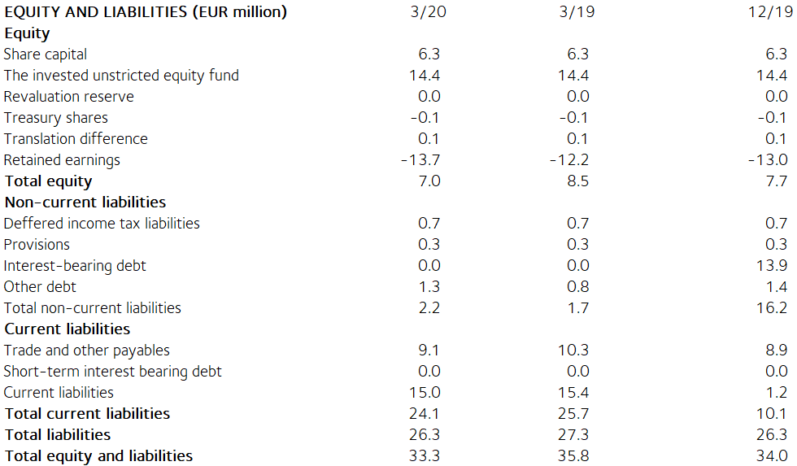

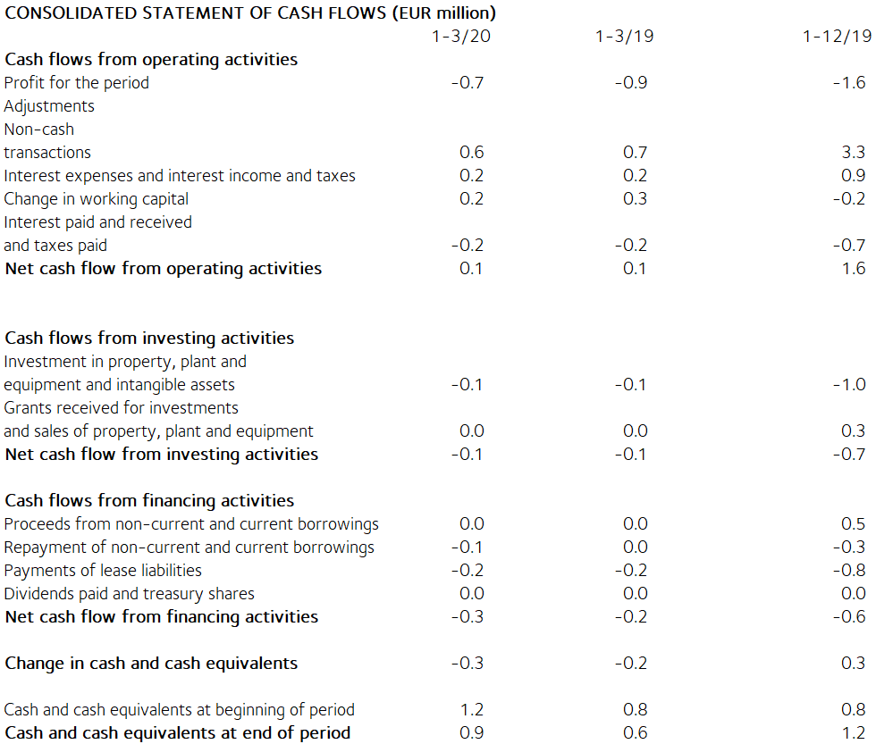

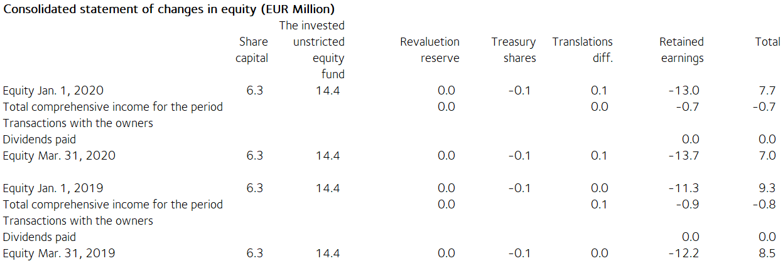

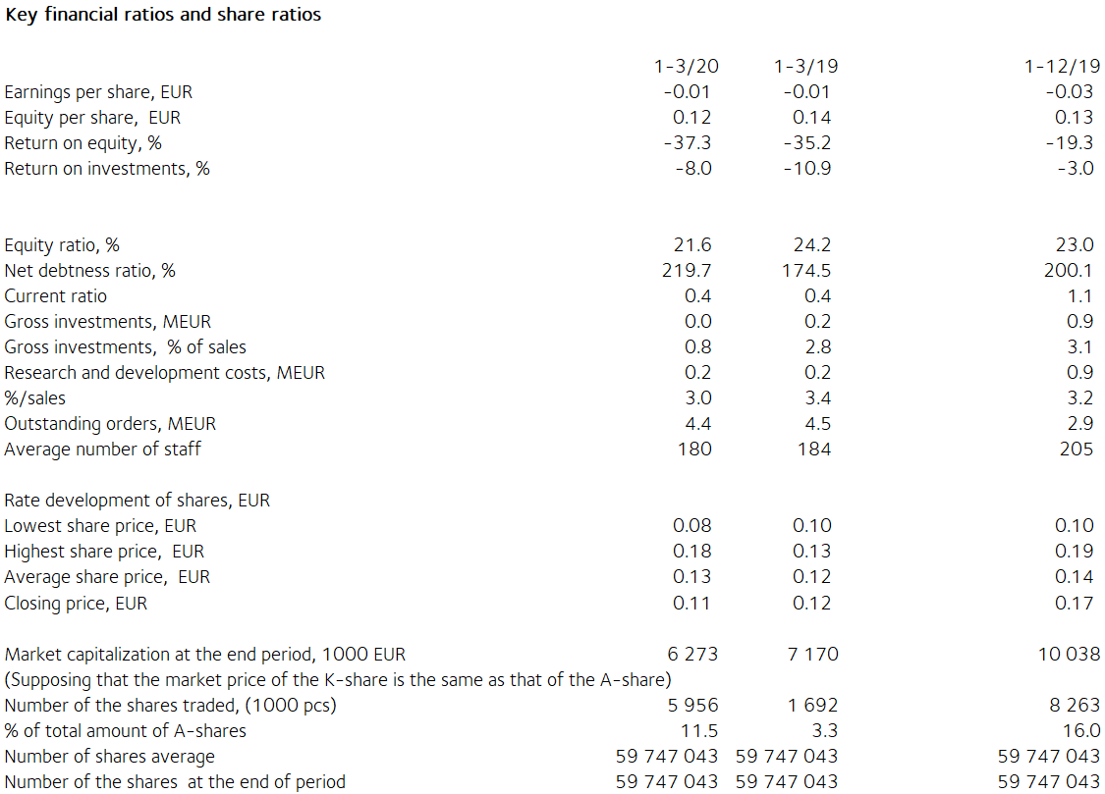

Notes to the financial statements

The information presented in the interim report is unaudited.

This interim report has been prepared in accordance with the standard IAS 34 Interim Financial Reporting. The company adopted the IFRS 16 Leases standard on 1 January 2019. Under the standard, a lessee will recognise assets and liabilities based on the right of use on its balance sheet. The company applied some of the recognition exemptions allowed by the standard, according to which short-term leases and leases where the underlying asset has a low value are not recognised on the balance sheet. The impact of IFRS 16 Leases on the opening balance sheet of 2019 was EUR 1.5 million, of which EUR 0.9 million were non-current and EUR 0.6 million were current liabilities. The balance sheet value of assets recognised under Buildings increased by EUR 1.4 million and that of assets under Machinery and Equipment by EUR 0.1 million. Leasing costs decreased by EUR 0.8 million and depreciation increased by EUR 0.7 million during the financial year 2019 due to the impact of IFRS 16, and hence IFRS 16 had no significant impact on profit or loss in 2019. The company chose the simplified approach in the transition to the standard, and thus the comparative figures for the previous year were not adjusted. The IFRS 16 lease liability in the balance sheet was EUR 1.5 million as at 31 December 2019 and EUR 1.4 million as at 31 March 2020. The weighted average discount rate for lease liabilities under IFRS 16 was 3.0%. Otherwise, Tulikivi has applied the same IFRS accounting principles in this interim report release as in its previous consolidated financial statements. The key figures presented in the financial statements release have been calculated using the same formulas as the latest financial statements for 2019. As there no longer were non-recurring expenses in this or the previous review period, no key figures based on non-recurring expenses are presented. The formulas are presented on page 88 of the Annual Report 2019.

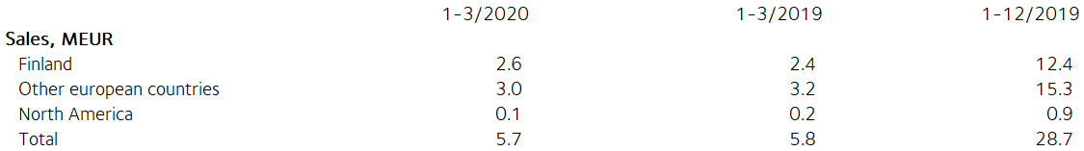

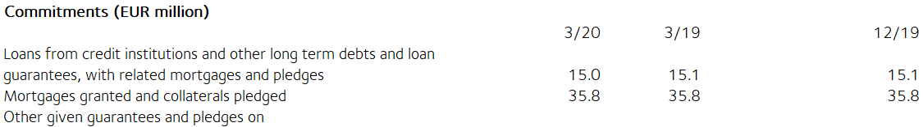

Available-for-sale financial assets are investments in unlisted shares. They are valued at acquisition cost because their fair value cannot be reliably determined.

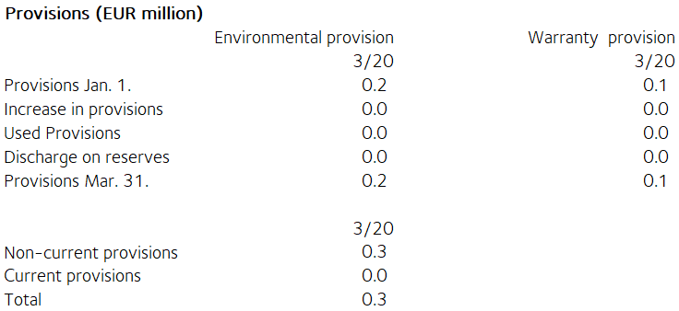

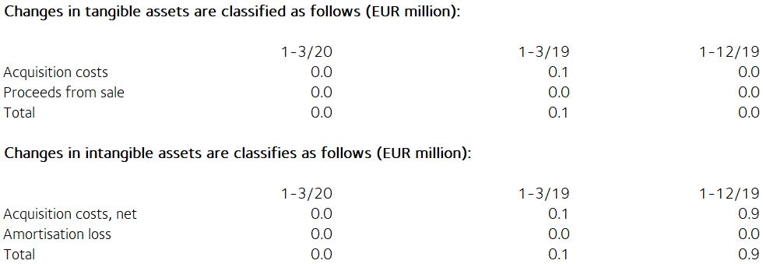

Share capital
Share capital by share series
Shares, Percentage, Percentage, Percentage,
number % % EUR
sha- votes share
res capital
Series K shares (10 votes) 7,682,500 12.8 59.5 810,255
Series A shares (1 vote) 52,188,743 87.2 40.5 5,504,220
Total, 31 March 2020 59,871,243 100.0 100.0 6,314,475

There have been no changes in Tulikivi Corporation’s share capital during the review period. According to the Articles of Association, the dividend paid on Series A shares must be EUR 0.0017 higher than the dividend paid on Series K shares. The A share is listed on the Nasdaq Helsinki. At the end of the review period, the company held 124,200 Series A shares.

Related party transactions
There were no transactions with related parties during the review period.

Management benefits (EUR 1,000)
1–3/20 1–3/19
Board members’ and Managing Director’s
salaries and other short-term
employee benefits 75 75

Principal shareholders on 31 March 2020

Name of shareholder Shares Percentage
of votes
- Heikki Vauhkonen 6,873,839 45.9%
- Elo Mutual Pension Insurance Company 4,545,454 3.5%
- Ilmarinen Mutual Pension Insurance Company 3,420,951 2.7%
- Eliisa Elo 3,108,536 5.7%
- Jouko Toivanen 2,531,259 2.7%
- Finnish Cultural Foundation 2,258,181 2.4%
- Susanna Mutanen 1,643,800 6.8%
- Fennia Mutual Insurance Company 1,515,151 1.2%
- Jarkko Nikkola 1,380,000 1.1%
- Mikko Vauhkonen 741,300 3.4%
Others 31,854,262 24.6%

The companies included in the Group are the parent company Tulikivi Corporation; Nordic Talc Oy; Tulikivi U.S., Inc., in the United States; and OOO Tulikivi in Russia. Group companies also include Tulikivi GmbH and The New Alberene Stone Company, Inc., which are dormant.

TULIKIVI CORPORATION

Board of Directors

Distribution: Nasdaq Helsinki

Key media

www.tulikivi.com

Further information: Heikki Vauhkonen, Managing Director, tel. +358 (0)207 636 555

