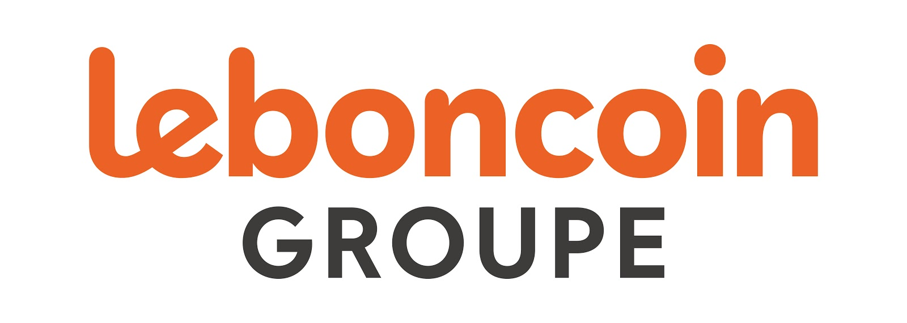

FOR IMMEDIATE RELEASE

Adevinta announces that leboncoin Group has reached an agreement to acquire Argus Group

Oslo, 9 September 2019: Adevinta announces it has reached an agreement to acquire the Argus Group, the leading player in digital marketing services to the automotive industry in France, to further strengthen leboncoin Group, France’s number one peer-to-peer website and leading online marketplace for cars, property and jobs. The transaction is expected to close by the end of October 2019.

Leboncoin Group continues to deepen its penetration of the automotive sector in France, building on from the recent acquisition of PayCar in June. With this acquisition, leboncoin will benefit from the Argus’ expertise and penetration of the professional market for second-hand car trade, particularly the Argus’ flagship product, a second-hand vehicle pricing tool which is the number one player in the French market. Leboncoin Group will also look at developing the Argus’ activities in line with its objectives and those of the wider Adevinta Group, notably by accelerating digitisation and refocusing international expansion within Adevinta’s footprint. In 2018, the Argus generated revenue of €39.1 million and operating earnings of €5.4 million (EBITDA).

“We have said we will engage in M&A activity to strengthen our positions in markets where we are already leading, and we are following through on that commitment,” said Rolv Erik Ryssdal, CEO of Adevinta. “We have also seen strong growth in our key sectors in cars, jobs and property, and acquiring the Argus Group enhances our strong position in the French car market segment.”

Founded in 1927 and headquartered in Paris, the Argus offers a range of products aimed at professionals in the automotive industry, including manufacturers, distributors, dealers, and auctioneers. Originally established as a trade publication more than 100 years ago, the group has successfully diversified and digitalised its services, to cover key aspects of the sector under five business segments: Argus Information, Argus Valuation, Argus Solution, Argus Acquisition and Argus Consulting. The group has created the number one market reference in valuing second-hand cars in France, through the Cote Argus® that has a 90% market share. The Argus employs approximately 270 employees in Paris, Nantes, Toulouse and Casablanca (Morocco).

Antoine Jouteau, CEO of leboncoin Group, commented, “leboncoin is the French second-hand car market leader with 9 out of 10 car professionals using us. This acquisition will help us further strengthen our position in the automotive market. The Argus’ offerings will complement our own solutions, especially their core pricing tool. Car professionals and their businesses will benefit greatly from our combined data knowledge, expertise and strength in the sector, and the improvements we’ll be able to offer across the entire value chain. The list of synergies to consider is almost endless, underlining the excellent fit of Argus’ core businesses with ours.”

"Argus is the leading player in second-hand car valuations and management software in France, while leboncoin is the undisputed leader of classified ads and data in France. The combination of the two brands is therefore complementary and innovative. We chose leboncoin as we share a similar vision for our businesses, to be ever more inventive in serving our customers better. This is also made possible thanks to the expertise of our employees,” said Alexandrine Breton des Loÿs, President of L’Argus Group.

The value of the transaction is undisclosed.

- End -

About leboncoin
The number one peer-to-peer website in France, leboncoin is the leading online marketplace for cars, property and jobs. It is used every month by 28 million unique visitors (Médiamétrie, March 2019). In a survey of French consumers, leboncoin was rated France’s 4th most useful company (IFOP 2017 ‘Terre de Sienne’ usefulness study), valued for the range of its offer and the ease of the transactions it facilitates every day. In a context of strong growth, leboncoin is committed to the well-being of its 900 employees, coming top five in France’s ‘Great Place To Work’ rankings. Today, leboncoin is a Group that encompasses the classified ad sites Agriaffaires (agricultural equipment), TrucksCorner (heavy trucks), MachineryZone (construction), A Vendre A Louer (property), Paycar (P2P payment for vehicles), Locasun (B2C holiday rental), and the second hand fashion website Videdressing, as well as a startup accelerator. Leboncoin Group is part of Adevinta, a marketplaces group listed on the Oslo Stock Exchange.

About Adevinta
Adevinta is a global online classifieds company with generalist, real estate, cars, jobs and other internet marketplaces in 16 countries, connecting buyers seeking goods or services with a large base of sellers. Its portfolio spans 36 digital products and websites, attracting 1.5 billion average monthly visits. Leading brands include top-ranked leboncoin in France, InfoJobs and Milanuncios in Spain, and 50% of fast-growing OLX in Brazil.

About L’Argus
Founded in 1927, Argus is a family and independent company and has been a privileged partner of the car business professionals, and is permeated by a culture of continuous evolution and innovation. Our growth and diversification strategy has enabled us to develop a rich and varied product portfolio, intended for professionals, including car manufacturers, distributors, dealers, auction houses, etc. This range of unique services combines performance and simplicity, and is 100% dedicated to greater commercial and financial efficiency. Today we offer a range of services structured around five strategic directions: Argus Information, Argus Valuation, Argus Solution, Argus Acquisition and Argus Consulting. Because the world is changing and mutations are accelerating, we must support our clients in these major evolutions and assist them in achieving their own digital transformation. Today's Argus has 250 involved and committed employees based in Paris, Nantes and Casablanca (Morocco).

Media contacts:

Adevinta
Mélodie Laroche
Corporate Communications
T: +33 (0) 6 84 30 52 76
melodie.laroche@adevinta.com

Jo Christian Steigedal
Investor Relations
ir@adevinta.com

Leboncoin Group
Anne Quemin
Head of Brand and Communication
anne.quemin@adevinta.com
Caroline Grangié
Media Manager
caroline.grangie@adevinta.com

