Very strong growth in revenue in the first quarter of 2022 of +16.2% at comparable exchange rates (+19.3% at real rates), driven by good performance in all areas

Public release on April 14, 2022 after market close

KEY FIGURES
Revenue  1st quarter 2022  €318.0 million | Growth at constant exchange rates and scope ¹  +16.2% including  companion animals +19.5%  food-producing animals +13.3% | Growth at constant  exchange rates  +16.2% | Overall change  +19.3%

¹ Growth at constant exchange rates and scope corresponds to organic growth of sales, excluding exchange rate variations, by calculating the indicator for the financial year in question and the indicator for the previous financial year on the basis of identical exchange rates (the exchange rate used is the previous financial year), and excluding change in scope, by calculating the indicator for the financial year in question on the basis of the scope of consolidation for the previous financial year.

Quarterly consolidated revenue
Our first-quarter revenue reached €318.0 million, or a 19.3% increase with respect to the same period in 2021. At constant exchange rates, growth was +16.2%, driven by very good performance in the companion animal segment. This growth benefited in part from a favorable baseline effect representing 2 points of growth in revenue, attributable to new products acquired starting in the second quarter of 2021. This growth was also supported in some countries by increases in distributor inventories. It should be noted that our actual performance was favorably impacted by the appreciation of certain currencies, in particular the US dollar, the Indian rupee, and the Brazilian real.

Our growth in the first quarter was driven mainly by the performance of Asia-Pacific, Europe and Latin America. In Asia-Pacific, the real-rates growth was +25.9% (+22.5% at constant exchange rates). Australia and India were the main drivers of this growth in the area, generating nearly 80% of it, offsetting the decline in China, impacted by Covid-19 and a very challenging baseline effect compared to the first quarter of 2021. In Europe, revenue grew by 11.2% at real rates (+10.4% at constant rates). The main contributors to this performance were France, Italy, the United Kingdom, the Export and OTC areas activities, and Germany, driven by strong momentum in the companion animal ranges (in particular petfood, specialty products, and vaccines), which offset the decline in ranges for food-producing animals. In Latin America, excluding Chile, the Group had an excellent start of the year. Revenue grew by 35.6% at real rates (+27,2 % at constant exchange rates), due to double-digit growth in all subsidiaries, particularly thanks to strong contributions of Brazil and Mexico. Chile posted growth of 9.5% at real rates (+6.0% at constant exchange rates), driven by sales in the companion animal and salmon ranges. Lastly, in the United States, first-quarter revenue increased by 26.2% (+17.5% at constant exchange rates). It benefited from strong sales of new products launched in 2021, as well as external parasiticides.

In terms of species, revenue in the companion animal segment grew overall by 22.3% at real rates (+19.5% at constant exchange rates), mainly driven by very good double-digit growth in the petfood, specialty, dermatology and hygiene ranges, as well as vaccines for dogs and cats. The food-producing animals segment also showed strong growth of 16.9% at real rates (+13.3% at constant exchange rates), mainly driven by the ruminant sector (+17.1% at constant exchange rates); and the aquaculture segment (+6.9% at constant rates) compared to the same period in 2021.

Outlook
Based on first-quarter performance, while also taking into account the uncertainties of the coming months as well as the market’s expected return to normal, we are expanding our revenue growth outlook at constant rates and scope to a range of between 5% and 10%. The ratio of “current operating profit before depreciation of assets arising from acquisitions” to “revenue” should be around 15% at constant exchange rates (with a deliberate overinvestment in R&D of approximately 1 percentage point of revenue compared to 2021). Furthermore, debt relief should be around €60 million, excluding dividends, at constant scope and exchange rates.

Covid-19 health crisis and the war in Ukraine
We continue to face significant production, logistical and supply constraints with regard to certain intermediaries, and more recently, the impact of inflation on our costs (energy, raw materials, etc.).

A lifelong commitment to animal health
At Virbac, we make innovative solutions available to veterinarians, farmers and animal owners in more than 100 countries around the world. Covering more than 50 species, our range of products and services can diagnose, prevent and treat the majority of pathologies. Every day, we are committed to improving the quality of life of animals and to shaping the future of animal health together.

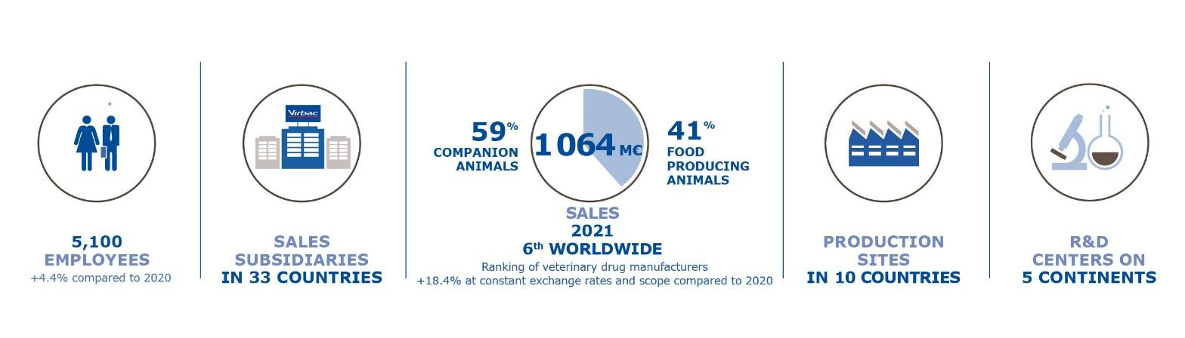

Virbac: NYSE Euronext - compartment A – ISIN code: FR0000031577 / MNEMO: VIRP
Financial Affairs Department: tel. 04 92 08 71 32 - email: finances@virbac.com - Website: corporate.virbac.com

