Press release
Regulated information

28 December 2018
Embargoed until 5.40 pm

Ascencio acquires 9 retail buildings, in France,
in the Retail Park “Le Parc des Drapeaux” in Caen
for an amount of 10 million euros

Ascencio made this acquisition on December 27th, in two stages :

- Ascencio has signed for the acquisition of 6 retail areas developing 1.950 m² GLA.
- Ascencio has signed a promise to purchase for 3 additional retail areas, developing 2.400 m² GLA.

This investment fits Ascencio’s strategy of investing in retail parks located in its target countries and working towards their control in order to determine the commercial mix and to offer a greater flexibility to its tenants.

This acquisition enables Ascencio to strengthens its control of the Retail Park, which rises from 60% to more than 70% of the retail areas, and to welcome new great retailers known as Marie Blachère, Celio, Jennyfer, Krys, Promod, Vertbaudet, Tape à l’oeil, Armand Thiery and Besson Chaussures.

This transaction will generate for Ascencio a gross annual indexed income of almost 558.000 euros.

The « Parc des Drapeaux », adjacent to the food store Cora, west of Caen (Rots), has an occupancy rate of 100% and knows since its opening in 2011 a great commercial success and the sustained interest of many retailers.

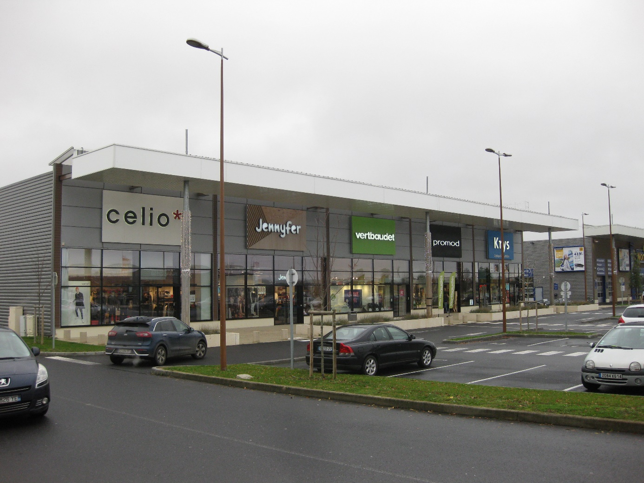

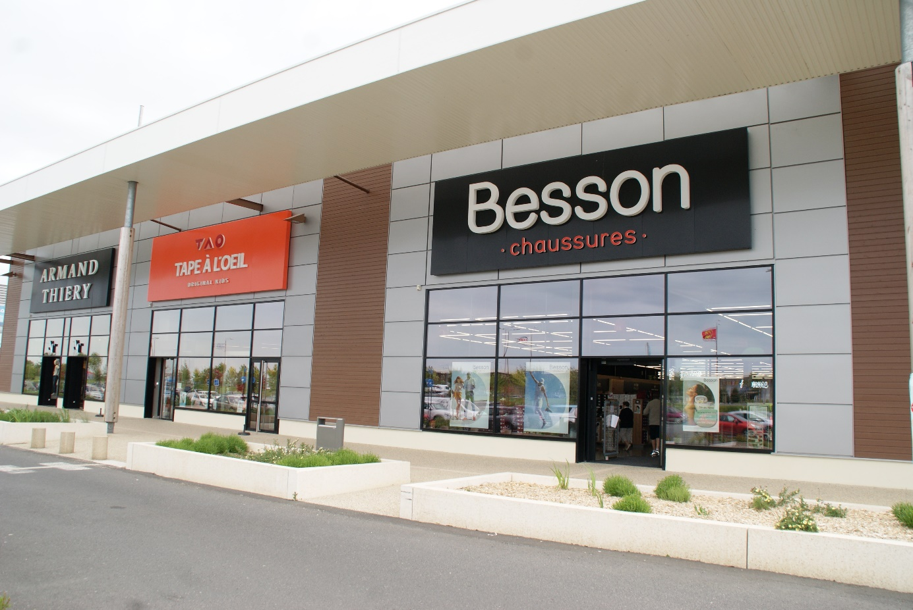

For additional information:

Stéphanie Vanden Broecke  Secretary General and General Counsel  Tel. +32 (0) 71.91.95.00  stephanie.vandenbroecke@ascencio.be | Vincent H. Querton  Chief Executive Officer  Tel. +32 (0) 71.91.95.00  vincent.querton@ascencio.be

Michèle Delvaux
Chief Financial Officer
Tel. +32 (0) 71.91.95.00
michele.delvaux@ascencio.be

Ascencio is a Regulated Real Estate Company (public SIR) operating in Belgium, France and Spain, which specialises in investment in commercial premises, located primarily on the outskirts of towns and cities.
It works with around ten business sectors, predominantly in the food industry.
Listed on Euronext Brussels since 2007, Ascencio pursues a coherent policy aimed at optimising its results over time and ensuring stable profits for all its shareholders.

