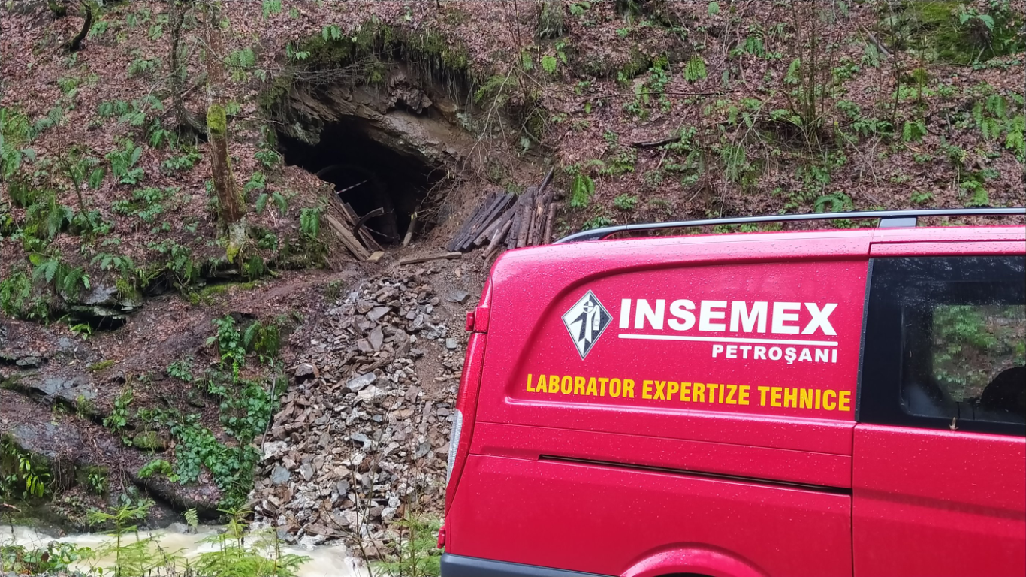
Figure 2: INSEMEX inspection team at reopened Gallery 7.

