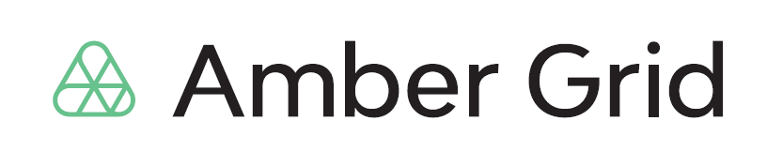

PRESS RELEASE
11/04/2023

Decision to assign European Energy Exchange as GET Baltic’s strategic partner was approved
Amber Grid’s General Meeting of Shareholders held on Tuesday approved the signing of agreements with GET Baltic’s strategic partner and the sale of 66% of the shares to the winner of the public tender – European Energy Exchange. The transaction with European Energy Exchange will be finalised in May-June, following the signing of the necessary contracts and other formal closing steps.
The aim of the selection of the strategic partner is to increase the choice and quality of services and products offered by GET Baltic to the region, following the integration of the Baltic and Finnish gas markets into the single European Union market last year. More intense trade and a larger number of market participants is expected to result in increased competition and lower gas prices.
After completing the transaction, it is planned to offer gas market participants a unified gas trading platform together with the strategic partner GET Baltic, which will expand trading opportunities and cover both short-term and long-term products and clearing services in line with the best market practice. This need was confirmed by expectations identified in the course of the Exchange’s customer surveys to upgrade the trading system, introduce improved functionalities and offer new trading opportunities.
The strategic partner met all the qualification requirements and offered the highest price for GET Baltic shares. The remaining 34% of the shares can be optioned to the same investor at a later stage, subject to the discharge of contractual obligations to secure benefits for the Baltic and Finnish markets.
Amber Grid’s selection of a strategic partner was open to companies with at least 3 years of experience in organising gas trading for short- and long-term gas products in the European Union and operating in a more advanced gas market. The tender was organised in several stages. Last year, applications were received from candidates, then holding consultations on material terms and conditions of the transaction with the selected tenderers, submission and evaluation of the final tenders.
GET Baltic is a licensed natural gas market operator with the status of a Registered Reporting Entity (RRM) granted by ACER. The company administers an electronic trading system for the trading of short- and long-term natural gas products with physical delivery at trading sites located in Lithuania and at common trading sites in Latvia, Estonia and Finland. The development of tailor-made solutions for natural gas trading aims to increase liquidity, competitiveness and transparency in the Baltic and Finnish wholesale gas market. Amber Grid is the sole shareholder of GET Baltic.

For more information:
Laura Šebekienė
Head of Communications at Amber Grid
Tel. +370 699 61246,
Email: l.sebekiene@ambergrid.lt

