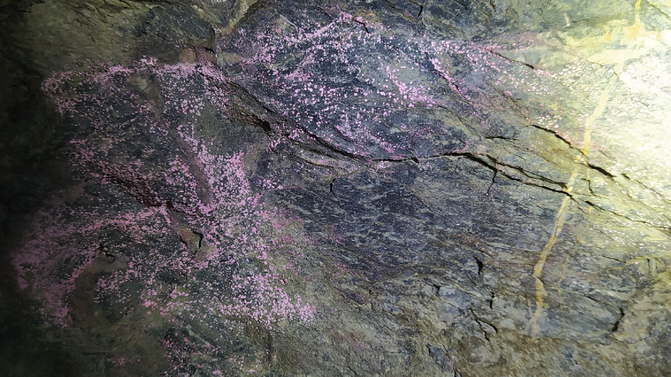
Figure 5: Powdery, pinkish cobalt oxide mineral on foliation in graphitic schist. Individual Co-oxide mineral grains are about 1 mm across.

