Nasdaq OMX
Nikolaj Plads 6
P.O. Box 1040
1007 Copenhagen K

28th September 2023

Company announcement No. 9/2023

Adjustment of expectations for the financial year 2022/23
The business development in the company’s Industrial and Building & Construction activities has in the last months of the financial year 2022/23 developed somewhat better than earlier expected.
The demand in the Building & Construction sector has after the summer holiday remained at a high level, even higher than budget, which was not anticipated.
Similarly, the Industrial sector has maintained a reasonable level which has contributed to supporting the increased earnings.
Based on the positive results in the recent months, an EBIT result for the financial year 2022/23 in the range of DKK 16.5 – 17.0 million is now expected, compared to an earlier expected EBIT result of DKK 14.5 – 16.5 million.

Yours sincerely RIAS A/S
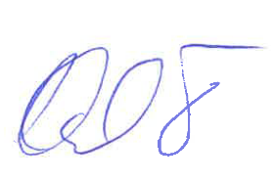
Karsten Due

