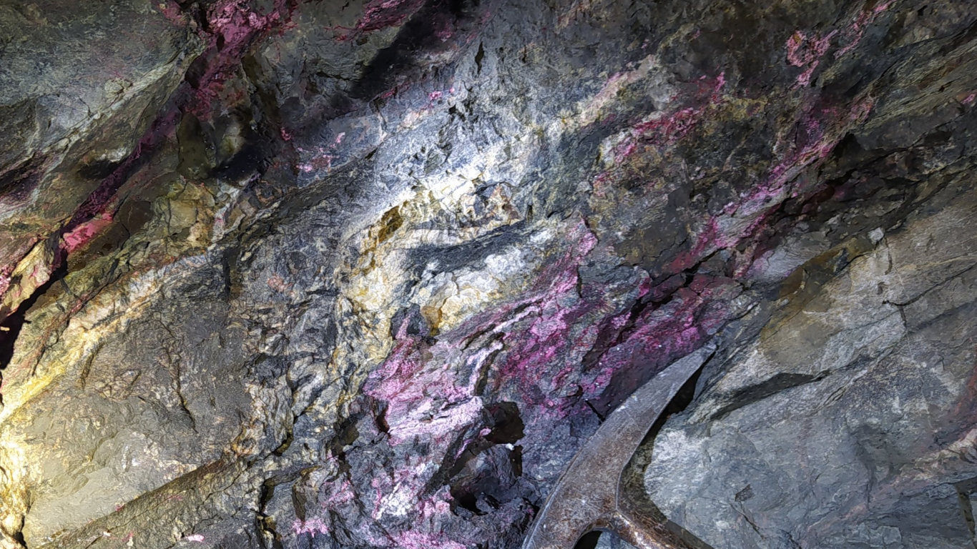
Figure 6: Pinkish cobalt oxide mineral weathering from schists. Hammer for scale.

