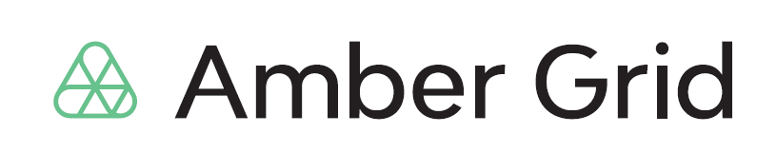

PRESS RELEASE
28 01 2022

With the connecting to the EU gas market, a search for a strategic partner of the gas exchange GET Baltic will be held

Lithuanian gas transmission system operator Amber Grid aiming to benefit on the synergies of the common EU gas market and to enable to offer the most advanced gas trading solutions to customers of the regional gas exchange GET Baltic plans to announce a selection of a strategic partner of the exchange. This week, the planned sale of a part of GET Baltic shares to a selected strategic partner was also approved by the Boards of Amber Grid and its holding company EPSO-G.

“After Lithuania, other Baltic countries and Finland will soon this year be connected to Poland and the pan-European gas market via GIPL interconnection, greater opportunities for cross-border gas trade will be opened up. Attracting a strategic partner will ensure for gas market participants access to the latest technological solutions – trading and clearing systems. This future partnership also aims to ensure competitive exchange fees, faster liquidity growth and attractive trading conditions. This way, we will meet expectations of the Baltic and Finnish gas market participants to receive top-notch services,” says Nemunas Biknius, CEO of Amber Grid.

Together with an experienced strategic partner operating in more advanced EU gas markets, GET Baltic is expected to offer gas market participants a modern, advanced solutions-based gas trading platform that includes both short-term and long-term products and clearing services in line with the best market practices. This need is also confirmed by expectations identified during the survey of the exchange clients to update the trading system, to implement improved functionalities and to offer new trading opportunities.

“Our aim is to strengthen and create a mature regional gas exchange. A strategic partner will attract global players to the gas market, which will benefit market participants, customers of the exchange and increase competition in the gas market, thus creating benefits through growing gas flows, higher revenues from the use of the gas transmission network and through price convergence,” says N. Biknius.

A public international tender will be held to select the most suitable strategic partner. Its documents will be published on 1 February 2022. The tender will be held in several stages: selection of participants, consultations on the key terms of the transaction with the selected participants, and submission and evaluation of tenders. It is planned that a strategic partner will be selected this year.

Companies with at least 3 years of experience in organizing gas trade in short-term and long-term gas products in the European Union and operating in more advanced gas market will be able to participate in the selection of a strategic partner. The participant who meets the qualification requirements and offers the highest price for GET Baltic shares will be able to acquire a stake of 66% in GET Baltic. The remaining part of the shares accounting for 34% would subsequently be sold as an option to the same investor, once it discharges the obligations under the sale-purchase agreement related to ensuring benefits for the regional market.

Amber Grid subsidiary gas exchange GET Baltic is a licensed natural gas market operator having the status of a registered reporting mechanism (RRM) granted by ACER. The company administers an electronic trading system for trading short-term and long-term natural gas products with physical delivery, in the market areas located in Lithuania, Latvia, Estonia and Finland. By developing solutions adapted for natural gas trading is intended to increase the liquidity, competitiveness, and transparency of the Baltic and Finnish wholesale gas markets.

During the past two years of GET Baltic operation, the company managed to achieve extremely good results: expanded its operations geographically by entering the Latvian, Estonian and Finnish gas markets, created conditions for price convergence in the region and offered services that meet the needs of market participants.

At the beginning of 2020, after Estonia and Finland were connected to the new Balticconnector gas pipeline, GET Baltic also started operating in the Finnish market, thus ensuring uninterrupted gas trading in the region and significantly increasing the number of exchange participants and transactions. Due to new customers and higher trading volumes, GET Baltic's turnover has almost tripled in two years, and about 12% of the total volume of gas consumed in the Baltic and Finnish markets was purchased on the exchange.

Listening to the needs of wholesale gas market participants, constantly improving and purposefully developing activities in the region allowed to achieve the trading turnover of 8 TWh of natural gas in 2021, which was the highest since the launch of the exchange.

For more information:
Laura Šebekienė
Head of Communications at Amber Grid
Tel. +370 699 61246
E-mail: l.sebekiene@ambergrid.lt

