NEWS RELEASE – LSE & TSX: EDV

ENDEAVOUR INCREASES INDICATED RESOURCES AT ITS TANDA-IGUELA GREENFIELD PROPERTY BY 303% TO 4.5MOZ
Indicated resource of 4.5Moz at 1.97 g/t · $11/oz discovery cost · PFS targeted by late 2024
HIGHLIGHTS:

- The Tanda-Iguela property in Côte d’Ivoire continues to be Endeavour’s largest exploration focus as over 226km of drilling has been completed on the property since late 2021, with 168km completed in YTD 2023
- Tanda-Iguela now ranks as one of the most significant discoveries made in West Africa over the last decade
  - 96% of the Assafou deposit has been converted to Indicated status while the overall endowment has significantly increased over the 2022 maiden resource based on this year’s drilling campaign
  - Assafou now hosts an Indicated resource of 4.5Moz at 1.97 g/t Au and an Inferred resource of 0.2Moz at 1.91 g/t Au, compared to the 2022 maiden Indicated resource of 1.1Moz at 2.33 g/t Au and Inferred resource of 1.9Moz at 1.80 g/t Au
  - Significant upside potential as the 3.3km Assafou mineralised trend is open along strike and at depth
  - Assafou is amenable to conventional open pit mining as mineralisation starts at surface
  - Preliminary metallurgical testwork indicates overall average gold recoveries of over 94%
  - Located in proximity to good infrastructure with paved highway and high voltage grid power nearby
- Low Indicated resource discovery cost of $11/oz, with a cumulative $50m spent on exploring the property
- Further exploration is underway at the Assafou deposit and at seven satellite targets identified within 5km of the Assafou deposit
- A Preliminary Feasibility Study is expected to be completed in late 2024
Abidjan, 29 November 2023 – Endeavour Mining plc (LSE:EDV, TSX:EDV, OTCQX:EDVMF) (“Endeavour”, the “Group” or the “Company”) is pleased to announce that the extensive 2023 drill programme at its Tanda-Iguela greenfield property in Côte d’Ivoire has resulted in the delineation of a 4.5Moz Indicated resource, grading 1.97 g/t Au, which marks a 303% increase over the maiden Indicated resource estimate published in late 2022, thereby confirming its potential to be a Tier 1 asset.
As shown in Table 1 below, drilling has resulted in an overall increase in the Assafou deposit’s endowment with 96% of the resource now classified in the Indicated category. The previous maiden resource was published in November 2022, based on 58,000 metres of drilling, while the updated November 2023 resource is based on 183,000 metres of drilling with further drilling yet to be incorporated. The Assafou deposit now spans 3.3 kilometres in length and remains open along strike and at depth, with further drilling planned to delineate along strike extensions in 2024. In addition, the 2023 drill programme confirmed mineralisation at seven targets located within 5 kilometres of the Assafou deposit, where further drilling is planned for 2024.
Table 1: Assafou Mineral Resource Estimate Evolution
 | AS AT 31 OCTOBER, 2022 |  |  |  | AS AT 14 NOVEMBER, 2023 |  |  | Δ  AU CONTENT
On a 100% basis | Tonnage | Grade | Content |  | Tonnage | Grade | Content
 | (Mt) | (Au g/t) | (Au koz) |  | (Mt) | (Au g/t) | (Au koz)
Indicated Resources | 14.9 | 2.33 | 1,114 |  | 70.9 | 1.97 | 4,493 | +303%
Inferred Resources | 32.9 | 1.80 | 1,903 |  | 2.9 | 1.91 | 176 | (91)%
Mineral Resource Estimate current as at 14 November 2023. No Measured resources have been estimated. Mineral Resources estimates follow the Canadian Institute of Mining, Metallurgy and Petroleum ("CIM") definitions standards for mineral resources and have been completed in accordance with the Standards of Disclosure for Mineral Projects as defined by National Instrument 43-101. Reported tonnage and grade figures have been rounded from raw estimates to reflect the relative accuracy of the estimate. Minor variations may occur during the addition of rounded numbers. Mineral Resources that are not Mineral Reserves do not have demonstrated economic viability. Resources were constrained by $1,500/oz gold price MII Pit Shell and based on a cut-off of 0.5 g/t Au.

Sébastien de Montessus, President and CEO, commented: “We are thrilled with the success achieved at our Tanda-Iguela greenfield property in Côte d’Ivoire as it demonstrates its Tier 1 asset potential. Given that we have delineated a 4.5Moz Indicated resource at 2 g/t Au for the Assafou deposit, it already ranks as one of the most significant discoveries made in West Africa over the last decade.
We are pleased to have achieved this success within a remarkably short period of time, with more than 226,000 meters drilled on the property in just two years. Coupled with our low discovery cost of $11/oz, it demonstrates our ability to quickly unlock significant exploration value and self-generate a high-quality project pipeline.
We look forward to completing a preliminary feasibility study next year, while we continue to focus on expanding the size of the resource and delineating additional satellite targets located within close proximity to Assafou.”

TANDA-IGUELA EXPLORATION PROGRAMME
The 100% owned Tanda-Iguela permits are located in the east of Côte d’Ivoire, adjacent to the Ghana border, as shown in Figure 1 below. The northern permit, Tanda, was introduced into Endeavour’s portfolio in late 2015 following Endeavour’s transaction with La Mancha. Endeavour conducted an initial drill campaign in early 2016 that yielded positive results and quickly identified the southern permit, Iguela, as having a high degree of geological prospectivity. The Iguela permit was awarded to Endeavour in May 2017, through the permitting application process.
Figure 1: Tanda-Iguela Map
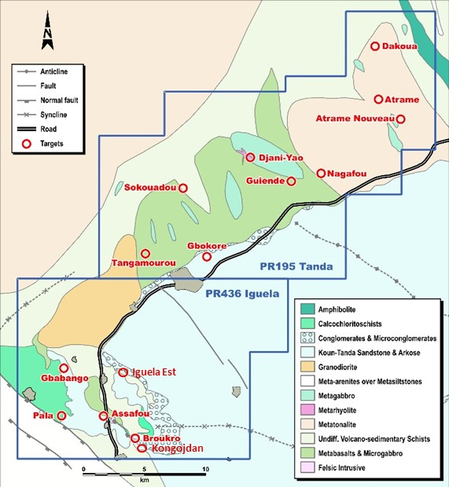
During 2018 and 2019, an initial geochemical campaign, comprised of 3,436 samples, was conducted over the Iguela permit. This campaign, coupled with considerable fieldwork and mapping, outlined a series of significant exploration targets, with the most attractive anomalies being located along the structural contact, extending over more than 15 kilometres, separating the Birimian Basement from the Tarkwaian Sandstones.
Positive initial assay results from the Assafou target preceded a focussed 58,000 metre drilling campaign, which successfully delineated a maiden resource comprised of Indicated resources of 1.1Moz at 2.33 g/t Au and Inferred resources of 1.9Moz at 1.80 g/t Au, that was published in November 2022.
Given the size and grade of the maiden resource and the prospectivity along strike and at depth, Endeavour launched an initial 70,000 metre drill programme at Tanda-Iguela in 2023, that was subsequently increased to 180,000 metres following successful results obtained early in the year. The 2023 drill programme was focused on infill drilling the existing Inferred resources to convert resources to Indicated status, extending the mineralised system at the Assafou deposit to add additional resources, and identifying potential satellite deposits within 5 kilometres of the Assafou deposit.
ASSAFOU DEPOSIT
The November 2023 updated mineral resource estimate for the Assafou deposit is comprised of an Indicated resource of 4.5Moz at 1.97 g/t Au and an Inferred resource of 0.2Moz at 1.91 g/t Au. The updated resource estimate, which is based on a cut-off grade of 0.5 g/t Au and a $1,500/oz gold price, is very robust due to its relative high-grade and thick, continuous mineralisation, as demonstrated with the sensitivity analysis performed at various gold prices, presented in Table 2 below.
Table 2: Assafou Mineral Resource Estimate Sensitivity
 | TONNAGE | GRADE | CONTENT
 | (Mt) | (Au g/t) | (Au koz)
INDICATED RESOURCE
Based on a gold price of $1,300/oz | 62.9 | 2.03 | 4,103
Based on a gold price of $1,500/oz | 70.9 | 1.97 | 4,493
Based on a gold price of $1,700/oz | 72.7 | 1.95 | 4,560
Based on a gold price of $1,900/oz | 73.5 | 1.95 | 4,607
Based on a gold price of $2,000/oz | 74.1 | 1.94 | 4,620
INFERRED RESOURCE
Based on a gold price of $1,300/oz | 2.3 | 1.74 | 129
Based on a gold price of $1,500/oz | 2.9 | 1.91 | 176
Based on a gold price of $1,700/oz | 3.2 | 1.98 | 203
Based on a gold price of $1,900/oz | 3.3 | 1.98 | 208
Based on a gold price of $2,000/oz | 3.4 | 2.01 | 220
Mineral Resource Estimate current as at 14 November 2023. No Measured resources have been estimated. Mineral Resources estimates follow the Canadian Institute of Mining, Metallurgy and Petroleum ("CIM") definitions standards for mineral resources and have been completed in accordance with the Standards of Disclosure for Mineral Projects as defined by National Instrument 43-101. Reported tonnage and grade figures have been rounded from raw estimates to reflect the relative accuracy of the estimate. Minor variations may occur during the addition of rounded numbers. Mineral Resources that are not Mineral Reserves do not have demonstrated economic viability. Resources are reported undiluted and were constrained by MII $1,500/oz Pit Shell and for sensitivity purpose by approximate MII at $1,300/oz, $1,700/oz and $1,900/oz and $2,000 pit shells and based on a cut-off of 0.5 g/t Au.
For technical notes and drilling results from the Assafou drill programme, please see the Technical Notes section and Appendix A below.
Mineralisation at the Assafou deposit is both disseminated and hosted in quartz veins within the Tarkwaian Sandstones. The deposit appears to be monometallic containing no potentially penalising elements associated with the gold. Mineralisation starts at surface extending down to over 300 metres depth, and is continuous along strike, along the prominent northwest trending structure that separates the Tarkwaian Sandstones from the mafic Birimian Basement rocks. The deposit comprises a thick main (up to 60 metres) continuous lens, appearing to be dipping at a low angle to the southwest, overlaid by a series of stacked lenses.
As shown in Figure 2 below, drilling has significantly increased the length of the mineralised trend from 2.2 kilometres in the November 2022 maiden resource to 3.3 kilometres in the updated November 2023 resource. Furthermore, the length of the Indicated resource envelope has increased from 0.6 kilometres to 3.0 kilometres.
High grade mineralisation and the thickest mineralised intercepts are located along the structural contact between the mafic Birimian Basement rocks and the Tarkwaian Sandstones. Infill drilling during 2023 has identified shallow mineralisation in the southeast, northwest and southwest of the deposit where shallow mineralisation had not been previously identified. The 2023 drill programme also identified deep mineralisation below 250 metres depth, below the maiden November 2022 resource pit shell.
Mineralisation at Assafou remains open along strike towards the northwest and towards the southeast, as well as at depth, where deep drilling below 250 metres has been limited. For 2024, a 60,000 metre drill progamme has been planned with 25,000 metres planned to further expand the Assafou resource and 35,000 metres planned to delineate potential satellite targets located in close proximity to Assafou.
Figure 2: Assafou Deposit Drill Programme
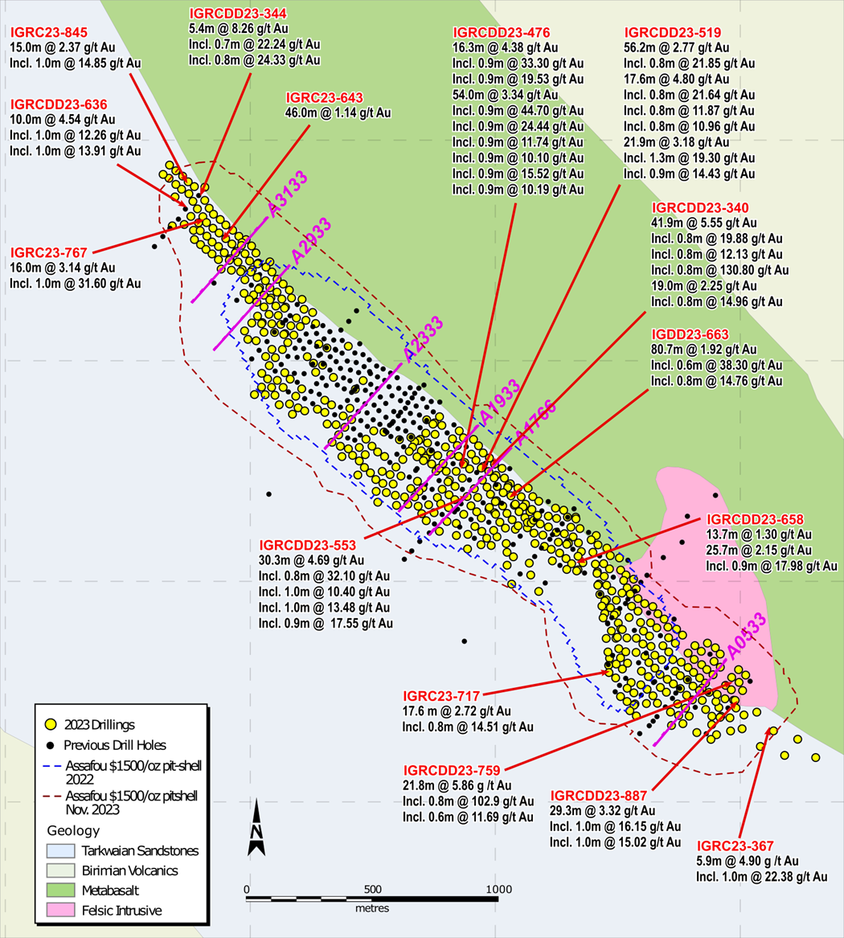

Cross Section 3133: Resources extended to the northwest outside of the November 2022 resource pit shell
As shown in Figure 3 below, further drilling confirmed the extension of the resource by approximately 400 metres to the northwest along the structural contact between the Tarkwaian Sandstones and the Birimian Basement. Furthermore, drillholes IGRCDD23-676 and IGRCDD23-342 drilled to over 300 metres depth have identified additional lenses of mineralisation, including 28.7 metres at 1.98 g/t Au, highlighting that mineralisation extends below the November 2023 resource pit shell.

Figure 3: Assafou Cross Section 3133
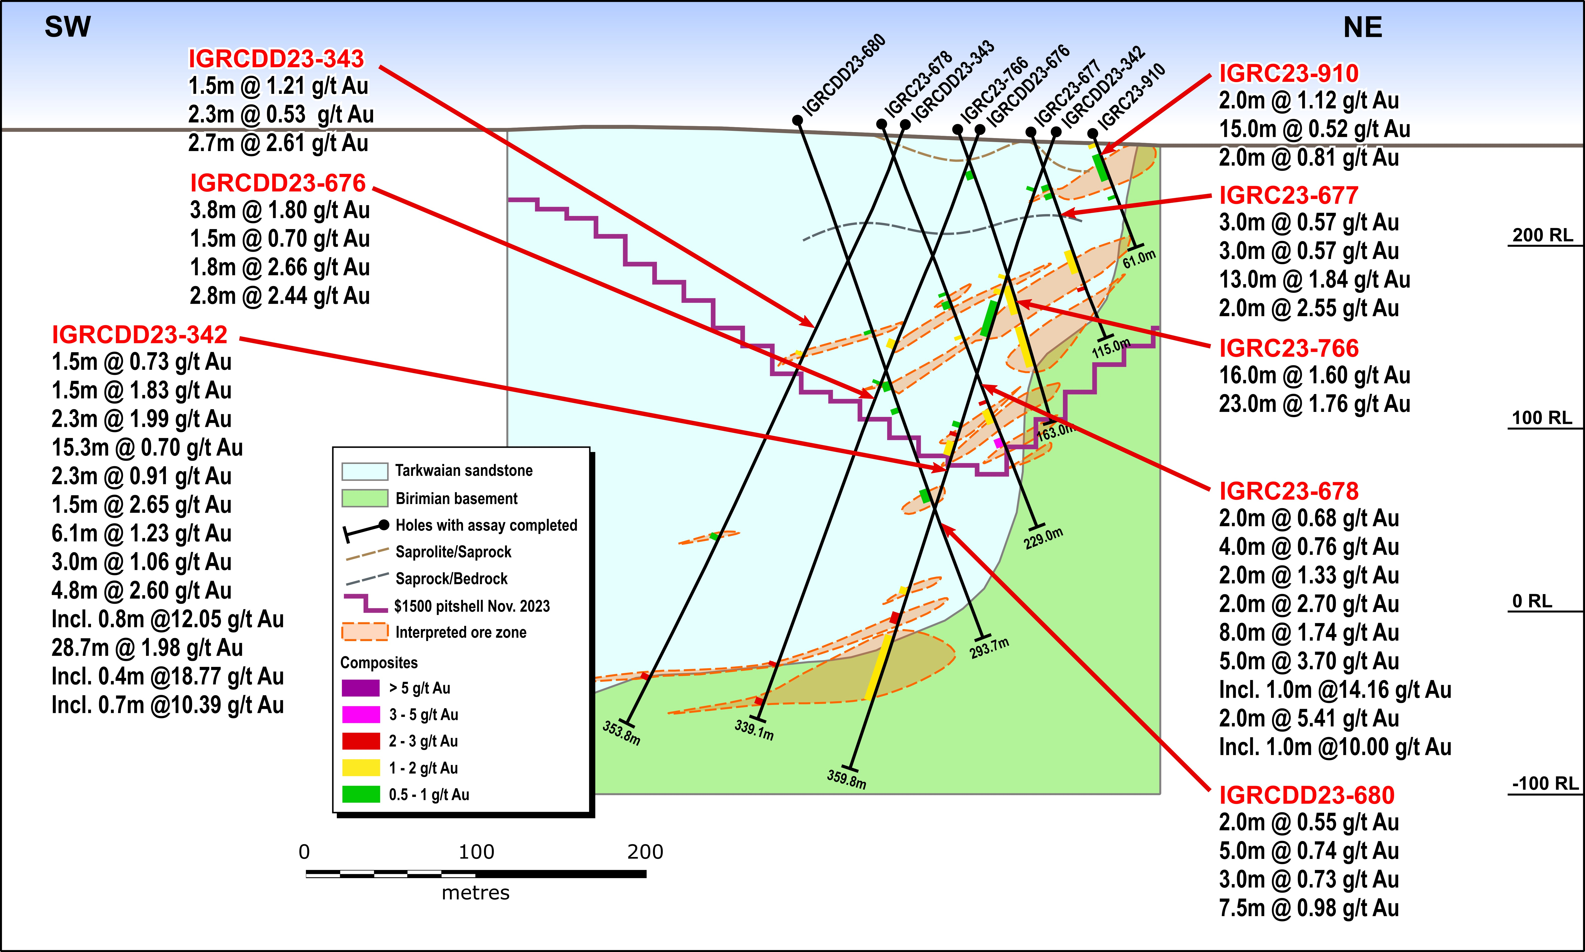
Cross Section 2933: Infill drilling in the northwest of Assafou extended resources at depth
As shown in Figure 4 below, drilling confirmed continuity of the mineralisation toward the northwest, beyond and underneath the November 2022 resource pitshell. In addition, further drilling highlighted the presence of deeper mineralised lenses below the November 2023 pitshell, suggesting that there is potential to further extend resources at depth.
Figure 4: Assafou Cross Section 2933
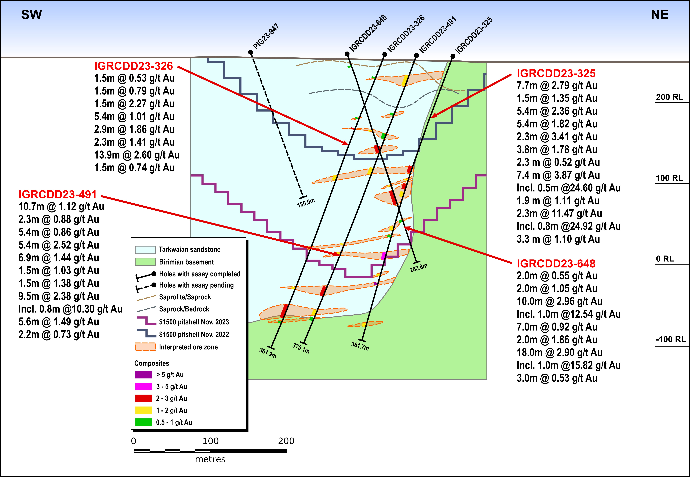

Cross Section 2333: Infill drilling identified shallow mineralisation in the southwest of the deposit
As shown in Figure 5 below, drilling conducted in 2023 within the November 2022 resource pit shell (in drillholes IGRC23-1157, IGRC23-1156, IGRC23-1151 and IGRCDD23-990) identified several shallow mineralised lenses starting at surface at the southwest, over 300 metres away from the structural contact with the Birimian Basement, in an area that was previously largely unexplored.
Figure 5: Assafou Cross Section 2333
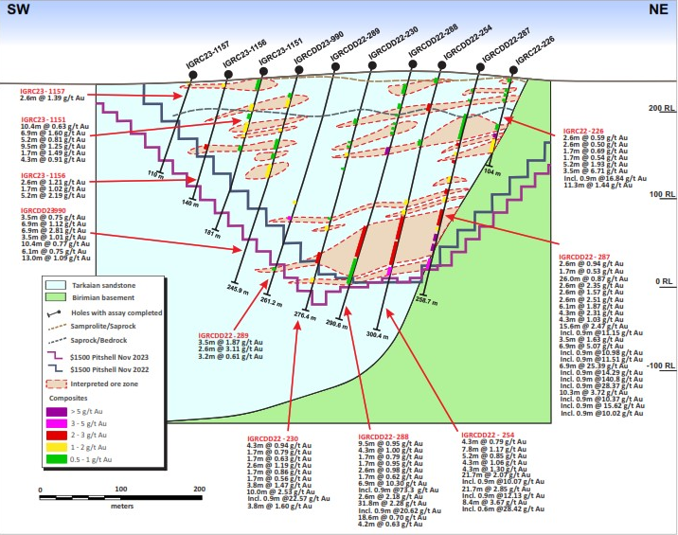

Cross Section 1933: Infill drilling in the centre of the deposit extended resources at depth
As shown in Figure 6 below, infill drilling within the November 2022 resource pitshell confirmed the presence of high-grade mineralisation and thickness of the main mineralised lenses in close proximity to the structural contact with the Birimian Basement rocks. In addition, further drilling highlighted the presence of deeper underlying lenses that have extended mineralisation to a depth of over 250 metres. The structural contact between the Birimian Basement rocks and the Tarkwaian Sandstones plunging towards the southwest below the Assafou deposit suggests potential for further high-grade mineralised lenses at depth.
Figure 6: Assafou Cross Section 1933
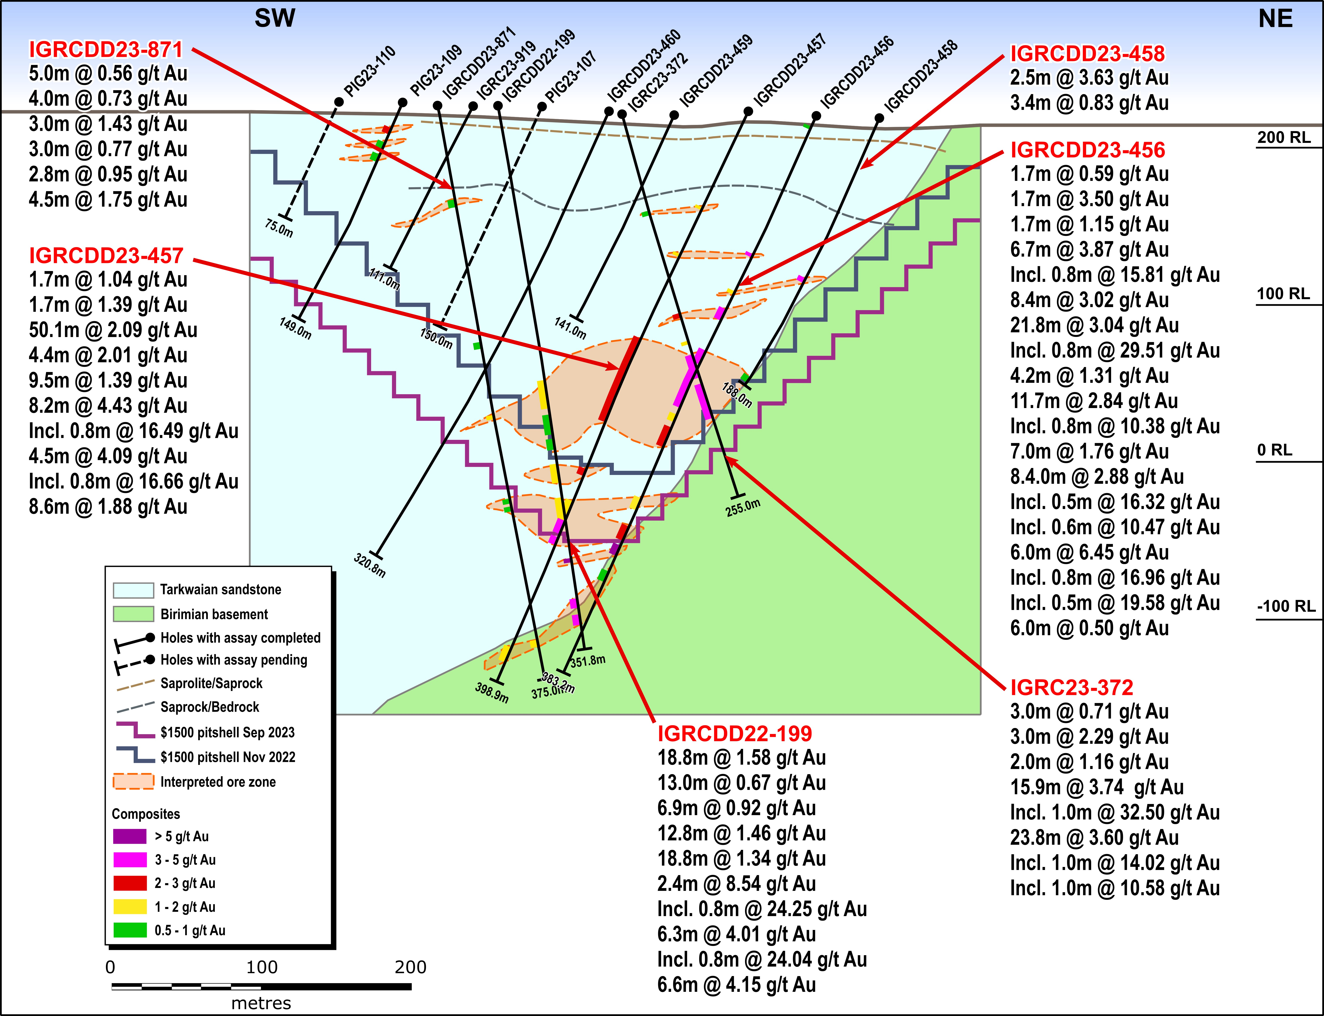

Cross Section 1766: Infill drilling has added additional resources close to surface and at depth
As shown in Figure 7 below, infill drilling has confirmed the presence of a series of stacked mineralised lenses towards the southwest of the deposit which are less than 100 metres below the surface. Further, drilling at depth has confirmed that mineralisation extends below the 2022 resource pit shell to a depth of over 250 metres at the contact zone with the Birimian Basement rocks.
Figure 7: Assafou Cross Section 1766
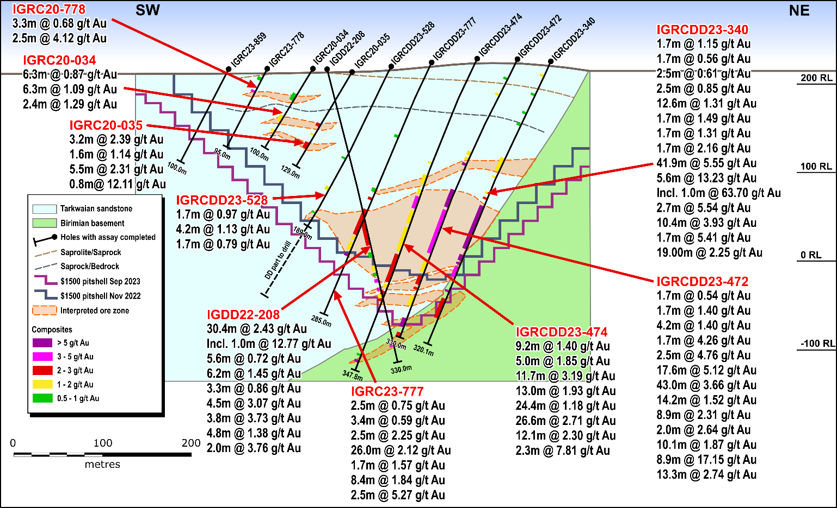

Cross Section 0533: Drilling has extended resources southeast of the November 2022 resources
As shown in Figure 8 below, additional drilling has identified high-grade, thick continuous mineralisation located approximately 1.5 kilometres southeast of the November 2022 Indicated resource boundary and over 300 metres southeast of the November 2022 Inferred resource boundary extending the pitshell significantly to the southeast. High-grade mineralisation occurs as stacked lenses extending from the surface down to over 200 metres depth.
Figure 8: Assafou Cross Section 0533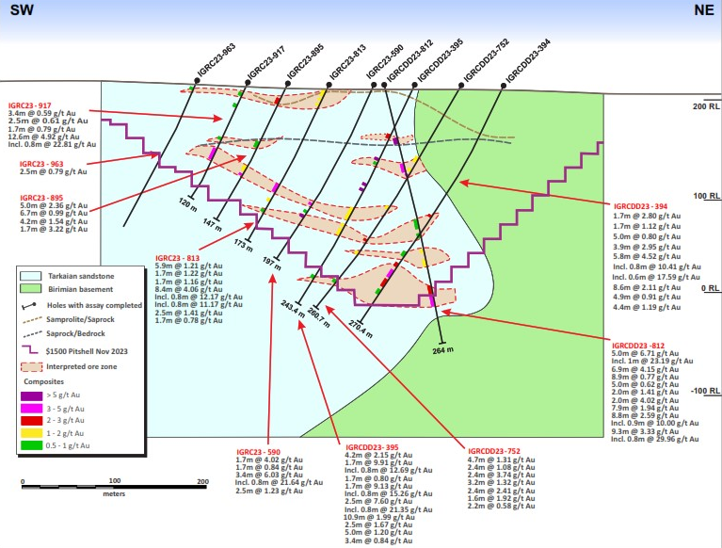

EXPLORATION ON TARGETS LOCATED NEAR ASSAFOU
A total of 20,000 metres of drilling is planned for FY-2023 to test high priority targets identified within a 5 kilometre radius of the Assafou deposit, with 17,000 metres of drilling completed year to date. As shown in Figure 9 below, drilling has focused on Assafou satellite targets, located within a similar geological setting and hosted along similar structural contacts between the Tarkwaian Sandstones and the Birimian Basement.
The mineralised structure that hosts Assafou has now been identified over a 12 kilometre strike length, extending from Kongodjan in the southeast to Gbabango to the northwest. Results from scout drilling at the Kongodjan target identified a continuation of mineralisation along a 3 kilometre untested corridor between the southeast end of Assafou and Kongodjan.
In addition to mineralisation discovered along the structural contact, parallel structures have also been identified on the southwestern part of the basin where two main gold in soil anomalous trends, Pala trend 2 and trend 3, were delineated following scout drilling this year, which revealed these mineralised structures along the contact between the Tarkwaian Sandstone and Birimian Basement.
The Pala trend 2 target, located 4 kilometres west of Assafou, displays continuity of mineralisation over more than 0.6 kilometres along a northwest strike. Significant mineralisation was also intercepted in scout drillholes at Pala Trend 3, located 2 kilometres west of Assafou. Mineralisaiton at Pala Trend 3 is open to the northeast as well as along strike in both directions.
Notably, gold occurrences have also been intercepted 0.5 kilometres to the northwest of Assafou at the Assafou NW target, where gold mineralisation occurs exclusively in mafic Birimian Basement rocks.
Together, these other gold occurrences are still at an early exploration stage and mineralisation remains open along strike and at depth as large portions of the structures have yet to be tested. Their position in a similar geological and structural setting to that of Assafou indicate a high level of prospectivity.
Figure 9: Tanda-Iguela Regional Targets
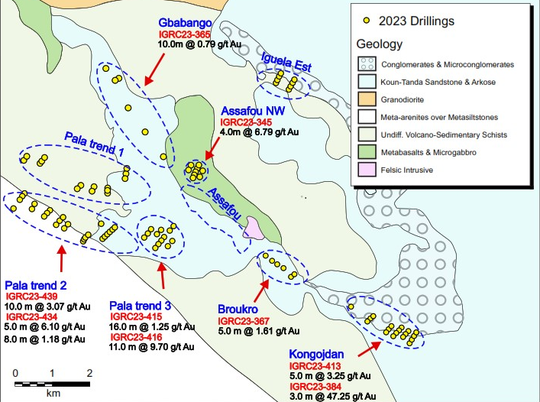

In 2024, at least 35,000 metres of drilling are planned to continue to test high-priority targets located within close proximity to the Assafou deposit. Follow up drilling is planned on the Gbabango, Assafou NW and Kongodjan targets located along the 12 kilometre structural trend that hosts the Assafou deposit as well as the parallel structure hosting the Pala trend targets. In addition, drilling will focus on testing new targets on the Tanda permit including Sokouadou, Gbokore, and Djani-Yao.

NEXT STEPS
- A Preliminary Feasibility Study (“PFS”) has been launched, based on the updated November 2023 resource estimate, which is expected to be finalised in late 2024.
- Long lead items within the PFS have been started, including metallurgical sampling, geotechnical, hydrogeological and sterilisation drilling and environmental permitting.
- Metallurgical sampling and testing is underway to follow up on the preliminary phase of testwork which demonstrated the potential for high gravity recoverable gold and overall average recoveries above 94%.
- Geotechnical and hydrogeological drilling are underway across the Assafou deposit.
- Sterilisation drilling is underway to the northeast of the Assafou deposit to identify and sterilise the probable location for mine and processing infrastructure.
- The environmental permitting process has been launched with study work underway that will form the basis of the environmental reporting.
- Drilling will continue in 2024, with at least 60,000 metres planned at Tanda-Iguela, of which 25,000 metres will focus on delineating further resources at Assafou, while 35,000 metres will focus on delineating potential satellite deposits in close proximity to Assafou.

TECHNICAL NOTES
Assafou Geology
Mineralisation at Assafou is mainly hosted in Tarkwaian Sandstone, at/or immediately in the vicinity of the structural contact with Birimian Basement rocks (mainly mafic rocks). Gold mineralisation occurs both as disseminated occurrences within pervasively altered sandstone and within, or at the edges of, quartz (±carbonate) veins and breccias that crosscut the altered sandstones. Alteration is reflected by an induration (silicification) and by the presence of sulphides (pyrite), disseminated within the matrix and distributed along the sandstone bedding. The more intense the silicification (and presence of pyrite), the more mineralised the sandstones tend to be.
The structural contact likely controlled the initial sandstone deposition (normal fault in extensional regime). It was then reactivated under a SSW-NNE compressive regime at the brittle-ductile transition, associated with strong mylonitisation and alteration (quartz, carbonate, pyrite, ± sericite, ± chlorite) of the Birimian Basement rocks, and to mafic and felsic intrusions as dykes and sills. Gold mineralisation is likely to have occurred during this reversal, in the post-Tarkwaian reactivation event. Mineralising hydrothermal fluids are believed to have preferentially invaded the Tarkwaian Sandstones rather than the Birimian Basement rocks, due to their higher initial porosity, permeability and competency.
Assafou Resource Modelling
The statistical analysis, geological modelling and resource estimation were prepared by a resource team of Endeavour. Geological modelling and mineral resource estimation study has been done by Can Aydogan. The Qualified Person as defined by NI 43-101 is Kevin Harris, Vice President of Resources with Endeavour Mining.
The Assafou mineral resource model was developed in Seequent’s Leapfrog Geo, Snowden’s Supervisor and Geovia’s Surpac software. The database used to generate the mineral resources comprised some 868 drill holes, totalling 183,081 metres. The drill hole data was supported by industry-standard quality assurance and quality control systems, with quality control sampling comprising blanks, coarse blanks, certified reference materials, and field and pulp duplicates. Endeavour’s resource team has reviewed the QAQC data available and considers the assay data to be suitable for use in the subsequent mineral resource estimate.
Mineralisation domains were modelled with the Vein System tool in Leapfrog Geo using the interval selection for each vein. The gold assays from the drill holes were composited to 1.0 metre intervals. Grade capping values were applied depending on the mineralised domain, between no cap and 45 g/t. Spatial analysis of the gold distribution within the mineralised zone indicated good continuity of the grades along strike and down dip within the mineralised zones. Variography has been applied using Snowden’s Supervisor for the largest mineralised zones (101, 102, 103, 104, 105, 106, 110 and 112) and variogram models were produced for these domains. These largest domains represent almost half of the entire population and have a good geological and grade continuity.
Density measurements from 401 drill holes and covering each of the lithologies, were averaged based on the material type (and lithology, in the case of fresh material). Average density values were applied to the associated portions of the block model as outlined below:
- Laterite 1.79 g/cm³
- Saprolite: 1.96 g/cm³
- Saprock: 2.36 g/cm³
- Fresh: 2.76 g/cm³
Gold grades were estimated in Geovia’s Surpac using Inverse Distance Squared (‘’IDW2’’) for most of the modelled mineralisation. Ordinary Kriging (‘’OK’’) was only used for the largest domains which include sufficient data for variogram models. The Ordinary Kriging (“OK”) estimation represents almost half of the mineralised volume. The grade was estimated in multiple passes to define the higher confidence areas and extend the grade to the interpreted mineralised zone extents.
The grade estimation was validated with visual and statistical analysis, and comparison with the drilling data on sections with swath plots comparing the block grades with the composites.
The majority of the resource is within the fresh rock, approximately 0.5% of the ounces is oxide, 5.7% is transition and 93.8% is fresh rock.
Endeavour considers that the quality and spatial distribution of the data used, the geological continuity of the mineralisation and the quality of the estimated block model for the Assafou deposit are sufficient for the reporting of Indicated and Inferred mineral resources, in accordance with the CIM Definition Standards. Indicated mineral resources have typically been defined in areas with a drill hole spacing of 30-40 metres along sections, and 30-40 metres between sections, where there is a reasonable level of confidence in geological and grade continuity. Inferred mineral resources have typically been defined in areas with a drillhole spacing of 50 to 75 metres, and where the controls on mineralisation are less well understood, or the continuity is reduced.
Mineral resources are reported within an optimised pit shell using a cut-off grade of 0.5 g/t Au. Technical and economic assumptions were agreed for mining factors (mining and selling costs, mining recovery and dilution, pit slope angles) and processing factors (gold recovery, processing costs), which were used for optimisation. The optimised factors are summarised below:
- Mining cost: US$4.06/t ore and US$ 3.12/t waste
- Processing cost: Oxide/Transitional: US$ 11.08/t ore; Fresh: US$ 11.66/t ore
- G&A cost: US$ 4.68/t ore
- Selling cost: US$ 71.50/oz Au
- Mining recovery: 95%; Dilution 0%
- Processing recovery: 95.7% for Oxide/Transition and 93.6% for Fresh at the average grade
- Average slope angles: 28-43°, dependent on geotechnical domain

Drilling, Assay, Quality Assurance / Quality Control Procedures
Reverse Circulation (“RC”) and Air Core (“AC”) drilling uses high pressure compressed air to deliver rock materials to the surface. The compressed air is delivered via a dual tube drill rod system, with an outer tube for air going down-hole, and an inner-tube for return going back to surface. In RC drilling, compressed air drives a percussion hammer. In both RC and AC drilling, compressed air carries rock particles back to surface via the inner-tube, minimizing potential contamination affects.
The samples are collected from the cyclone at surface at 1 metre intervals. The cyclone is cleaned after every 6-metre rod by flushing the hole and physical opening of the cyclone and blowing out with compressed air at the end of each hole. Additional manual cleaning is required in saprolitic or wet ground, closely monitored by the site geologist / geotechnician to ensure no sample-to-sample contamination occurs. Samples are manually split at the drill site using several different riffle splitters, based on bulk sample weight. 2 to 5 kilograms laboratory samples and a second 2 to 5 kilograms reference sample are collected. Bulk and laboratory sample weights, in addition to moisture levels are recorded. Representative samples for each interval were collected with a spear, sieved into chip trays and retained for reference.
Drill core (PQ, HQ and NQ size) samples are selected by Endeavour geologists and cut in half with a diamond blade at the project site. Half of the core is retained at the site for reference purposes. Sample intervals are generally 1 metre in length, adjusted with geologic and/or structural contacts. All samples are transported by road to Bureau Veritas in Abidjan. Each laboratory sample is secured in poly-woven bags ensuring that there is a clear record of the chain of custody. On arrival samples are weighed. Complete samples are crushed to 2 mm (70% passing) with 1 kilogram split out for pulverization. The entire 1 kilogram is pulverized to 75 μm (85% passing). A 50-gram sample is extracted and analysed for gold using standard fire assay technique. An Atomic Absorption (“AA”) finish provides the final gold value.
Blanks, field duplicates and certified reference material (“CRM’s”) are inserted into the sample sequence by Endeavour geologists at a rate of 1 of each samples type per 20 samples. This ensures that there is a 5% Quality Assurance / Quality Control (“QA/QC”) sample insertion rate applied to each fire assay batch. The sampling and assaying are monitored through analysis of these QA/QC samples. This QA/QC program was audited by a consultant, independent from Endeavour Mining and has been verified to follow industry best practices.
In 2021 and 2022, 1,757 samples were sent to ALS Ouagadougou for umpire (referee) analysis. Comparison of the Original analysis against the umpire analysis revealed a very strong Correlation Coefficient of 95.90% suggesting that the original assays provided by Bureau Veritas in Abidjan are accurate. Core sampling and assay data were monitored through a quality assurance/quality control program designed to follow NI 43-101 and industry best practice.
This news release highlights the best selected intercepts from drilling activities between 1 January 2023 to 14 November 2023. Full drill results are available by clicking here.

QUALIFIED PERSONS
The scientific and technical content of this news release has been reviewed, verified and compiled by Silvia Bottero, Professional Natural Scientist, Senior Vice President - West Africa Exploration for Endeavour Mining. Silvia Bottero has more than 20 years of mineral exploration and mining experience and is a "Qualified Person" as defined by National Instrument 43-101 – Standards of Disclosure for Mineral Projects ("NI 43-101"). The resource estimation was completed by Kevin Harris, CPG, Vice President - Resources for Endeavour Mining and "Qualified Person" as defined by National Instrument 43-101.

CONTACT INFORMATION
Martino De Ciccio  Deputy CFO & Head of Investor Relations  +44 203 640 8665  mdeciccio@endeavourmining.com | Brunswick Group LLP in London  Carole Cable, Partner  +44 7974 982 458  ccable@brunswickgroup.com

ABOUT ENDEAVOUR MINING CORPORATION
Endeavour Mining is one of the world’s senior gold producers and the largest in West Africa, with operating assets across Senegal, Cote d’Ivoire and Burkina Faso and a strong portfolio of advanced development projects and exploration assets in the highly prospective Birimian Greenstone Belt across West Africa.
A member of the World Gold Council, Endeavour is committed to the principles of responsible mining and delivering sustainable value to its employees, stakeholders and the communities where it operates. Endeavour is listed on the London and Toronto Stock Exchanges, under the symbol EDV.
For more information, please visit www.endeavourmining.com.

CAUTIONARY NOTE REGARDING FORWARD-LOOKING INFORMATION
This news release contains "forward-looking statements" including but not limited to, statements with respect to Endeavour's plans for further exploration of the Tanda-Iguela property, the extent and timing of Endeavour’s drilling campaign, the timing of the updated mineral resource estimate, the estimation of mineral resources, and the success of exploration activities. Generally, these forward-looking statements can be identified by the use of forward-looking terminology such as "expects", "expected", "budgeted", "forecasts", and "anticipates". Forward-looking statements, while based on management's best estimates and assumptions, are subject to risks and uncertainties that may cause actual results to be materially different from those expressed or implied by such forward-looking statements, including but not limited to: risks related to the successful integration of acquisitions; risks related to international operations; risks related to general economic conditions and credit availability, actual results of current exploration activities, unanticipated reclamation expenses; changes in project parameters as plans continue to be refined; fluctuations in prices of metals including gold; fluctuations in foreign currency exchange rates, increases in market prices of mining consumables, possible variations in ore reserves, grade or recovery rates; failure of plant, equipment or processes to operate as anticipated; accidents, labour disputes, title disputes, claims and limitations on insurance coverage and other risks of the mining industry; delays in the completion of development or construction activities, changes in national and local government regulation of mining operations, tax rules and regulations, and political and economic developments in countries in which Endeavour operates. Although Endeavour has attempted to identify important factors that could cause actual results to differ materially from those contained in forward-looking statements, there may be other factors that cause results not to be as anticipated, estimated or intended. There can be no assurance that such statements will prove to be accurate, as actual results and future events could differ materially from those anticipated in such statements. Accordingly, readers should not place undue reliance on forward-looking statements. Please refer to Endeavour's most recent Annual Information Form filed under its profile at www.sedar.com for further information respecting the risks affecting Endeavour and its business.
APPENDIX A: BEST SELECTED INTERCEPTS
HOLE ID |  | FROM  (m) | TO  (m) | TRUE LENGTH  (m) | AU GRADE  (g/t)
IGRCDD23-336 |  | 125.0 | 132.0 | 5.9 | 5.53
 | including | 128.0 | 129.0 | 0.8 | 22.75
 | including | 128.0 | 129.0 | 0.8 | 27.63
 | and | 135.0 | 143.0 | 6.7 | 4.05
 | including | 141.0 | 142.0 | 0.8 | 11.62
 | and | 155.0 | 175.0 | 16.8 | 7.49
 | including | 160.0 | 161.0 | 0.8 | 13.80
 | including | 164.0 | 165.0 | 0.8 | 10.39
 | including | 165.0 | 166.0 | 0.8 | 77.90
 | including | 166.0 | 167.0 | 0.8 | 10.39
 | and | 189.0 | 209.0 | 16.8 | 4.39
 | including | 195.0 | 196.0 | 0.8 | 18.97
 | including | 202.0 | 203.0 | 0.8 | 11.57
 | and | 211.2 | 239.4 | 23.7 | 3.90
 | including | 220.0 | 221.0 | 0.8 | 11.37
 | including | 228.2 | 228.9 | 0.6 | 21.62
 | including | 228.9 | 229.9 | 0.8 | 14.11
 | including | 237.8 | 238.8 | 0.8 | 12.13
 | and | 287.4 | 296.1 | 7.3 | 2.79
 | including | 288.3 | 289.0 | 0.6 | 14.61
 | and | 303.7 | 315.0 | 9.6 | 2.52
 | including | 288.3 | 289.0 | 0.6 | 14.61
 | and | 303.7 | 315.0 | 9.6 | 2.52
IGRCDD23-356 |  | 119.0 | 171.0 | 43.6 | 1.83
 | including | 149.0 | 150.0 | 0.8 | 11.35
IGRCDD23-359 |  | 105.0 | 116.0 | 8.7 | 2.66
 | and | 151.0 | 166.0 | 11.8 | 8.94
 | including | 158.0 | 159.0 | 0.8 | 97.30
 | and | 169.0 | 190.0 | 16.6 | 2.35
 | and | 200.7 | 234.0 | 26.3 | 3.52
 | and | 237.0 | 252.0 | 11.8 | 3.39
 | including | 230.0 | 231.0 | 0.8 | 37.50
 | including | 240.0 | 241.0 | 0.8 | 18.70
 | including | 249.0 | 250.0 | 0.8 | 13.44
 | and | 302.3 | 309.4 | 5.6 | 6.24
 | including | 306.3 | 307.0 | 0.6 | 36.10
IGRCDD23-457 |  | 155.0 | 214.7 | 50.1 | 2.09
 | and | 270.5 | 281.8 | 9.5 | 1.39
 | including | 290.0 | 291.0 | 0.8 | 16.49
 | and | 374.8 | 385.0 | 8.6 | 1.88
 | including | 290.0 | 291.0 | 0.8 | 16.49
IGRCDD23-531 |  | 121.0 | 129.0 | 7.9 | 6.41
 | including | 122.0 | 123.0 | 1.0 | 16.56
 | including | 123.0 | 124.0 | 1.0 | 17.13
 | and | 138.0 | 210.0 | 71.5 | 5.29
 | including | 140.0 | 141.0 | 1.0 | 19.21
 | including | 146.0 | 147.0 | 1.0 | 21.27
 | including | 160.0 | 161.0 | 1.0 | 22.91
 | including | 165.0 | 166.0 | 1.0 | 12.26
 | including | 183.0 | 184.0 | 1.0 | 29.36
 | including | 186.0 | 187.0 | 1.0 | 11.73
 | including | 203.0 | 204.0 | 1.0 | 16.59
 | including | 204.0 | 205.0 | 1.0 | 12.98
 | including | 205.0 | 206.0 | 1.0 | 48.20
 | including | 206.0 | 207.0 | 1.0 | 13.99
IGRCDD23-541 |  | 51.0 | 65.0 | 12.0 | 0.75
 | and | 91.0 | 100.0 | 7.7 | 0.62
 | and | 105.0 | 111.0 | 5.1 | 1.37
 | and | 166.0 | 248.0 | 70.3 | 2.94
 | including | 189.0 | 190.0 | 0.9 | 56.60
 | including | 213.1 | 214.1 | 0.9 | 10.80
 | including | 217.1 | 218.0 | 0.8 | 13.30
 | including | 238.8 | 239.8 | 0.9 | 18.02
 | and | 294.5 | 302.5 | 6.9 | 0.98
IGRCDD23-599 |  | 74.0 | 80.0 | 5.0 | 1.58
 | and | 111.0 | 143.0 | 26.8 | 2.05
 | including | 130.0 | 131.0 | 0.8 | 15.85
 | and | 200.0 | 209.8 | 8.2 | 3.62
IGRCDD23-700 |  | 132.0 | 138.0 | 6.0 | 1.33
 | and | 150.0 | 166.0 | 15.9 | 4.05
 | including | 155.0 | 156.0 | 1.0 | 13.24
IGDD23-749 |  | 76.8 | 84.6 | 7.8 | 2.16
 | including | 78.7 | 79.5 | 0.8 | 11.38
 | and | 118.3 | 123.3 | 5.0 | 0.57
 | and | 127.4 | 140.4 | 13.0 | 1.28
 | and | 145.6 | 175.2 | 29.6 | 3.10
 | including | 173.7 | 174.4 | 0.7 | 51.20
 | and | 63.0 | 78.0 | 12.6 | 4.92
 | including | 68.0 | 69.0 | 0.8 | 22.81
Best selected intercepts include intercepts with a true length greater than 5 metres. Full drill results are available by clicking here.
Drill sampling parameters: For compositing Infill drill holes a 0.3 g/t Au cut off for samples, 0.5 g/t Au minimum value composite and 2.0 metre maximum interval dilution length. Composite interval represent calculated downhole (true) thickness. “Including” represents >10 g/t Au.
For compositing exploration drill holes a 0.3 g/t Au cut off for samples, 0.3 g/t Au minimum value composite and 2.0 metre maximum interval dilution length. Composite interval represent calculated downhole (apparent) thickness. “Including” represents >10 g/t Au.

