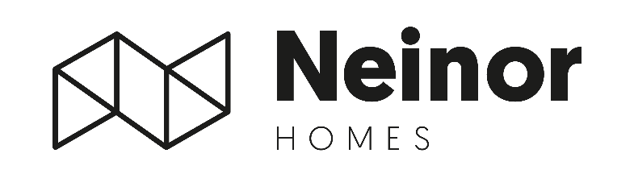
Neinor Homes Initiates €50M Share Repurchase Program: Capitalizing on Dislocation
- Neinor announces a share buyback of up to 3 million shares (€50mn)
Madrid, 30 March, 2026 – Neinor Homes (“Neinor”), Spain’s leading listed residential developer announces the launch of a share buyback program of up to 3 million shares, representing an investment of up to c.€50 million.
The program will be used to meet obligations arising from share-based remuneration plans and to reduce share capital through the cancellation of treasury shares, contributing to shareholder remuneration and enhancing earnings per share.
This initiative forms part of Neinor’s €500 million shareholder remuneration plan for the 2026–2027 period (€250 million per year), under which the Company has already distributed €92 million to shareholders.
Borja García-Egotxeaga, CEO of Neinor Homes, commented: “Geopolitics are reshaping capital flows. And yet, the structural undersupply of housing in Spain is not going away, if anything it is getting worse. We are building something that will matter for over a decade. We’ve been through similar times during 2021 and 2022 when we had supply chain issues due to COVID, energy cost inflation at the first time of Ukraine war, and rates increase after 2022. We have handled before these kind of situations where challenges and opportunities arise. We will be very focused on execution while we keep looking to generate new long-term shareholder value”.
Jordi Argemí, Deputy CEO and CFO of Neinor Homes, added: “The math is straightforward. We have €500mn committed to shareholder returns over 2026–27, €92mn already delivered, and a balance sheet that supports continued growth and execution without compromising our development pipeline.”
* For the full regulatory announcement please refer to Neinor’s webpage (https://www.neinorhomes.com/en/corporate/investors/market-notifications/other-relevant-information/)
-ENDS-

For more information:
NEINOR HOMES
Investor Relations Department
investor.relations@neinorhomes.com

