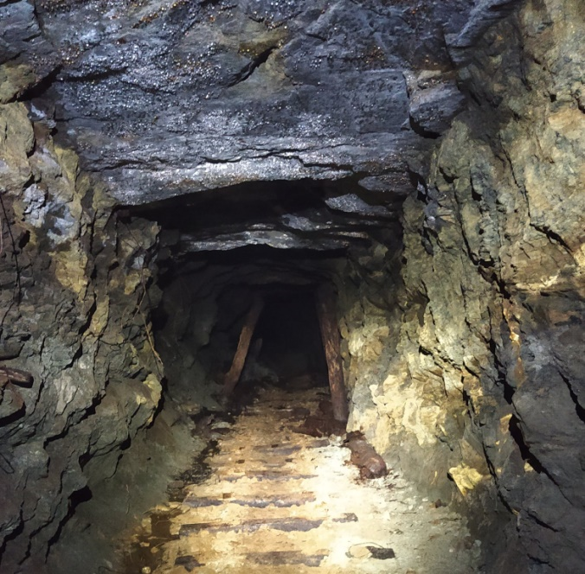  Figure 3 (Above): Well preserved state of G7. Most of the rails are removed.  Figure 4 (Right): Powdery, greenish nickel oxide minerals on the gallery wall and rocks on the gallery floor. Yellow magnetic pen for scale. | 